Table of contents

Introduction 3
1. Appraising employability skills in the workplace 3
1.1 Familiarise yourself with the process students have embarked upon 3
1.2 Appraise students’ employability skills 3
1.3 Write a personal commendation 4
2. Employer Appraisal Form 5
3. The STAR Method 7
Appendix I 8
1. Workflow 8
1.1 Workflow graphic 8
1.2 Example of procedure 8

Introduction

This guide presents both the rationale and the necessary information to appraise students’ ePortfolio through a guided process from an employer or human resources perspective.

1. Appraising employability skills in the workplace

1.1 Familiarise yourself with the process students have embarked upon
You are required to appraise the ePortfolio that final year students have created to showcase their employability skills and professional persona. Alongside their online profile, and supporting evidence, you will find a three-to-five minute video testimony that we are asking you to watch and appraise (see appraisal form below) from an employer or human resources perspective. In this video, the student evaluates how they have acquired the employability skill(s) at hand, and presents their understanding as to how they believe such skill(s) will help them in the workplace and may contribute to their career.

Importantly, the aim of this process is to ensure students have the ability to articulate their employability skills in a relevant manner for job seeking. This process follows a skill assessment procedure by university teachers, guaranteeing the reliability and veracity of the evidence provided before this is made available to you.

1.2 Appraise students’ employability skills

Students whose grade is 80% and above in one or more employability skills (this is an institutional decision) in the first phase, are invited, in phase two, to record a video and submit it together with evidence for your appraisal. The video testimony that students have recorded follows the STAR method of interviewing (see below). STAR is an acronym that stands for: situation, task, action, and result. At a job interview, candidates usually set the scene and give the necessary details of the situations they would have chosen to present, followed by a description of what their responsibilities were, and the steps they took to address said situation(s). Finally they share the outcomes that their actions achieved. Similarly, in the video which final year students have been asked to put together, they will review the context(s) they believe helped them acquire/develop a certain employability skill (or skills), describe how they engaged with it (them), explain the steps they took to actively make it (them) a part of their practice, and share how this (these) skill(s) will help them contribute to the workplace and how they believe it (they) will set them apart from other candidates applying for a job.

All in all, we strongly suggest that you carefully appraise students using the “Student appraisal scale” to certify whether you believe the student has demonstrated an understanding and active engagement with said employability skill(s), and has confidently showcased their professional persona, both in the video and throughout their ePortfolio..

In section 2 of this document you will find the criteria for the Student Assessment Scale which we recommend you to read before reviewing students’ work in order to familiarise yourself with the criteria students ought to meet.

1.3 Write a personal commendation

Should you believe a student has cogently articulated their employability skills in a way which would set them apart in the workplace, you will be asked to comment on the student-candidate’s performance, and endorse them with a written commendation outlining that the student has shown outstanding potential. Check the “Employer Process Simulation” document for step-by-step guidance.

After all appraisals have been completed, you will be sent a survey asking you to assess the process and your experience. This information will be used for the improvement of the approach and the tool.

2. Employer Appraisal Scale
The purpose of this appraisal scale is twofold:
- to help you become acquainted with the criteria students’ work ought to meet before appraising it;
- to inform the final questionnaire which will be made available to you by link to appraise students’ EPICA ePortfolio at large using these criteria.
The Student Assessment Scale is strongly recommended as it provides a series of criteria for easy identification and assessment. Moreover, the scale supports reducing bias and maintaining objectivity in the evaluation of the students. Based on a spreadsheet we will provide you, the values for each item are distributed on a scale of 1 to 4. The total is calculated automatically and provided at the base of each column (with an individual total score for each student). These results are guidance values that the employer can use to help finalise their decision. However, the employer is free to make a final decision and give their opinion according to the relevant situational factors that they feel should be taken into account

Criteria in the Student Appraisal Scale
Overall ePortfolio

Is the ePortfolio fit for the workplace?
Did the student present enough information to showcase their professional persona?
Did s/he do so in a professional manner?
Was the language used suitable for the workplace?
Video testimony - STAR method

Has the student successfully showcased the development of the presented skills?
Is the situation (S) presented by the student representative of the skill/s s/he was aiming to showcase?
Is the task (T) described by the student representative of the skill/s s/he was aiming to showcase?
Are the described actions (A) consistent with the task/s assumed?
Has the articulation of the results (R) been clear and efficient, that is, do the conclusions reached by the student show a growth in skill/s?
Has the student explained that s/he can transfer the skill/s to the workplace?
Has the student been able to limit the video to the established time (3 to 5 minutes)?
Is the information provided by the student objective?
Is the student's presentation focused on personal achievements and not on shared achievement?
Has the student presented himself / herself in a professional manner?
Evidence

Was the evidence submitted relevant to the task at hand?
Was the evidence presented representative of the skill/s it was aiming to showcase?
Was the evidence sufficient to demonstrate the skill/s s/he aimed to showcase?
Was the evidence reliable?
Was the evidence objective, that is, not based on subjective personal experience alone?

Overall Appraisal
Is the student’s work worthy of a commendation on your part?

You will be provided with the Student Appraisal Scale document in excel format:

Figure 1

Screenshot of a section of the Student Appraisal Scale (original document in a spreadsheet)
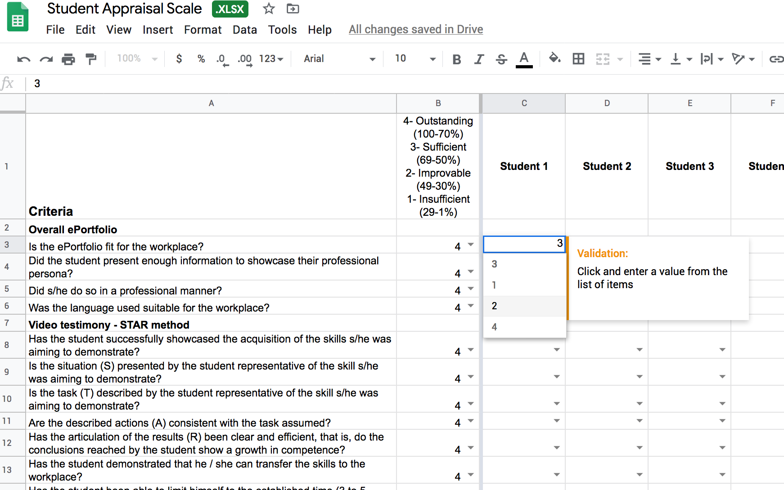

3. The STAR Method

In the video testimony which completes students’ ePortfolio, students will be required to apply the STAR method of interviewing to the evidence they submitted prior to the platform, and reflect upon it using the same method. The STAR method of interviewing is a structured manner of responding to a behavioural-based interview by discussing specific situations and associated tasks, actions, and results of the situations they are describing. In the current study, students will be required to think of the employability skill(s) they are showcasing, and present (a) situation(s) where they believed they acquired or developed said skill(s) following the structure below:

Situation(s): Describe the situation(s) that you were in or the task(s) that you needed to accomplish which you feel showcased the employability skill(s) at hand. You must describe specific event(s) or situation(s), not a generalised description of what you have done in the past. Be sure to give enough detail for the interviewer to understand. Situations can be from an academic endeavour, previous job, a volunteer experience, or any relevant event.

Task(s): What goal were you working towards?

Action(s): Describe the action(s) you took to address the situation(s) with an appropriate amount of detail and keep the focus on you. What specific steps did you take and what was your particular contribution? Be careful that you do not describe what the team or group did when talking about a project, but what you actually did. Use the word “I,” not “we” when describing actions. Keep in mind the employability skill(s) you are showcasing.

Result(s): Describe the outcome of your actions and do not be shy about taking credit for your behaviour. What happened? How did the event end? What did you accomplish? What did you learn? Make sure your answer contains multiple positive results and clearly showcases the employability skill(s) you have intended to demonstrate throughout.

Students ought to make sure that they follow all parts of the STAR method in their video testimony. They should be as specific as possible at all times, without rambling or including too much information. They are encouraged to eliminate any examples that do not paint them in a positive light whilst keeping in mind that some examples that have a negative result (such as “lost the game”) can highlight their strengths in the face of adversity. Therefore, they are encouraged to choose their examples wisely so they clearly prove acquisition/development of employability skills.

Appendix I

1. Workflow

1.1 Workflow graphic

Figure 2

Step by Step Method for the Appraisal of Student EPortfolio, Competences and Evidence

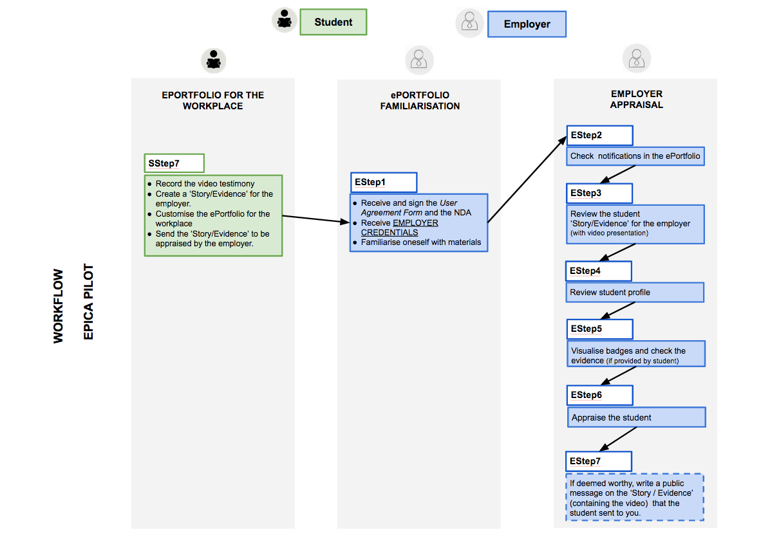

1.2 Example of procedure
This example illustrates the procedure followed within the Epica framework.

Appraisal by employers
EStep1

- sign the Pilot User agreement
- receive the EMPLOYER CREDENTIALS to access the EPICA platform (MyD)
- receive the Employer Guide and the link to the appraisal form
- familiarise yourself with the ePortfolio, the micro-credential process, and the relevant materials. Review in detail the employer appraisal form (see Section 2) in order to acquaint yourself with the criteria set for students’ appraisal.

EStep2

- check notifications and read the message from the student
- receive the link to the online appraisal form by email

EStep3
- review the "Story/Evidence" received from the student

EStep4
- review student profile

EStep5
- visualise badges and review evidence (if provided by student)

EStep6
- appraise students by completing the online appraisal form received outside the platform.
- provide the student with qualitative feedback based on the appraisal form by answering the private message first sent by the student within the ePortfolio. The text written in the final text box of the appraisal form can be used as feedback by copying it into the private message

EStep7
- write a recommendation, if deemed worthy, by writing a public message to the student in the text box available, below the ‘Story/Evidence’ presented by the student (see Process Simulation below).
Our recommendation is to write a personal text highlighting virtues and professional skills of interest from an employer’s point of view.

