UNIVERSITAT OBERTA DE CATALUNYA
Final Project Report

Title: Fighting pollution, misery and conflict. The case of the mining exploitation
in Haut Katanga, Province of Democratic Republic of Congo
-------------------------------------------------------------------------------

Project carried out in Democratic Republic of Congo
Haut Katanga province, Lubumbashi

Specialization: Conflictology

By Liliane MBUMB MAYOMBO

Supervisor: Cristina Sala Valdès

Academic year: 2015-2018
Content

Contents

- Foreword………………………………………………………………………………..…4
  - Pollution from mining activities has a very negative impact
on the province's economy, which justifies: the increase in
mining activity, the greater the poverty of the population……………………………….4
  - The infrastructure is dilapidated………………………………………………………….5
  - The rural exodus………………………………………………………………………….5
  - Increase in the unemployment rate……………………………………………………….5
  - The level of study has fallen sharply……………………………………...……………...5
- Introduction…………………………………………………………………………………….8
  - Overview of the problem…………………………………………………………………8
  - Project justification……………………………………….…….………………………..9
  - Motivation………………………………………………………………………………11
  - Project structures………………………………………………………………………..12
- Contextual framework………………………………………………………………………..13
  - Theoretical framework…………………………………………………………………..13
  - Population concerned……………………………………………………………………13
  - Methodology chosen for the project……………………………………………………..14
    - Bibliographic method or documentary analysis……………………………………16
      - The mission of the mining administration in the protection
of the environment;
        - Dispositions provide by Congolese mining codes………………17
        - Dispositions provide by Congolese Mining Regulation….…….18
    - Methodology of the survey…………………………………………………………16
    - The method of data collection……………………………………………………...21
- Objectives………………………………………………………………………………...…...21
  - Main objective…………………………………………………………………...………21
  - Specific objectives………………………………………………………………...……..22
    - The identification of the consequences of the pollution resulting …………………22
from the mining activities…………………………………………………………..22
    - After thorough studies and analyzes of these effects, identify
methods and techniques and related procedures to address them………….………22
    - Identify the acts that demonstrate the misery of the population
in the proliferation of conflicts in general and armed
conflicts in particular………………………………………………………………23
    - to identify the gaps in the application of the legal texts with
regard to the protection of the environment in the
mining exploitation…………………………………………………………………23
    - Referring to the case of mining in Zambia…………………………………………23
  - Expected results………………………………………………………………..………..23
    - Reduction of the pollution rate…………………………………………… ………23
    - Compensation for damage caused by mining work due to land occupation………24
    - The allocation of the territory or city in the distribution of the mining royalty……24
- Writing the project…………………………………………………………………………….24
Activities:
  - The constitution of a team which integrates all the actors concerned……………. ….25
    - Training team members to bring them to a better understanding of the project…27
    - The descent of the field team to conduct investigations: interviews, interviews, document collection, ..............................................................................................27
      - Meeting with the different mining companies,…………………..…….27
      - Meeting with the mines administration…………………………..……28
      - Meeting with the communities,…………………………………..……28
      - Meeting with the courts, tribunals and public prosecutor's offices…....28
  - Organization of team work sessions to read survey results:……………………..…….29
  - Working session to identify all necessary documents:………………………...……….29
Obstacles encountered during field activities…………………………………………………….30

- Conclusions……………………………………………………………………..……………30

- Notes……………………………………………………………………………………..31
- Bibliography…………………………………………………………….………………..33
- Appendix I : List of mining companies operating in Haut Katanga………….………….35
- Appendix II : Pollution in Likasi…………………………………………………………39
- Appendix III: Pollution in Kipushi: ………………………………………………………44
- Appendix IV: Along the Likasi Lubumbashi Road:………………………………………49
- Appendix V: Along the Likasi Lubumbashi Road:………………………………………..52
- App Appendix VI: View of a Chinese company from the Likasi road……………………53
- Appendix VII: Pollution with bottles and other plastic materials………………..………..54
- Appendix VII: A polluted farm, the images before and the moment of the pollution…….56

- Foreword

According with the World Bank (Institution that is helping to fight poverty and improve living standards for the people of the Democratic Republic of Congo, through education, energy, health and other social services), “Despite a decrease in the poverty rate, from 71% to 64% between 2005 and 2012, the DRC still ranks among the poorest countries in the world, at position 176 out of 187 countries, on the most recent Human Development Index calculated by the UN (2015). The United Nations estimates that there are some 2.3 million displaced persons and refugees in the DRC and 323,000 DRC nationals living in refugee camps outside the country” (1)
This situation is even more catastrophic today, everyone can see it on the ground:

- 1. Pollution from mining activities has a very negative impact on the province's economy, which justifies: the increase in mining activity, the greater the poverty of the population. This is shown by:

- the contamination of rivers that serve the population by water with discharges and residues from the cleaning and processing of minerals by companies: all watercourses and even lakes are contaminated and therefore fish and other marine products become rather toxic to the population, the market gardening products irrigated by this water too, the neighboring populations as much of the city population consume the polluted water, contaminated by the rejections of the factories of treatment of the companies.
Almost all streams are polluted. There are even reports published on this subject by local NGOs. As we can see in Annex I;
- Pollution of fields, fish ponds, grazing lands used for livestock farming are disappearing and both wild and domestic animals are becoming scarce because of wastewater discharged from ore processing plants and other toxic wastes. Vegetables normally grow only when chemical or other products are used to enrich the soil. Otherwise, harvests are lean or the products rot a few hours after harvest;
- air pollution by the dust of ores from the transport, storage and even extraction of minerals (explosives), sites and warehouses being located in neighborhoods, cities and inhabited cities. And sometimes even smoke from factories. Very often, there are trucks experiencing crashes and dump their contained, acid, sulfur or other products involved in the processing of ores, which spill over in built-up areas, inhabited areas, because of the poor state of the roads, depriving the population of the oxygen for normal breathing, polluting their fields and other property, destroying their homes, ....
- Pollution by the noise caused by the explosives at the time of extraction of minerals and the noise of the trucks that crisscross residential neighborhoods, not to mention the number of accidents.
- The pollution of watercourses deprives the population of access to drinking water, which has increased the consumption of mineral water. As a result, too many plastic bottles in nature, while there is no waste treatment plant. These bottles increase the amount of filth that is poured into the streets and into waterways, which clog the gutters, which narrow the stream beds and cause flooding and the spread of disease.
It should be noted that even the cleaning of watercourses that could be incorporated in the Environmental Impact Studies of mining companies is not done, whereas agglomerations are often flooded. During the rainy season, there are rivers that overflow and cross roads through which companies evacuate their minerals, as can be seen in the image in Annex II, what justifies the poor state of roads.

  - The infrastructure is dilapidated: the transport of minerals is done by road and not by rail as was done in time. As the roads are not built for the transport of heavy goods vehicles, they are generally in poor condition. What causes accidents at any time, the case of the road that connects the city of Lubumbashi to that of Likasi which is continually under repair. The National Company of Congolese Railways (SNCC) whose mission is the management of the railroad, mainly the transport of minerals, is falling into bankruptcy, having almost no more activities. This leads to the isolation of several agricultural cities that do not know how to sell their goods, and the economy has totally returned to the outside world. Add to that the pollution of the soil and the water makes the land not fertile. For a good harvest, it is necessary to go further, or to make intensive use of chemicals (fertilizers, pesticides, ...)
The further the fields are from the cities, the more difficult the products to sell. Since the preservation methods are unknown in these remote corners, the products rot and the farmers abandon their activities to give themselves to the artisanal mining (which is done in appalling conditions) or it is the rural exodus.

  - The rural exodus leads to the overpopulation of cities, while the unemployment rate is already very high due to the technical disruption of the majority of the state-owned enterprises' workers, the lack of activities because the main activity is agriculture: no more fertile land with pollution, we must go further to find, while there is no road to transport agricultural products. This increases the misery of the population. We can see in Appendix III how certain families live who have abandoned the work of the fields to live on the highways where they live from the manufacture and sale of charcoal. Therefore, we have deforestation.
  - Increase in the unemployment rate: with all this destruction by pollution and the transport of minerals by road, the rural exodus; most of the province's population is left without activity, without decent work. And yet all these families must live and satisfy at least their primary needs. The increase in the unemployment rate leads to an increase in the number of civil servants. Given that there is not enough employment, each person appointed has a position of responsibility hires his family, without breaking the contracts of work of the workers he found in office while the wage bill 'not increase. This leads to delays in the payment of wages or non-payment of certain agents, inadequate salaries for civil servants who feed corruption and other anti-value-money-destroyers that destroy the economy. As a result of this, very few families can cover primary needs: food; to educate their children and to have access to medical care, ...
  - Under these conditions, the level of study has fallen sharply: there are academics who can neither read nor write correctly, the professional conscience is almost non-existent, the professional skills are to look for: drop in quality of the hand of national work and it is necessary to resort to foreign labor, a solution which also presents several disadvantages.
The more the mining, the more pollution there is, the less income-generating activities, the more unemployment, the less food production, the more diseases, the more there is dead in the artisanal exploitation, ....so thus misery.
The subject being very vast, we limited ourselves to the mining by the companies while knowing that the artisanal exploitation also remains a very big problem for the socio-economic situation in the Haut Katanga province.
This increases the misery of the population, which is a very favorable climate for the spread of conflicts. As a result, cycles of endless violence, corruption, impunity, and all kinds of anti-values.

Without effective educational structures, it is difficult to rely on human capital to address these problems.
And yet, the exploitation of minerals cannot be done without destruction of the environment, the Congolese legislation has provided texts that provide obligations to the holders of mining rights to take measures for the rehabilitation of the environment, the pollution mitigation, the mechanisms of collaboration with the local population, ... and this in compensation for the sudden damage.
Unfortunately, this legislation is not respected by the majority of mining companies who justify this by the political and economic insecurity that prevails in the country. This has a negative impact on the population, not only the local population (living in the mining areas), but the entire population of the province.
In such an environment, it is difficult to think about solving these problems and ending them with one act or one procedure. It may be necessary to think, as the advocates of the transformative approach to mediation urge, to include more intangible goals such as better understanding or communication, making people better and social transformation, because of better relationships. Human capital is already important (high rate of demography), It is difficult to place structures for the respect of ethical standards and other values ​​in this environment (corruption, impunity, misery, ...) to claim to restore a lasting peace.
And yet we need the involvement of the entire population for a better result. Counting on the effect of contamination in multicultural societies, the present project can serve as a starting point for the involvement of the population in the development of their society through work, the protection of the environment, discipline and especially respect for values.

The development of sustainable peace and long-term economic growth requires investment in human capital, not only from a demographic point of view, but especially from an educational perspective. With the situation of the Congolese population as described above, whatever the financial means invested, it will be difficult to achieve long-term economic growth and lasting peace. These displacements of the populations resulting from the armed conflicts, increase the misery and the misery fuel the armed conflicts. Even the demobilization of child soldiers will have no positive impact. After having demobilized him, he remains without a decent job and enters a very poor family, living in misery, he will be pushed still to seek easy money and it is easier for him to return to the practice of violence even more severely.
The result is a vicious circle of rebellions that have come back in different forms and names since 1996, with the country's natural resources as interest at stake.

For a lasting peace, we cannot rely solely on the efforts of the leaders. We need the participation of all the population. Bringing money, food and medicine is a help of course, but just for a time. This form of aid, in a society dominated by corruption and impunity, rather feeds conflicts. On the other hand, helping the people to create the tranquility of their families by combating all forms of nuisance is the most effective method of combating armed conflict and establishing lasting peace.

With a focus on household stabilization, basic education, access to education for the majority of the population and reform of the education system, we can contribute to a good foundation for sustainable development by exploiting human capital. If the majority of the population has a decent job and possesses assets to protect, the perpetrators of armed conflict, will lose their rule because very few people will support them.
This brings us to contribute to efforts that are already in action through the achievements of several institutions for the stabilization of peace and security in DRC and also the aid supports the government for the reduction of poverty, the fight against global warming, the support of humanitarian assistance, development aid, ...
We count on the organization of churches that have always fought for the improvement of the social conditions of the population, to join us. They have already invested a lot in the education system, despite the difficulties of paying school fees by parents because of poverty.
If we succeed in putting this framework of consultation in place for a strict application of the legal texts and a transparent management of the actions of all the actors in the mining exploitation, the population will be able to increase his competences and to get involved validly in the defense of the interests not only of the province, but of the whole territory.
At the level of the international institutions, the greatest help that can be done for this province is to enable peoples to contribute to development and not to be an eternal burden for donors. It will therefore be necessary to convert this force, this intelligence devoted to the proliferation of armed groups into actions contributing to a lasting peace.
The awareness of the degree of destruction of the country and contribute to its stability, must be a challenge for any Congolese, as for any natural or legal person who wants stability. We know there are many ways, but we propose to focus on household stability to improve the education system.
The respect of the legal texts by the mining companies will lead the fight against the pollution and this will protect the environment. Thus, the population will be able to develop activities to raise their standard of living and to no longer be totally dependent on the outside even for essential products.
Also, multinationals will no longer have an excuse to not implant their businesses in the territory and will have to avoid resorting to small businesses that have difficulty in respecting ethical standards, unaware that they are also victims of insecurity creates by the practice of illicit methods.

We took advantage of the opportunity of the master's program in conflictology to propose a project that will allow us not only to put into practice the knowledge acquired throughout this training, but above all to contribute to a path of solution to alleviate the misery of the population by targeting human capital. By reducing misery, we will reduce the number of armed conflicts and the displacement of people.

We will focus initially on the Haut Katanga province and in view of the result, this project can be improved and adapted to be executed throughout the Democratic Republic of Congo.

- Introduction

  - Overview of the problem
The misery of the population in Haut Katanga, DRC province that is nevertheless very rich in mineral resources, has grown, taking with it all sorts of threats to human security. And yet mining by the largest company in the state, Gécamines (2) had to contribute not only to the construction of the DRC, formerly Belgian Congo, but also to that of Belgium. But why the exploitation of these ores no longer contributes to the development of only the Province where this society is implanted and on the contrary, contributes to its destruction?
It all began with the liberalization of mining activities: Gécamines signed partnership contracts with private companies operating in its operations s areas. This situation worsened with the advent of the signing of Chinese contracts with the Congolese government.
Obviously, the most respectful companies with ethical standards and legislation are also the properties of the Chinese, we will quote TENKE FUNGURUME Mining MMG Kinsevere ...
But many mining companies in Likasi particularly, excel in the practice of illegal standards and contribute a lot in the destruction of the province.
As a native of Likasi, one of the cities of the Haut Katanga province and having evolved in this city until the age of university, we returned to this city by the functions of my husband twenty years later. This allowed us to personally see how this city has changed over the years.
Reason why, our work will focus more on this city, which seems the most disturbed, the most destroyed by mining.
Likasi was, some years ago, the most beautiful city, very fit for the norms and values ​​that produced men and women of value, having played a very big role in the country or elsewhere. The company, Gecamines alone, took care of the infrastructure in the execution of its environmental management plan: the construction and maintenance of roads, schools, hospitals, even recreational circles for his agents and their families ... ..In the framework of the respect of ethical standards, all its workers and their families were treated beyond the rights that are depending on the duties and grades, the agents were housed in beautiful residential neighborhoods, in which everything was standardized in accordance with human values.
Today, everything is nothing but a spectacle of desolation. What strikes as soon as we approach this city are the consequences of pollution and the destruction of the city as well as the environment.
Already on the road that connects this city to the city of Lubumbashi, the repair work never ends. This road is no longer 3 months old without being destroyed by trucks of minerals, acids, fuel and other products and goods for the extraction and processing of ores. The vegetation is totally transformed, where there was dense forest, there are rather savannas; on the banks of this road, we can see families living in subhuman conditions and mainly around the mining areas. Many have activities: the manufacture of charcoal. We read on the faces of these men, women and children, misery. Appendix IV shows us a dwelling of a family of 4 children.
We cross polluted streams, the Kapolowe River, which produced a large quantity of fish a few years ago for the whole city, produces only a few fish that rot after a few hours. Just as agricultural products and especially market garden produce, rot after a few days, or even a few hours like tomatoes.

This city contains several rivers: the rivers Panda, Buluo, Kikula, Likasi, Kikula, Nguya are all polluted by the discharges of the mining that the mining companies pour there, while it is these same rivers which serve the great part population.
Agriculture, which was the main activity of the population, is no longer possible without the use of chemical products. And yet these products are not within the reach of everyone. With the destruction of roads, villages far from mining activities are isolated.
This situation makes the population very vulnerable to the manipulation of those who have the financial means. This feeds the conflicts because a population living in extreme poverty is very vulnerable, ready to be influenced to do acts that may be against their will, just to satisfy the primary needs: to integrate the armed groups, to contribute to the destruction of the environment, to act violently towards others, ....
While mining offers enormous opportunities for the economic and social development of some countries, we cite Zambia (which is Africa's second-largest copper producer after the DRC), which collects 75 percent of revenues for its budget from this activity, most of the population of the DRC does not benefit at all and lives in extreme poverty.
"Today, DRC has become the world's fifth largest producer of copper. It is also the largest producer of cobalt. Yet 90% of the population of Likasi, (nearly 500,000 inhabitants) live on less than half a dollar a day. 70% do not have access to drinking water or electricity. And even less to quality health care. And as if poverty were not enough, they must live in a polluted and contaminated environment by mining companies that exploit their mineral wealth. » (3)

This is why our study will focus more on the case of local community populations around Mining Company mining areas in the Haut Katanga province. The misery of these populations is increasing as 90 percent of these people live in agriculture, yet mining activities lead to pollution of water, air and soil, not to mention diseases, lack of water drinking and sometimes even noise pollution, the destruction of authorizations, the loss of funds, relocation and so on. ...
Several studies show the cleavage between the quantity of minerals mined by mining companies in this province and the development of the population.

  - Project justification
The precarious conditions of the population fuel several immoral acts, unethical behavior both in mining and in the management of resources related thereto (taxes, duties and fees) by state institutions:
Despite the government's efforts to maintain macroeconomic and financial stability by mobilizing resources (financial management), mobilizing fiscal resources (taxes, fees, royalties), improving the business climate, taking steps to stabilize the national currency against depreciation, ... the social and economic conditions of the population continue to deteriorate.
Several international institutions bring their help to support the government in the fight against poverty, against the destruction of the environment, for development, humanitarian interventions, ... ..; unfortunately misery always comes back at a gallop.
The environment is characterized by lack of infrastructure, depleted human resources (more skill), distorted markets and dysfunctional governance structures / institutions. Naturally, investing in such an environment is very risky:
- Corruption,
- Fraud,
- Impunity
- Diversion,
- Insecurity (theft, murder, murder, ...)
As a result, investors are wary of immobilizing their capital in an uncertain environment: rising unemployment rate and with poverty, parents are unable to educate their children. Difficulty of enforcing the law by an uneducated population while it has a great role to play in the establishment of mining companies in their agglomerations as well as in the execution of environmental management plans for the protection of the environment.

The weakness of government institutions leads to non-compliance with ethical standards and national legislation on mining. And this has negative consequences for the population:
- Pollution of air, soil and water: scarcity of drinking water, impoverishment of the soil which leads to the intensive use of chemicals, the disappearance of wild animals following explosives, intoxication and disappearance of fishery products, ....
- Destruction of infrastructure: roads, railways, animal parks, ...: To evacuate their minerals or transport from the extraction site to the treatment plant, ore trucks, acids, fuel, ... crisscross residential neighborhoods, the main arteries and even the national roads that connect the cities. As a result, roads are almost non-existent and there are companies that spend their time filling holes every 3 months. Because these roads were not built for heavy trucks. The railroad that was intended for these purposes has almost disappeared and the state company that was created for this management is almost bankrupt. This contributes to the isolation of several agricultural areas. And the population having no more activities to support themselves, leave to settle either in the cities, or in the agglomerations where they practice the artisanal mining under very difficult conditions as described below.
- The destruction of the environment without renewal;
- The spread of certain diseases following exploitation in populated cities;
- The rural exodus, the overpopulation of urban centers: crime, theft, drugs, ...
- Creation of digging camps around mining quarries for artisanal mining in subhuman conditions: families live in tents made with orange tarpaulins, no sanitary facilities, no drinking water, ... In these camps, finds all sorts of anti-values: alcohol, drugs, prostitution, banditry, armed gangs that appropriate arbors that lead to the extraction of minerals underground, ...
- The deterioration of the educational program: while the DRC has human potential, from a demographic point of view, its educational system remains very weak for the following reasons: the poverty of parents who do not have the means to educate their children, a very low budget allocated to education which does not allow to give teachers a decent salary, nor operating expenses for schools.
While the constitution provides for free primary education, the government fails to meet this obligation, as its budget is insufficient. The solution to this concern could be having a solution start by giving parents a decent job.
If it is true that before colonization having a high number of children was a wealth for a family, this is not the case for this world dominated by multiculturalism and globalization where high technology is the reference of the development.
And yet this population lives mainly from agriculture, livestock, fishing, and petty trade, this situation has increased the rate of unemployment and the scarcity of agricultural products that currently must be imported from other countries.
In this way, development actions can mitigate acts of violence and thereby break cycles of violence that create threats to human security.
To undertake these actions, training is essential, because misery has greatly affected the mentalities of individuals: corruption, impunity, non-respect of public goods, the proliferation of anti-values that the population finds normal in his daily life, ...
However, the idea of ​​creating a platform that will serve as a functional framework to coordinate all the activities of different stakeholders and consolidate all the data related to the improvement of the living conditions of the population in relation to the mining, the fight against for the protection and the mitigation of the pollution, to make the follow-up of the execution of the EMPPs of each mining company, to establish statistics which will allow to have a global view at any time; analyze and find solutions; constitute a specification.
Also, organize trainings and other activities in various fields to constitute a class of competent people who have the mastery and especially to be able to ensure the application of the national and international legislation in the management of the minerals and a transparent management of the resources. This will improve the impact of mining on the quality of life of the population.
The different formations will be based on: human security; conflict management; business mediation, business ethics; labor law, family mediation, ... will have as impact, the restoration of ethical values ​​which constitute a foundation for a lasting peace necessary for the development of any society.
However, as part of our work, we will focus on the misery amplified by:
- Pollution which decreases biological and zoological biodiversity, air, water and soil pollution, desertification, deterioration of animal and botanical parks, ....
- The scarcity of subsistence goods for the satisfaction of primary needs;
- The spread of diseases, epidemics, ...
- Rural exodus,
- Etc.

  - Motivation
Our conflictology program has taught us several methods and techniques not only for resolving conflicts, but especially for turning them into peaceful actions for sustainable development. And since every human being comes and lives in a family, our target will be more the family environment. In view of the above, the family is not protected and is exposed to a culture of violence. We can say that there is the trivialization of violence in this climate, because just to follow the media and social networks we see that there are so many atrocities both in image and in words and in everyday life. Even worse, it does not shock anyone. No day passes without talking about deaths, massacres, epidemics, village fires, armed robberies, kidnappings, rapes, population displacements, traffic accidents, ....
And it is every day that there are victims of violence that cause frustrations and fuel the spirit of revenge. And conflicts do not stop, leaving behind misery.

That is why we are trying to find all possible means to alleviate the misery of the population, starting with the poor families in order to divert this culture of violence into development action. The fact that a father or a mother sees the day ending without being able to find food for his children, exposes him to commit even immoral or violent acts just for to have something to take home.
On the other hand, a head of household who is reassured to meet the needs of his family, who has a decent job, has time to devote to family tranquility, to the education of his children, to contribute to the work of public utility and even development activities, including environmental protection.

Our attention will therefore be focused on methods that can make these poor families, creators of their own happiness by assisting them in the implementation of the rights recognized by Congolese legislation, participation in mining activities in their communities. Thus, they will be able to offer a life of descent, a good education to their children, at home as at school. This can avoid the situation of very precarious that induce individuals to carry out acts of violence: that justifies the interminable conflicts.
From the bibliographic survey, we learned that: "In the DRC, only some 50% of Copperbelt's territory has been reasonably well explored and is known to technicians. The rest has just been scratched on the surface. There is still a huge undiscovered potential throughout Katanga to update new products and significant deposits of copper, cobalt, gold, tin, uranium and raw materials such as limestone. (4)
This article provides a very basic overview of the regional geology and known mineral deposits in Katanga Province.
This has confirmed the relevance of our work to contribute to the harmful effects of mining.

Several studies carried out in this context show that the socio-economic growth of DRC depends on the development of agriculture and the industrialization of the processing of agricultural products.
As agriculture is the main activity of the Congolese, the environment and human capital are therefore our target in this project.
Our challenge being the transformation of conflicts into positive actions for sustainable development, we will try to use the knowledge gained during this training to achieve our goal.

To carry out our project, we will proceed as follows:
Surveys of all actors involved in the management of mining activities in the context of environmental protection: the Congolese government through the administration of mines, mining companies, local communities, institutions that have already worked in this problem (local and international NGOs) and justice through courts, tribunals and prosecutors.

  - Project structures
To make the project a reality, the following actions will be carried out:

- The collection of legal texts, from the mines administration, the Ministry of Environment and Justice. The legal provisions that provide for:

- The obligations of the holders of mineral rights in the protection of the environment: the development of the environmental plan: the environmental document which includes
  - The Mitigation and Rehabilitation Plan, the Environmental Impact Study (EIA), the Project Environmental Management Plan (EMPP) and the Environmental Adjustment Plan. These documents contain: the description of the surrounding environment, the description of the mining or quarry work considered, the analysis of the impacts of mining or quarry operations on this environment, the mitigation and rehabilitation measures, the commitment to comply with the terms of the plan and to implement the proposed mitigation and rehabilitation measures;
  - The Environmental Adjustment Plan: the description of the state of the location of the mining operation and its surroundings as well as the environmental protection measures already carried out or envisaged and their gradual implementation. These measures are aimed at mitigating the negative impacts of the mining operation on the environment and the rehabilitation of the site and its surroundings;

- The obligation to provide security to ensure the fulfillment of environmental obligations during research and / or exploitation and to provide a provision to rehabilitate the site in accordance with the provisions of article 208 of the Mining Code, to cover, prevent or to remove the causes of the dangers that the work brings to safety, public safety, the conservation of deposits, water sources and public roads;
- The obligation to respect the relations between him and the occupants of the soil in accordance with the legal texts;

- On the basis of the elements collected, have working sessions with each mining company concerned to collect data on the progress of the work planned in their EMPP and verify their compliance with their EIA and their contribution to improving conditions life of the local people, their relationship with the local population, their achievements in the development of the social, the difficulties and problems to meet, their expectations and their fears about the Institution which is the object of this project;
- Based on the same elements collected from the mines administration, organize working sessions with all the sections of the population concerned to know the history of development work already carried out, their collaboration with the administration of mines as well as with the mining companies;
- Justice, to gather information on cases already dealt with in connection with this problem, difficulties in enforcing the law, the relationship between the mining administration, the mining operators and the population concerned; their suggestions in the relations between the institution to be created and the justice, because the work of this one, will have as main legal base, the mining code as well as all the legal texts are busy there.
- After reviewing the diagnosis, through surveys, interviews and interviews, collect all the data and make statistics, based on tables and sketches to identify the obstacles to compliance with legal texts in the field of protection of the environment, the environment and the implementation of sustainable development plans as well as the contribution of this activity to improving the living conditions of local populations;
- Organize interviews with the institutions that have carried out actions in this framework to analyze with them the obstacles, the risks of the implementation of the project in relation to all the above actors, the capacity and the legitimacy of the project. intervention of the Institution.
- Initiate the procedure for the creation of the independent institution that will serve as a framework for consultation for the protection of the environment in the field of mining by companies.

- Contextual framework

  - Theoretical framework
Conflictology training allowed us to acquire skills not only in the analysis, resolution and transformation of conflicts, but also the use of techniques, methods and action to be carried out in each case. This project will allow us to put into practice the theories acquired in the various courses.
Thus, to better identify the problems encountered that are obstacles to the development of local populations, the notions learned from courses such as: Human Security, Media and Peace Building and Philosophy of Peace, will allow us to identify the different threats to human security and group them as statistics.
Also, Business mediation, Family mediation and business ethics, we will use to organize the various pleas and interviews with the parties involved in the implementation of the project.
Conflict analysis and conflict resolution will allow us to make an analysis and with the notions acquired in mandate evaluation, we will develop projects to submit to the partners who intervene in the activities of development NGOs.
And this with the aim of harmonizing the relations of the ones and the others and to maintain activities of development and consolidation of peace of the said populations. Note that the misery of the population is detrimental to everyone. Even those who believe in benefiting today, are still victims even in the long run.
  - Population concerned
This project aims at first, some mining companies, whose list in annex 1, the cities, villages, localities and neighborhoods that we call local communities; the services of the administration of mines intervening in the sector environment and social development, the justice, the local authorities as well as the local and international NGOs working in this sector.
However, we note that conflicts, pollution and poverty are more prevalent around some mining sites and very few in others. This is why the methods and techniques used in our survey should be adapted to the level of understanding, types of conflict, pollution, deterioration of the socio-economic situation and culture of each stakeholder for inclusive work and especially for all apparent and underlying causes are identified.
The creation of the platform or consultation framework, will not only centralize data, but also the analysis of different concerns, expectations for solutions adapted to the needs of the local population.
Although it is the government's responsibility to look after the well-being of families, public services are irregular and failing due to weak institutions. As a result, even in the case of aid or support from the government by international institutions, this situation means that projects are only executed with a small part of the amount released, the rest being distributed among the various stakeholders for their personal needs.
This framework will create a transparent management and monitoring of the implementation of environmental management plans and contribute to the improvement of the living conditions of the population by the fight against pollution caused by mining in this province. While noting that a number of studies and surveys have been carried out in this context, as well as problems related to the worrisome socio-economic situation, the cycles of violence resulting from armed conflict and even publications, there is need of an independent institution to coordinate all the activities carried out in the framework of the improvement of the living conditions to reduce the misery of the population of the high Katanga, which has a financial autonomy.
This led us to focus on the impact of pollution from mining activities on the people of Haut Katanga, through surveys, interviews, direct observation by site visits, meetings with NGOs , local authorities, populations as well as representatives of the mining administration.

  - Methodology chosen for the project
The observation made on the ground of the pollution and damages caused by the mining, will lead us to choose the methodology for the present project:

- The spaces that were used for the disposal of the wastewater of the great mining company Gécamines, decades ago turned into arid areas of land, devoid of any vegetation. We found that a few kilometers from the city of Lubumbashi, Kipushi, a city in Haut Katanga (see images in annex ) even in Likasi. Dense forests and streams are nothing more than patches of land where there is no tree and the grass grows hard: desertification is visible. And the population picks up rubble that they break and sift to make gravel; used in construction: another danger, these rocks contain acid and other toxic materials.
- The lack of drinking water has led to the consumption of mineral water, resulting in the pollution of all cities and neighborhoods by piles of filth, watercourses by plastic bottles and other packaging non-biodegradable. Add to this, the use of packaging that mining companies use for the conditioning of the minerals (Big-bags) and tarpaulins they use to cover trucks, are recovered by the population as roofing their homes and sometimes even as wall. (see Annex ) The intensive use of these non-biodegradable materials also increases pollution, while there is no waste treatment plant in this province.
Also, in case of fire, the damage is enormous. This is not uncommon in the cold season and in the rainy season.
In Likasi especially, the water flowing from the tap is colored, cloudy and sometimes after a while, we see the earth residues.

- Agents working in some companies without any protection: The working conditions neither within the Congolese legislation, nor the Ethics Standards.
- Trucks that transport the raw minerals drop the dust of minerals as they pass through inhabited neighborhoods, making the air unbreathable, what consequences on their health? (See annex );
- Companies that discharge wastewater into the watercourse or the population gets supplies for the needs of their households;
- Several farms, fields, farms that once produced large quantities of maize, cassava, peanuts and other agricultural products, investments and properties of individuals were polluted overnight and are nothing more than abandoned remains without any compensation (see images in annex);
- With the corruption and impunity that has taken hold, the state services who distribute the land, sell a lot of lands in unhygienic and dangerous areas at an affordable price for the poor who are victims of floods in each rainy season. Due to the lack of a waste treatment plant and the organization of the household waste disposal by the state services, households take advantage of the rains to pour their garbage into ditches, streams, .... This shrinks the stream beds and causes flooding of several houses during each rainy season. The consequences are harmful.
Indeed, from our research, we found that although Congolese legislation provides for national policies, plans and programs for implementation as well as the establishment of an institutional framework and the necessary funding mechanisms for this purpose; but no structure is in place for seamless monitoring.

However, we will try to use methods that will allow us to understand why these texts are not respected, why there are no sanctions for those who do not respect the law? And why neither the population nor the companies react when they all suffer enormous damage.
With surveys of all stakeholders; interviews with the population, meetings and interviews with NGOs, churches and other organized institutions working in this context, we will be able to gather the necessary data for the creation of a framework of consultation, able to treat all the problems and apply effective solutions.
To clarify the effective methodology to our project, we recall that the objective, is the improvement of the living conditions of the population of Haut Katanga and particularly that living in the agglomerations around the mining areas, fighting for protection of the environment through the respect of the legal texts: the management of the relations between the mining companies and the local communities, the follow-up in the EMPP on the basis of the EIA to ensure the protection of the environment, in accordance with the Congolese legislation with regard to management of Mines and also allow mining companies to operate in a reassuring environment. This will enable them to adopt an ethical behavior.

We will also seek to understand why, in spite of the measures taken by the legislator in the protection of the environment, in addition to: "Within one hundred days of the anniversary date of the approval of the Environmental Impact Assessment of the project and the Project Environmental Management Plan, the Holder is required to submit an annual report to the Directorate for the Protection of the Mining Environment. This report should briefly describe:
  - the exploitation work carried out and its impact on the environment;
  - the mitigation and rehabilitation work that have been carried out;
  - the status of mitigation and rehabilitation measures in relation to those provided for in the approved Project Environmental Management Plan;
  - costs incurred in connection with the implementation of this mitigation and rehabilitation work;
  - the progress and results of the implementation of the sustainable development plan. "(5); the environment is destroyed: pollution of water, air and soil.

Also, the non-application of the obligations of the holder of a mining right vis-à-vis the populations affected by the project of exploitation as envisaged in the following disposition: "... the obligations of:
  - collect their information and concerns about the impacts of the exploitation project;
  - develop a plan for their consultation;
  - inform them about the project of exploitation and the measures of rehabilitation and mitigation of environmental impacts in accordance with its Project Environmental Impact Assessment and Project Environmental Management Plan;
  - maintain a constructive dialogue with them " (6)
Thus, we asked ourselves the following questions to be sure that the chosen methodology is effective:
- How? the answer to this question will allow us to find the technique to use to achieve our goal while the question;
- With what? the answer will allow us to identify the specific tool.
For the conception of a good methodological, we will try to associate with each objective, the actions to be carried out starting from the causes.
We will start with the specific objectives because in order to draw up specifications specifying the criteria for the designation of the institutions concerned by the project as we need a document that will serve as a basis for the various interviews.

So, we have:

3.3.1. Bibliographic method or documentary analysis
Based on the objective of our project, we believe that it is useful to create a consultation framework in which all parties involved in the mining sector must find, for a better study and analysis of barriers to the application of legal texts.
So, we started by researching texts related to this field to form a basis for studying our project.

This research allowed us to gather the legal texts which establish the rights, the obligations, the modes of collaborations, the procedures of the mining operations as well as all the intervening parties;
We will rely especially on the provisions of the Congolese Mining Code and the Mining Regulation which provide the legal provisions:
- Who identify the natural or legal persons who may hold mineral rights;
- which governs the collaborative relationship between mining companies and local communities affected by the exploitation;
- That govern the implementation of the Project Environmental Management Plan and its control by an annual report of the implementation of the exploitation, mitigation and rehabilitation works;
- Which provide the control procedures and sanctions in case of non-compliance with legal provisions.
Apart from this, we also have the law number 11/009 of 09 July 2011 on basic principles relating to the protection of the environment, the international instruments in the field of the environment, the Congolese labor code, the penal code Congolese.
We will also refer to any other legal text as necessary.

The purpose of the consultation will be to identify all the obstacles to the application of the legal provisions provided for in Congolese legislation, which include measures to improve the living conditions of local populations and the protection of the environment through mining, their strict application by all parties concerned. Analyze why mining has devastating consequences for the environment and the local population today, more so than in the past.

However, we will move to the survey method that will allow us to identify all the mining companies, the local communities affected by their exploitation, the various consequences that hinder the improvement of the living conditions of the population, thus plunging in misery.

    - Methodology of the survey
The location of the exploitation areas as well as local populations of different mining companies working in Haut Katanga: by research that will start from direct observation, the testimonies to collect the information on the ground then the confrontation of the results with the documentation constituted will lead us to determine the framework and geographical location of our project.

This has confirmed the relevance of our work to contribute to the harmful effects of mining.
We give an overview of the legal provisions provided by the Congolese legislation, which include measures to improve the living conditions of local populations and the protection of the environment.
      - The mission of the mining administration in the protection of the environment
The organ of inspection and control of mining activities in social matters is the Mines Administration, which has within it several services including the department in charge of environmental protection.
In his duties assigned to him in environmental instruction, this department is responsible for conducting a careful study of the Environmental Impact Assessment (EIA) and the Environmental Management Plan (EMPP), documents that must be submitted by all applicants. a mining permit initiating the procedure for obtaining this title.
The EIA, according to the Congolese mining code, "... presents a description of the ecosystem before mining operations, including fauna and flora; soils and topography; the quality of the air, groundwater and surface water. It specifies the aspects that can be affected qualitatively and quantitatively by mining activity or quarrying. It also contains the measures envisaged for the protection of the environment, the elimination or limitation of pollution and the reconstruction of sites, as well as to verify the envisaged effectiveness of these measures.
The holder of mining and quarry rights is required to provide security to ensure the fulfillment of their environmental obligations during research and / or exploitation. In addition, the holder of mining rights is authorized to make a provision for the rehabilitation of the site in accordance with the provisions of article 258 of the same Code ... "(7);
The results of this instruction are sent to the mining cadaster for the decision to grant or refuse the mining right. When the feasibility study submitted by the applicant for the operating license is not in conformity with its environmental impact study, a refusal of the permit will be opposed.
Coordination and participation in the assessment of the EIA, EMPP and Environmental Adjustment Plan (EAP) are carried out by the Mining Environmental Protection Directorate in order to monitor the effectiveness of the measures. mitigation and environmental remediation by holders of mineral rights.
In addition, the holder of mining rights must comply with the measures ordered by the mines administration to prevent or eliminate the causes of the dangers that the work poses to public safety and security, to conservation deposits, sources and public roads. In case of urgency or refusal by the interested parties to comply with these measures, they are taken and executed ex officio at the expense of the interested parties. In case of imminent danger, the agents of the Mines Administration authorized for this purpose immediately take the necessary measures to remove the danger and may, if necessary, send for this purpose all necessary requisitions to the local authorities and the operators. . The officers of the mines administration, duly authorized, have the capacity of judicial police officer to search for and record any infringements of this Code and its implementing measures. »(8)

As for the transportation and storage of mining products, it has the right to store them in fenced sites designed for this purpose, located around the loading sites, provided they comply with the regulations on site safety and on the control of industrial pollution.
The implementation of these measures, the control mechanisms as well as the penalties for non-compliance are also provided for in the mining regulations.

      - The intervention of the local population in the management of mining
The Congolese legislator has given the local population a very active role to play given the inevitable damage it will have to suffer as a result of mining. It is thus that it has provided the legal texts in this matter:
Analysis of the legal texts intervening in the management of the relations between the mining companies and the communities.
      - Dispositions provide by Congolese mining codes
In the process of granting mining rights, as in the issuance of mining titles, the following articles of the Mining Code provide for the protection of the environment, social development and the participation of the local authorities and communities in the process of granting titles and mining rights.
We have:
- Article 32: "The Principle of Transparency of Procedures to Ensure Transparency, Objectivity, Efficiency and Timeliness in the Receipt, Examination, Decision and Notification Processes Related to Applications the granting of the mining or quarrying rights and in the issue of the titles granted thereto, the procedure provided for in this Chapter applies, subject to the provisions peculiar to each mining and quarry right, to the granting of rights. and quarries organized in this Code.
The procedure for granting mining or quarry rights and issuing the relevant titles is strictly applied. "
- Article 42 provides the environmental instruction and gives all the procedure to follow: "... the department responsible for the protection of the mining environment instructs the EIA and the EMPP relating to the mining rights application for exploitation or the permanent quarry permit and the RAP relating to an application for a temporary quarry permit in accordance with the provisions of this Code ... ".
- Article 69 lists the conditions for the establishment of an exploitation permit, including consultation with local authorities and community representatives.
- Article 46 has judicial registration, which involves the judiciary in the procedure.
- Section 75 defines the environmental statement of the application for a mining license.
- Articles 195 to 204 list the obligations to maintain the validity of the law and the penalties provided for failure to fulfill one or the other obligation (PAR, EIA, EMPP): protection of the environment.
- Article 207 to 211: health and safety,
- Articles 212 to 214: infrastructure: consultation of the local authority with territorial jurisdiction. Also, the compensation, in case of relocation, which must be fixed by mutual agreement.

      - Dispositions provide by Congolese Mining Regulation
This decree sets the terms and conditions of application of Law No. 007/2002 of 11 July 2002 on the Mining Code. It also regulates related matters not expressly provided for, defined or regulated by the provisions of Law No. 007/2002 of 11 July 2002 on the Mining Code.
It also states: "Operations attesting the commencement of development and construction work under a mining exploitation right or a permanent quarrying license pursuant to the provisions of Article 197 of the Mining Code, the holder of a Mining Right of Exploitation or Authorization of Permanent Quarry Exploitation must, as the case may be, within one year or three years from the issue of his mining title, carry out the following operations:
- the filing of two copies of its approved Environmental Management Plan for the Project at the Provincial Mining Registry where the operating perimeter is located;
- The transmission of a summary of the Project Environmental Management Plan to the local authorities and the explanation of the planned mitigation and rehabilitation measures;
- the creation of a financial security for the rehabilitation of the perimeter;
- the commitment of the development and construction work for an amount greater than five times the amount of the surface rights payable for the first full year of the duration of the Exploitation License, the Small-scale Mining Exploitation License or the Permit of Exploitation of the Releases, as the case may be. A Ministerial Order will specify the work that is considered development and construction work. (1) art 390 mining regulation.
Article 391-point the provides: "Proof of commencement of development and construction work. Within the period stipulated in article 381 above, the Holder of a Mining Right of Exploitation or a Permit of Permanent Exploitation is required to provide the Mining Registry with the proof of the beginning of the works of development and construction following an attestation containing the sworn declaration by the Holder on the accuracy of the information relating to the execution of the aforementioned operations.
The certificate of commencement of the development and construction works includes the following particulars:
    - the full identity, address and other contact details of the Holder;
    - the references of the act of granting the Exploitation Mining Right or the Permit for Permanent Quarry Exploitation and the related certificates;
    - the code and geographic coordinates of the mine or quarry operation perimeter;
    - the indication of the Provincial Mining Registry where the Project Environmental Management Plan has been deposited and the date of the deposit;
    - the names and addresses of the local authorities to whom a summary of the environmental management plan of the project has been sent and explained, as well as the dates of the interviews about the Project Environmental Management Plan;
    - the form, amount and date of filing or opening of the pardon;
    - the description of the development and construction work undertaken.
The certificate of commencement of development and construction work is to be withdrawn from the Mining Registry. It is duly completed and signed by the Holder. » (9)
We note that with the above legal provisions, the impact on community development should be rather positive.
Then, who is responsible for the misery of local communities?
Already at the prospecting stage, the holder of the prospecting certificate must inform the local authority of his arrival and departure from each administrative territory where he carries out his work.
In the process of granting mineral rights, there is the principle of transparency that requires a tender in the granting of mining rights. Conditions that are considered promptly include socio-economic benefits for the state, the province and the surrounding community, including the signing bonus offered. How to evaluate the benefits of the surrounding community?
No competent institution exists to supervise the community in this area.

When obtaining the mining title, before starting its activities, the holder of a mining right has the obligation to report to the local authorities of the area and to give them, against a receipt, a copy of his mining title. Who represent the community to analyze these documents and specially to ensure the implementation of the EMPP?
During operation, it is obliged to keep the records and reports that contain, in addition to the development of the project, a program for implementing and monitoring the measures envisaged by its EIA to eliminate, reduce and possibly compensate for the damaging consequences of the project on the environment. Although these reports are filed with the mining authorities, the local population, being the primary beneficiary, may have the right to look and give notice. Is this population equipped enough to analyze the impact of mining on the environment?
In the relationship between the holder of mineral rights and the occupants of the soil, or local population, the legislator has provided restrictive measures for the occupation of the soil: "Except with the consent of the competent authorities, no one may occupy land:
- reserved for the cemetery;
- containing archaeological remains or a national monument;
- located on or within ninety meters of a dam or a building belonging to the State;
- close to National Defense facilities;
- forming part of an airport;
- reserved for the railway project;
- reserved for the forest nursery or forest plantation;
- located within ninety meters of the boundaries of a village, city, town or city;
- constituting a street, a road, a highway;
- included in a national park.
Except with the consent of the owner or legal occupant, no person may occupy land that is less than
- one hundred and eighty meters of occupied or unoccupied or temporarily unoccupied houses or buildings;
- 45 meters of rooted and tilled land for farm crops;
- ninety meters of a farm with a cattle farm, a reservoir, a dam or a private water reserve.
Protection perimeters of any size within which exploration and mining may be subject to certain conditions or prohibited, without the holder of the mining title being able to claim any compensation, may be established by the provincial governor, on the finding of the competent department of the mines administration, for the protection of buildings and agglomerations, sources, lines of communication, works of art and works of public utility as in all other points where they would be necessary for the general interest .
An indemnity representing the amount of the expenses relating to the works or works demolished or abandoned is however due by the interested public person, in case the holder should demolish or abandon works or works regularly established or started by him for the exploitation of said perimeters prior to their fixation. » (10)
Not only does this legislation contain provisions that involve this population in management, but it even provides for penalties in the event of a breach of the obligations of the holder of the mineral rights to it.

Is the local population aware of the obligations of the holder of the mining rights to note the failings?
Having noted the above, a decent on-the-ground will allow us to realize the application of the legislation by all parties involved in the management of social and environmental protection in the field of exploitation mining, namely: agglomerations around mining areas, mining companies, mines administration through its services, courts and local NGOs working in this area.

3.3.3. The method of data collection
As the management sector in DRC is not computerized, we chose the methodology of the survey, the organization of interviews with the various stakeholders to collect the necessary data in the elaboration of our project.
Given the time given to us, the multiplicity of mining companies, the agglomerations around the exploitation zones, the distances and the difficulties to reach certain places, we chose a sample for our descent on ground in each field of intervention for a preparatory work for the execution of the project.

Agglomerations, neighborhoods, cities and towns around the mining areas of the mining companies visited: Ruashi commune and Kawama at Lubumbashi, Kipushi town, Likasi town, Bungubungu village, Kapolowe village.
We focused more on Likasi, where we met local NGOs very active on the ground in the fight against pollution, who accompanied us in our investigation.
Also, according to us it is the city most polluted by the mining, as the documents in appendix demonstrate it.
Being rural Urban, the activities of the population are paralyzed by the pollution of soil, water and air. The population is thus converted into artisanal mining activities in very dangerous conditions, in the manufacture of charcoal, as well as petty trading. Men, women and children dive into retention ponds of the discharges of waste exhausted from the treatment of minerals to pick up the earth mixed with the ores; they invade the sites of the companies to steal minerals, in complicity with some drivers of the trucks, they cause accidents of trucks to overturn and steal products,
All this without measuring the risks they take in relation to the gain they will have.

- Objectives

  - Main objective
The main objective of our project is: the improvement of the living conditions of the population of Haut Katanga and especially that living in the agglomerations around the mining areas, fighting for environmental protection by respecting the texts legal.
Indeed, according to the legal provisions on mining in DRC, to obtain a mining license, each company (holder of the mining rights) must develop an environmental impact study (EIA) which presents a description of the ecosystem before mining operations, including fauna and flora, soils and topography, air quality, groundwater and surface water. And that this study must specify the aspects that may be affected qualitatively and quantitatively by mining or quarrying and contain measures envisaged for the protection of the environment, the elimination and limitation of pollution and the protection of the environment, reconstruction of the site as well as to verify the envisaged effectiveness of the said measures.
The holder of mining rights is also required to provide security to ensure the fulfillment of his environmental obligations during research and exploitation.
The EIS must obtain the approval of the mining authority for the permit to be issued. If the feasibility study is non-compliance with the EIA due to lack of financial capacity of the applicant, the application may be rejected. Also for one of the following reasons:
  - the non-compliance of the financing plan with the feasibility study;
  - the manifest insufficiency of the justifications for the likely availability of financing obtained from the sources identified by the applicant.
And the filing of two copies of its approved Environmental Project Management Plan (EMPP) in the Provincial Mining Registry where the scope of operation is located and the transmission of a summary of the Project Environmental Management Plan to the local authorities and the explanation of planned mitigation and rehabilitation measures;
The commitment of the development and construction work for an amount greater than five times the amount of surface rights payable for the first full year of the duration of the Exploitation License, the Small-scale Mining Exploitation License or the Permit to Exploitation of the Releases, as the case may be. A Ministerial Order will specify the work that is considered development and construction work.
The purpose of the legislation is to preserve, protect the environment, since mining cannot be done without its destruction. Given that the local population lives mainly from agriculture, the provisions to harmonize the reports of the holders of mining rights and the local population have also been defined to ensure the benefit derived from these activities: improvement of living conditions for sustainable development and, consequently, the peace-building of these populations.

In executing this project, we expect to arrive at the creation of an institution whose mission will be:

- To identify all the mining companies that operate in the province of Haut Katanga;
- To work in collaboration with the representatives of the mines administration to harvest according to the Congolese legislation all the Mitigation and Rehabilitation Plan, the Environmental Impact Assessment, the Environmental Management Plan of the Project and the Environmental Protection Plan. Environmental adjustment supposed to be filed with the local authorities to ensure a good follow-up taking into account the needs, to identify and evaluate real damages that the local population undergoes, to frame this population in the development of their activities;
- Assist the local populations in the management of the funds granted to them by the mining companies in the social framework, by elaborating development projects such as: the creation of cooperatives, the conservation of food, the improvement of the conditions of studies to make schools capable of producing a competent workforce for businesses, and above all, to monitor the implementation of environmental and social plans taking into account the priority needs of communities;
- To work with the NGOs and other institutions working in this framework to develop a state of need of the population taking into account the priority needs, supervise the execution of the projects, publish annually the statistics of the resources received, the executed projects and the progress of achievements in the development of the population;
- Analyze the results of the implementation of the EMPs in relation to the EIA to improve the impact in the protection of the environment by making corrections to the methods used to make them more effective, in case of failure in the rehabilitation.

  - Specific objectives
Among the specific objectives, the project aims to:

    - The identification of the consequences of the pollution resulting from the mining activities on the population which are at the base of the misery of the population. To this end, the consultation framework will require the establishment of a team to be trained to conduct surveys of all parties involved in mining. This team should include: representatives of all mining companies, representatives of local authorities from all agglomerations around mining areas, representatives of local and international NGOs opening in the field of environment and sustainable development, the representatives of the courts, tribunals and public prosecutors of each city.
    - After thorough studies and analyzes of these effects, identify methods and techniques and related procedures to address them. Knowing that the means are provided for by the legal provisions, find the obstacles to the application of these legal provisions.
    - Identify the acts that demonstrate the misery of the population in the proliferation of conflicts in general and armed conflicts in particular. Misery makes the population vulnerable. It is at the root cause of corruption, impunity, the proliferation of all kinds of anti-value: crimes, theft, murder, prostitution, ... which creates a very favorable climate for conflicts. With the minerals that abound in this province, the greed of these riches leads to fraud that allows the entry of weapons on the territory. This led to endless armed conflicts.
    - After having demonstrated the contribution of misery to the proliferation of armed conflicts, it will be necessary to identify the gaps in the application of the legal texts with regard to the protection of the environment in the mining exploitation. The company as described above, demonstrates the weakness of government institutions. It will be necessary to identify the acts that justify the non-application of the legal provisions by the institutions that have this management in their competence.
    - Referring to the case of mining in Zambia, where the bulk of the budget comes from this farm, make a comparative study in accordance with the legal texts in this sector and use this experience in the context of the protection of the 'environment. Find an explanation why the 2 countries with similar environmental conditions and the DRC much richer in mineral resources, that this province can depend on Zambia in several social areas.

  - Expected results
Such management will result in:
    - Reduction of the pollution rate
By complying with the legislation, companies will no longer implement their operations in cities, towns or inhabited areas. In case it is impossible to relocate their activities, the law provides for the provisions to be followed to relocate the population. This is not currently the case while the province still has gigantic unoccupied spaces and mining companies have the means to develop the infrastructure.
Mining companies must:
- Build tailings ponds to collect wastewater and use new technology where water is recycled and waste is treated until there is no ore content;
- For discard sites already established where the population practices artisanal mining, companies must find mechanisms to restore them;
- For rivers and other polluted rivers, companies must clean them and stop channeling wastewater;
The Mine administration will have to decentralize the power to monitor the implementation of the mining companies' management plans, because it is the people who live in the environment where are engaged in the mining activities that are more suitable for this work. For having knowledge of the circumstances, the financial capacity of the company, the degree of destruction of the environment and the needs of the local population.
The protection of the environment will allow the development of agriculture that will respond to the food independence of the province, the reduction of the unemployment rate, parents will be able to educate their children, schools will have the means to improve the conditions Operating, …. A high level of study will improve the skills of local authorities who will be able to fully exercise the power granted to them by the legislator in the management of mining.
    - Compensation for damage caused by mining work due to land occupation.
This will help companies to reduce the expenses spent in securing their sites, facilities as well as their products, against the invasion of diggers, theft, diversion, the use of competent labor, ...
The holder or the lessee is, as of right, bound to repair the damage caused by the work, even authorized, which it carries out within the framework of its mining activities. He is also required to provide security, pay any compensation if his work is likely to cause specific damage, and if there is any fear that his resources are not sufficient to meet his potential liability.
The courts are judges of the necessity of this bond and fix the nature and the amount. All damage to the property of third parties shall be adjusted to the real value of the replacement, plus one-half, unless it is restored to its original state prior to the occurrence of the damage.
    - The allocation of the territory or city in the distribution of the mining royalty.
The distribution of the mining royalty according to the mining code is as follows: as soon as the holder of the mining exploitation title pays his royalty to the public treasury. The latter is responsible for distributing the revenue from the mining royalty according to the following distribution key: 60% will remain acquired by the Central Government, 25% will be paid into an account designated by the Administration of the Province where the project is located and 15 % on an account designated by the City or Territory in whose jurisdiction the operation takes place. These funds (15%) are earmarked exclusively for the realization of basic infrastructures of Community interest.
These fees may be used for the operation of the institution and allow it to finance development projects such as;
- The creation of cooperatives, which will be able to sell their products to the company,
- Education and different training to make the population competent and meet the recruitment criteria of the company;
- To allow population to be more active and to be able to defend not only their rights, but also the interests of their territory: the protection of the environment, respect for public property, the exercise of revenue-generating activities to be autonomous, get involved totally in building a lasting peace

- Writing the project
Although Congolese legislation provides for all these measures for the protection of the environment, pollution and other forms of nuisance continue to deteriorate the socio-economic situation of this province and, as a consequence, the increase in the poverty rate of the population that creates a situation conducive to the spread of conflict.
We have approached the various stakeholders in this sector to try to understand why these measures are not strictly enforced while they are accompanied by both administrative and criminal sanctions. (Not granting the exploitation permit, withdrawal of the exploitation permit, the fines, the main penal servitude of up to 10 years of incarceration.)
For what reasons, despite all these precautions, local communities are always poorer?
This is the reason that led us to elaborate the present project which has the challenge, not to find definitive solutions to the different conflicts, but to look for ways and means to transform these conflicts into positive actions, adapted to each type of conflict. while making use of the appropriate tools and techniques to achieve the sustainable development of these communities.

This approach requires a functional framework to coordinate all the activities of different stakeholders. This is where the need to create an institution arose.
While recognizing that the responsibility for monitoring the implementation of environmental and social plans rests with the mines administration, the institution will intervene more in the supervision of communities to whom Congolese legislation has given many responsibilities than they are not able to exercise, for lack of intellectual skills: in view of their level of study, a long-term supervision is essential for a certain result.
With the weak institutions of DRC, it is difficult to take measures overnight to remedy the change in mentalities of individuals.
But, starting with small group actions, while focusing on behavioral change, mentalities; developing conflict transformation actions, empowerment actions, prevention of human security; we can alleviate misery and create a ripple effect in the management not only of natural resources, but also of public affairs.
As we said above, our activities have become more concentrated in the city of Likasi. We were assisted in our field actions by two local NGOs, namely: the NGO UMOJA and the NGO Sud-Ouest Development (SOD).
The NGO UMOJA is a civil society organization for the promotion of good governance, peace, the approach of gender and social justice and the fight against AIDS. And SOD does the same work, with a focus on gender.
The choice was motivated for the following reasons:
- These 2 NGOs have been very cooperative and are very involved in the fight for the protection of the environment in all sectors.
- They carried out several activities: publications, pleas to accompany the victims in their claims in case of damage caused by the mining, the population not being informed about the rights recognized by the Congolese legislation. Their actions have had some positive results, we can mention the relocation of warehouses of ore deposits from residential neighborhoods to uninhabited sites, the compensation of the inhabitants of a city in which an acid truck had overturned, thus polluting the air and many goods of the population, injuring some people, ect.

- The NGO UMOJA already has a consultation framework at the level of the city of Likasi, which allowed us to get in touch with the various stakeholders;
- These NGOs have also facilitated us through their contacts for collaboration with several institutions, which are very wary of receiving foreign people and especially who come for research, given the prevailing climate in the country.

We conducted our surveys, organized work sessions, interviews and visited several places where we found or noticed the extent of pollution.
- The Keep land basin: Old wastewater basin where the Gecamines company channeled wastewater from its treatment plants. Having obtained the maximum of its capacity, the surplus of its contents is poured into the streams which supply a large part of the population. Located between Shituru and Toyota neighborhoods, this pond collects tailings that contain copper, lead and other minerals. That's why we find men, women and even children practicing artisanal mining. While these residues contain a high rate of ore, people dive in this water and even in the mud, in some places, there are even children who swim there without worrying about the effects on their organisms. (See Annex IX)
To the questions we asked them, they answer, it is better to die of pollution than to be incapable of satisfying the primary needs of one's family. There is no job in Congo, they do not know how to do otherwise. (See Annex X)
- Chinese companies (The majority of them, because there is Chinese mining very respectful of the law, as said above) are those that do not meet any standard: not only in the protection of the environment, but even in the protection of their workers. The factories are prefabricated: centenarians as a building that can be abandoned overnight without any damage, no large investment in buildings and furniture companies. They did not receive us, but from outside we noticed the dust of the ores, the smoke, the trucks that transported raw ores for the treatment plants, crossing the inhabited agglomerations (See annex XI);
- The old Kipushi suspension basin, transformed like the Keepland of Likasi into an exploitation quarry, but here the gravel is exploited: men, women, children in the dust of ores breaking the rubble to make the gravel. They also collect the sand. (See Annex XII);
- The Kapolowe River and the riverside population: ladies and children who sell poor quality agricultural products, complaining about pollution that forces them to use chemicals;
- There are almost no more fish and other seafood. The few fish that are rotting rot a few hours after fishing.
The resident riverine population is engaged in mining activities.

In view of the difficulties encountered on the ground during our investigation, for the realization of this project, we will proceed as follows:

As the effects of environmental destruction are visible, before the project is implemented, we will have to take precautions to make corrections before it’s execution.

  - The constitution of a team which integrates all the actors concerned:

During our field trip, we noticed that there are several local NGOs working in the field of pollution, good governance, sustainable development, ... who meet in consultation for work that they undertake in environmental protection.
While there are many obstacles to implementing their work, they are very active on the ground, making publications and case studies that each city knows in this field as we can see in annex 2 of this work.

The team will consist of:
- One or two representatives of each department of the mining administration involved in the field of environmental and social management;
- Four representatives of each local NGO and two representatives of NGOs and other international institutions working in this field;
- Two representatives of each mining company concerned, one on behalf of the employer and another on behalf of the workers;
- Four representatives of the judiciary, a public prosecutor, a magistrate of the seat and two judicial police officers and each, within the limits of its competence;
- a territorial authority;
- Five members of each community, with one representative from each layer (woman, youth, religious denomination, ...).

    - Training team members to bring them to a better understanding of the project.
Work sessions we had with the various stakeholders, we found that the problem is much more complex and the harm is very deep. At the pace where things are progressing, it is difficult to undertake certain actions:
- Local authorities do not exercise any rights over mining companies. They do not have any environmental impact study as provided by the legislation, they are not consulted for the establishment of companies, they are powerless in the face of the damage caused by mining in their agglomerations, they do not know not even who owns the mining rights, obviously, they do not know their rights, the power granted them by the legislator both in mining and in the protection of the environment. Training to give them skills in this area is essential.
- The representatives of the mines authorities have no answer to our questions, since all the files and the documents are processed by the national administration. At Kinshasa.
- At the level of justice, the procedure to access court files already processed in this context was so long that we could not collect information. But nevertheless, we met several victims of the damage caused by the mining exploitation and the great part complains of not being compensated and very few were but in the case of the damage undergone, compensation is more minim.
This leads us to conclude that training is essential, starting with the team that will execute this project:
- Training on the concepts of surveys: data collection, interview, elaboration of questionnaires, ....
- Training on the moral values ​​and qualities of a world citizen;
- Training on the basics of law, focusing on the legal texts involved in social development, the protection of the environment and the management of mining;
- Training on the notions of analysis, the modes of resolution and the transformation of conflicts,
- Training on human security.

    - The descent of the field team to conduct investigations: interviews, interviews, document collection, ...
To facilitate the collection of data, bypassing the obstacles as is the case during our descent, the team will first meet the boss of the mining, in this case the Minister of Mines to present the project and if necessary, have agreements to access EIA, EMPP, reports and records of mining companies and other documents needed to build the project's document base. It is on the basis of these documents that the institution will have to carry out the execution of the work planned by the EMPPs of each company on the ground and compare this with the real needs of the local population.
Note that for the moment, several companies and especially Chinese companies, do not care about the degree of pollution and its consequences on the population and are content to build just a fountain or some buildings for the local population, arguing that they pay all the taxes to the Congolese State and so that these interventions just show their good faith towards the misery of the population.

The question is: are they in good faith, but they ignore the law? where is greed?
In both cases, before the granting of the mining titles, the mine administration has the obligation to bring this legislation to their attention.
With the blessing of the Minister of Mines who shares the same concerns as us, the team will be able to meet:
      - The meeting with the different mining companies,
This approach will aim to make a plea: explain to the holder of mining rights his rights and obligations, the benefits he will have to draw from this organization, and define the working arrangements with the institution. The documents to be transmitted, the procedure for evaluating the work as provided for in the EMPP, relations with the local population, etc.
Also, the team will have to record the grievances, the fears and the expectations of the mining companies of the institution thus created.
Given that within the team there will be a representative of the mine administration, the obligations of the companies towards this institution will have to be well informed for a better collaboration.

      - Meeting with the mines administration
With the mine administration, the team will have to define the modes of collaboration. The control of the regularity of the documents being the competence of the administration of the mines, the institution will serve just to support the local population and not the control of the documents. As the legislator obliges the holder of the mining rights not only to inform the population of the implementation of its activities, but also has to give the local authority a copy of its EIA, this collaboration will have for object, the transparent management of the works for a visible impact especially in the protection of the environment.
What we have encountered on the ground: there are companies that are in good faith, which in case of damage releases an amount to compensate the victims, but it is only a small sum that reaches the victims, the intermediaries being very numerous, the sum diminishes at each level.
The institution should be competent to assess the extent of the damage, evaluate together with the holder of the mineral rights and give the victims their dues in the presence of all the stakeholders.

      - Meeting with the communities,
Local NGOs already organize meetings with the population and assist them in case of damage. But the intellectual level of the population is so low and misery helping, most of them do not even measure the danger they run by doing certain acts. For example, diggers who invade sites owned by companies arguing that the minerals belong to the state, therefore to the Congolese population. The owners of the sites, in securing their concessions, put armed policemen who can shoot at them.

Training of the population to enhance their level of understanding is necessary for collaboration.
Local authorities will also need to understand that it is necessary to build better equipped schools and with a program that respects national education standards rather than accepting a derisory number of mineral rights holders, appropriating part of and assign the minimum to the educational program. As a result, the skills produced from these schools are not up to finding a decent job in the same companies.
The communities therefore have an interest in being supervised by the institution, to produce indigenous people capable of exercising all the rights recognized by the Congolese legislator and thus developing their communities. And not to be used and exploited by politicians or armed groups for a little food.

      - Meeting with the courts, tribunals and public prosecutor's offices
The team will have to make a plea to these institutions, to ask for their collaboration in case of non-compliance with the legal texts, the evaluation of the amount of damages as provided by legal provisions, to have access to the files already processed for the development of statistics.
After all these meetings, the team will have to continue its activities;

  - Organization of team work sessions to read survey results:
The grouping of all the collected data on the ground, the concerns, the expectations, the complaints, ... and to make statistics, meticulous work not to forget or neglect certain elements.

  - Working session to identify all necessary documents:
From the data collected and the work done on the ground, the equipped will have a clear vision on the status of the institution to be created, its modalities of operation, its needs as well in human resources as in material and financial resources. At this session, we will discuss:
- About constitute the documentation of the NGO to create,
- To reflect on the final objectives, in the light of the results of the surveys;
- About the operating procedures: steering committee, executive committee, resources (revenue generation for the operation of the NGO);
- Name, status, legal personality, ...

  - Creation of the independent institution:

- Preparation of statutes and other documents necessary for the functioning of the NGO, in accordance with the Congolese legislation;
- Regularization of all formalities;
- Availability of funds for the installation of the NGO.
The Institution or the NGO will have to ensure and facilitate the strict respect of the legal texts by all the actors in the management of the social development of the agglomerations located in the zones of mining, the protection of the environment, to note the drawbacks, the obstacles and benefits arising from the application of legal texts, which could be made available to the government and parliament for study, vote and promulgation;
- After reviewing the diagnosis, through surveys, interviews and interviews, gather all the data and make statistics, based on tables and sketches to identify the obstacles to improving living conditions: identifying obstacles , difficulties, ... that the entities that control the execution of pollution mitigation and environmental rehabilitation plans and especially the obstacles to the exercise of the rights of the local population as well as some mining companies in the protection of the environment;
- Organize interviews with the institutions that have carried out actions in this framework to analyze with them the obstacles, the risks of the implementation of the project in relation to all the above actors, the capacity and the legitimacy of the project. intervention of the Institution.
The NGO or institution will be created on the basis of the designation of members of institutions and NGOs already working in this field. Representatives of the population, mining companies and mining administration officials will be part of this institution.
The institution will then move on to the development of the operational plan with the main objective of creating a consultation framework to co-ordinate all the activities and actions carried out for the protection of the environment for the improvement of the environment. living conditions and social development.
In its mission, it will have to define the main orientations in terms of environmental protection; to guide the companies that need to become established in the design of their EIA, taking into account the needs of the local population as well as the prevention of the risks of destruction of the environment by pollution or other forms of nuisance., ...
Through the studies made and the data at its disposal, the NGO can put at the disposal of the legislator, the necessary elements to adapt the laws to the realities of the province, thus making them effective for the improvement of the living conditions of the population and avoid the spread of conflicts: objective of this project
To achieve this, the institution will have to identify the populations concerned, their agglomerations as well as their needs and constitute the list of needs classified according to their priority: The misery of this population increases for various reasons.

  - Obstacles encountered during field activities.

- We did not have much information on the implementation of environmental management plans of mining companies' projects, nor of EIAs.
- Mining companies do not receive visits from NGOs and do not provide information on their methods of environmental protection. And yet they claim to help the local population by investing large amounts. When we looked at the 2015 EITI report, we found that the amounts reported by companies for the construction of schools, hospitals, .... Do not correspond with the works in the field.
And apparently, there is confusion among several mining companies that confuse the execution of environmental management plans with the assistance of the local population by works of public utility. It was a great surprise to note that many mining companies are unaware of their obligations in protecting the environment and especially working with local communities. They thought that their intervention in favor of this population was only ethical behavior and not a legal obligation as define on legal texts in this field.
- Find competent, dedicated and honest people for the management of the NGO to fight against impunity, corruption, complacency and especially indiscipline; It will not be easy for people who will have to manage the NGO as well as the representatives of all the people in the communities.
- Political will: The interference of politics in justice and in the management of natural resources will be the major obstacle in the implementation of this project.
- The conditions of exploitation that are prejudicial to their communities: the dust of minerals during transportation to processing plants, noise and rock fragments ranging from simple injuries to the death of people as well as the destruction of residential houses, sewage pipelines in the waterways that serve as water supply for the inhabitants of the community, the desertification of large areas of cropland, the impoverishment of the soil, ..., created a hostility of certain local populations who find it legitimate to steal minerals, to invade the sites belonging to companies, to perform acts of malicious destruction towards the mining companies, ...
- The greed of some local authorities which appropriates the money made available to the communities in the event of the relocation of the villages, districts, ... the inhabitants receive just small amounts and do not even manage to obtain houses equivalent to those abandoned, ...
To deal with these obstacles, we will make use of methods, techniques and procedures in conflict resolution, probably transformative mediation, to win the trust of all parties. The surveys and interviews, we will allow a better knowledge of the problems of each other, their expectations and especially their fears. The impoverishment of the population may be conducive to communication. The population is tired of misery and will be willing to solve these problems.
Faced with the mistrust of my interlocutors during the interview, we presented our project, highlighting the causes of the misery of the population, the involvement of the efforts of all stakeholders, the solutions provided by its implementation and its contribution in building a lasting peace.
Also, mentioning disasters such as the recent flood in the city of Kinshasa caused by overcrowding, non-compliance with urban standards, the non-evacuation of rubbish, the spread of diseases; the desertification of a large tract of land in the town of Kipushi, where the mining company had poured wastewater from the processing of its ores for a few years, ... seemed to challenge several people who had become more favorable to the execution of the present project.

- Conclusion
Despite the precautions taken by the Congolese legislator to secure the populations of local communities, mining does not benefit the latter, on the contrary, the more exploitation increases, the more misery also increases.
Some factors feed this situation:
- The intellectual level of the members of the communities who are not able to allow them to exercise the rights recognized to them by the legislator,
- The lack of transparency in monitoring the implementation of the various environmental and social plans;
- The working culture, the populations of the local communities accustomed to the easy money of the artisanal exploitation, are no longer persevering to make a career in a company; We are waiting for the help of a third person rather than provide our own efforts to make a living;
- The egoism of some leaders, who prefer corruption, thus preventing mining companies from carrying out projects of community utility.
- The weakness of state institutions.
- The majority of mining companies that adopt unethical behavior: no respect for legal texts and especially, the execution of their environmental plans to mitigate or fight pollution, which destroys the socio-economic conditions of the local populations and especially have disastrous consequences for Congolese territory: desertification, landslides, floods, etc.
This situation is at the root of the permanent conflicts not only between the Mining and the local communities, but also armed conflicts where the use of child soldiers is observed, with the high unemployment rate, the recruitment is very easy to commit violence. Thus, several threats to human security, which spread in cities by the rural exodus, the increase in the unemployment rate and crime.
The proliferation of armed conflicts destabilizes not only the Haut Katanga province in all sectors, but the entire national territory of DRC; thus, provoking the misery of the population.
And yet this country is full of several minerals including cobalt or it is the world's leading producer, copper, coltan, ... .minerals that are indispensable in technology. This instability does not reassure investors, who are wary of immobilizing their capital.
To remedy this situation, our project provides for the creation of an NGO, which will serve as a platform, a framework for consultation, which will establish collaboration between the various stakeholders in the mining, so as to make transparent the contribution of each part in favor of sustainable development. The big problem is the destruction of the environment by mining, the main activity of the population being agriculture.
The NGO will also collect all the data to compile the statistics of all elements and make them available to anyone interested in taking action in this area.
Far from being a substitute for the mine administration, the NGO will just support it so that people from different communities contribute to sustainable development as well, rather than burdening the government entirely.
Climate change is a matter for the entire population, because every act performed on a daily basis can either contribute to the protection of the environment or contribute to its destruction.
As we have mentioned in the introduction to this paper, human capital is indispensable for sustainable development, not only from a demographic point of view, but also from an educational point of view.
Achieving the reduction of pollution and the rehabilitation of the environment, we can develop agriculture, the main activity of the population and reduce the misery of the population who will be returned to work, rather than doing acts of violence to provide for his needs. By following the example of Gécamines' operation before the liberalization of the mining sector and the Chinese contracts, the minerals will benefit the population, thus improving the socio-economic conditions of the province by revitalizing agriculture. Security and stability will allow multinationals to enter the territory.
By adopting an ethical behavior, the population will be able to have a life descent, as it is the case for the workers of certain companies: MMG Kinsevere, TFM, Boss Mining, ect, respectful of the ethical standards in spite of the instability of the province.

Notes:
- (1) http://www.worldbank.org/en/country/drc/overview Last Updated: Dec 05, 2017;
- (2) geopolis.francetvinfo.fr/rdc-pollution-miniere-les-populations-du-katanga-en-paient-l. by Martin Mateso publishes Published on 19/08/2016 at 11H13;

- Article 391 of the Mining Regulations
- http://www.worldbank.org/en/country/drc/overview Last Updated: Dec 05, 2017
- GCM: Gecamines: General des Carrieres et des mines : The mining company of the Congolese State
- geopolis.francetvinfo.fr/rdc-pollution-miniere-les-populations-du-katanga-en-paient-l. by Martin Mateso publishes Published on 19/08/2016 at 11H13;
- Mining and Business Magazine: www.miningandbusiness.com/.../apercu-general-de-la-geologie-et-des-mines-au-katan...23 March 2017;
- Art 458 Mining Regulation;
- Art 459 Mining Regulation;
- Art 204 Mining Regulation;
- Art 209 of Mining Regulation;
- Art 391 of Mining Regulation;
- Art 279 of Mining Regulation.

Bibliography

- Online Journal

- International Alert (2010): Practice Note 6: Natural Resource Governance in Conflict-Affected Contexts. Peace building Essentials for Economic Development Practitioners. http://www.international-alert.org/pdf/Leo6.pdf.
- Kayla Patel, John Rogan, Nicholas Cuba and Anthony Bebbington, “ Evaluating conflict surrounding mineral extraction in Ghana: Assessing the spatial interactions of large and small-scale mining”, The Extractive Industries and Society, (on line) available online 19 February 2016 www.elsevier.com/locate/exis,
- Marie Godin. Child labor, agency and family dynamics: the case of mining in Katanga (DRC), SAGE ( on line) 2014, vol 21(2)161-174 chd sagepub.com;
- Simon Haikola and Jonas Anshelm:” Mineral policy at crossroads? Critical reflections on the challenges with expanding Sweden s mining sector” , The Extractive Industries and Society, (on line) available online 10 February 2016, www.elsevier.com/locate/exis;
- Siri Aas Rustad, Gudrun Ostby and Ragnhild Nordas: “Artisanal mining conflict, and sexual violence in Estern DRC”, The Extractive Industries and Society, (on line) available online 9 February 2016 www.elsevier.com/locate/exis;
- Rami Al Rawashdeha, Gary Campbellb, Awwad Titi:” The socio-economic impacts of mining on local communities: The case of Jordan”, The Extractive Industries and Society, (on line) available online 23 February 2016 www.elsevier.com/locate/exis;
- Roy Maconachie:” The extractive industries, mineral sector reform and post-conflict reconstruction in developing countries”, The Extractive Industries and Society, (on line) available online 24 March 2016 www.elsevier.com/locate/exis,
- www.colorado.edu/conflict/transform/jplall.htm

- Course materials

- ACCORD (2004): Training in Negotiation: Seeking African Solutions to African Challenges. http://www.accord.org.za/downloads/courses/Negotiation.pdf;
- Business Mediation Manual by Michael Schneider and James South (PID_00174354) – course materials provided by UOC;
- Beyond Intractability-Transformative Mediation by Brad Spanglar (October 2003: updated 2013) (https://www.beyondintractability.org/essay/transformative-mediation#sthash.rcDvYhot.dpbs);
- Family mediation by John Winslade –PID_00168744 (UOC course materials);
- Galtung, J. (1990). "Cultural Violence". Journal of Peace Research (vol. 3, no 37, pages 291-305).
- Kriesberg, Louis (2007): Constructive Conflicts: From Escalation to Resolution, 3rd ed. Oxford: Rowman & Littlefield.
- Lederach, John Paul. Preparing for Peace: Conflict Transformation Across Cultures. Syracuse University Press, 1995.
- Martinez GUZMAN V. Aviable on http://materials.cv.uoc.edu/daisy/Materials/PID_00148508/pdf/index.html.
- Syllabus UNITAR, Conflict Resolution;
- Syllabus UNITAR, Human Security in post-conflict interventions; and
- Theories of Conflict (Definitions, Dimensions, Negations, Formations) by professor Johan Galtung; (https://www.transcend.org/files/Galtung_Book_Theories_Of_Conflict_single.pdf).

- Research Report

- 2015_Katanga_Baseline_report_extractives pdf; Cordaid.org 12 December.: “ L’exploitation minière au cœur des zones rurales : Quel développement pour les communautés locales ?
- http://www.worldbank.org/en/country/drc/overview Last Updated: Dec 05, 2017.

- Decree, law, circular

- République Démocratique de Congo, La loi Numéro 007-2002 du 11 Juillet 2002 portant Code Minier, publiée au journal officiel numéro spécial du 15 Juillet 2002, P1 ;
- République Démocratique du Congo, décret numéro 038/2003 du 26 Mars 2003 portant Règlement Minier ;
- République Démocratique du Congo, La loi numéro 015/2002 du 16 Octobre 2002 portant code du travail, publiée au journal officiel, numéro spécial du 15 Juillet 2002.
- République Démocratique du Congo, La loi numéro 11/009 du 09 Juillet 2011 portant principes relatifs a la protection de l’environnement.

Appendix I : List of mining companies operating in Haut Katanga

According to the 2015 EITI Report, we have 58 mining companies as listed:

N⁰ | NIF |  |  |  | RAISON SOCIALE | SIGLE |  |  | PHASE |  | PRODUITS
1 | A0700172W |  |  |  | ANVIL MINING CONGO SARL | AMC |  |  | PRODUCTION |  | Concentré de Cu
2 | A0704864W |  |  |  | AURUM SPRL | AURUM SARL |  |  | EXPLORATION
3 | A0704693K |  |  |  | BOLFAST COMPANY | BOLFAST |  |  | EXPLORATION
4 | A0905972C |  |  |  | BOSS MINING | BOSS |  |  | PRODUCTION |  | Cathode de Cuivre, Concentré de cuivre et de cobalt
5 | A0708211J |  |  |  | CHEMICAL OF AFRICA SARL | CHEMAF |  |  | EXPLORATION |  | Hydroxyde de Cobalt, cathode de cuivre
6 | A1217593M |  |  |  | CNMC HUACHIN MABENDE MINING SPRL | CNMC |  |  | PRODUCTION |  | Cathode de Cuivre
7 | A1113407L |  |  |  | LA CONGOLAISE D'EXPLOITATION MINIERE SPRL | COMINIERE |  |  | EXPLORATION
8 |  | A1007580B |  |  | COMPAGNIE DE TRAITEMENT DES REJETS DE KINGAYAMBO ( Metalkol) |  | METALKOL |  | EXPLORATION
9 |  | A1100211S |  |  | COMPAGNIE MINIERE DE KAMBOVE SPRL |  | COMIKA |  | EXPLORATION
10 |  | A0815428E |  |  | COMPAGNIE MINIERE DE LUISHA |  | COMILU |  | PRODUCTION |  | Cathode de Cuivre
11 |  | A0906511N |  |  | COMPAGNIE MINIERE DE SAKANIA SARL |  | COMISA |  | EXPLORATION
12 |  | A1505983W |  |  | COMPAGNIE MINIERE DE TONDO |  | CMT |  | EXPLORATION
13 |  | A1105012L |  |  | CONGO COBALT CORPORATION SARL |  | CCC |  | PRODUCTION |  | Minerais de cuivre (oxydé & sulfuré) Tcu
14 |  | A0712822W |  |  | CONGO DONGFANG INTERNATIONAL MINING |  | CDM |  | PRODUCTION |  | Concentré de CuCo, Cuivre Blister ou Cu Noir , Cathode de Cuivre, hydroxyde de cobalt
15 |  | A0815188T |  |  | CONGO INTERNATIONAL MINING CORPORATION SPRL (CIMCO) |  | CIMCO |  | PRODUCTION |  | Cathode de Cuivre
16 |  | A0907120A |  |  | CONGO JINJUN CHENG MINING COMPAGNY |  | CJCMC |  | EXPLORATION
17 |  | A1301003F |  |  | DRAGON INTERNATIONAL MINING SARL |  | DRAGON SARL |  | EXPLORATION
18 |  | A0700518X |  |  | ENTREPRISE GENERALE MALTA FOREST |  | EGMF |  | EXPLORATION
19 |  | A1506604W |  |  | ENTREPRISE MINIERE DE MUSOSHI |  | EMM SA |  | EXPLORATION
20 |  |  | A0704870C |  | EXPLOITATION ARTISANALE DU CONGO |  |  | EXACO |  | EXPLORATION
21 |  |  | A0906442N |  | FEZA MINING |  |  | FEZA |  | PRODUCTION | Alliage Blanc
22 |  |  | A0905460W |  | FRONTIER SPRL |  |  | FRONTIER |  | PRODUCTION | Concentré de Cu
23 |  |  | A0701147F |  | GENERALE DES CARRIERES ET DES MINES |  |  | GECAMINES |  | PRODUCTION | Matte de Cobalt FE, Alliage Blanc, matte de cuivre, Concentré et cathode de cuivre, Cuivre Spot Bleu,Nodule de Cuivre
24 |  |  | A0900876N |  | GOLDEN AFRICAN RESOURCES SARL |  |  | GAR |  | PRODUCTION | Cuivre
25 |  |  | A0814445L |  | GROUPE BAZANO SPRL BAZANO |  |  | BAZANO |  | EXPLORATION
26 |  |  | A07004273D |  | GROUPEMENT POUR LE TRAITEMENT DU TERRIL DE LUBUMBASHI |  |  | GTL |  | PRODUCTION | Alliage blanc
27 |  |  | A1113665R |  | HUACHIN METAL LEACH |  |  | HLM |  | PRODUCTION | Cathode de Cuivre
28 |  |  | A0900939G |  | HUACHIN MINING |  |  | HUACHIN MINING |  | PRODUCTION | Cuivre Blister, Concentré de cuivre
29 |  |  | A1205579D |  | IVANHOE MINES EXPLORATION DRC |  |  | IVANHOE MINES EXPLORATION DRC |  | EXPLORATION
30 |  |  | A1507517N |  | IVERLAND MINING CONGO SARL |  |  | IVERLAND MINING CONGO SARL |  | EXPLORATION
31 |  |  | A1205049C |  | JIAYA METAL TECHNOLOGY |  |  | JMT MINING |  | EXPLORATION
32 |  |  | A1206441Q |  | KAIPENG MINING |  |  | KPM |  | EXPLORATION
33 |  |  |  | A0704875H | KINSENDA COPPER COMPANY SARL (ex MINIERE DE MUSOSHI & KINSENDA) |  |  | KICC |  | EXPLORATION
34 |  |  |  | A1009298T | KIPUSHI CORPORATION |  |  | KICO |  | EXPLORATION
35 |  |  |  | A0814790L | LA MINIERE DE KASOMBO |  |  | MIKAS |  | PRODUCTION | Concentré de Cu
36 |  |  |  | A0907596S | LONG FEI MINING |  |  | LONG FEI MINING |  | EXPLORATION
37 |  |  |  | A1103169H | LUNA MINING SPRL |  |  | LUNA |  | EXPLORATION
38 |  |  |  | A0814788J | MACROLINK JIAYUAN MINING SARL |  |  | MJM |  | PRODUCTION | Cathode de Cuivre
39 |  |  |  | A0905251T | MAGMA MINERAL |  |  | MAGMA |  | EXPLORATION
40 |  |  |  | A0814803A | METAL MINES |  |  | MTM |  | PRODUCTION | Concentré de Co , cathode de cuivre
41 |  |  |  | A0800394N | MMG KINSEVERE SARL (Ex. AMCK MINING SPRL |  |  | MMG |  | PRODUCTION | cathode de cuivre
42 |  |  |  | A1212519X | OM METAL RESSOURCES SARL |  |  | OMR |  | EXPLORATION
43 |  |  |  |  | PANCOM CONGO SPRL |  |  | PC |  | PRODUCTION | Cuivre Blister
44 |  |  |  | A0704687D | RUASHI MINING |  |  | RUMI |  | PRODUCTION | Hydroxyde de Cobalt, cathode de cuivre
45 |  |  |  | A0814809G | RUBACO SARL |  |  | RUBACO SARL |  | EXPLORATION
46 |  |  |  | A814806D | RUBAMIN SARL |  |  | RUBAMIN SARL |  | PRODUCTION | Cuivre Blister ou Cu Noir
47 |  |  |  | A1236645N | SASE MINING SARL |  |  | SASE MINING SARL |  | EXPLORATION
48 |  |  |  | A1008279L | SHITURU MINING CORPORATION |  |  | SMCO |  | PRODUCTION | Alliageblanc
49 |  |  |  | A1007484X | SOCIETE DE DEVELOPPEMENT INDUSTRIEL ET MINIER DE KATANGA |  |  | SODIMKA |  | EXPLORATION
50 |  |  |  | A0905363Q | SOCIETE DE DEVELOPPEMENT INDUSTRIEL ET MINIER DU CONGO |  |  | SODIMCO |  | EXPLORATION
51 |  |  |  | A0700357X | SOCIETE DE TRAITEMENT DU TERRIL DE LUBUMBASHI |  |  | STL |  | EXPLORATION
52 |  |  |  | A0811655D | SOCIETE D'EXPLOITATION DE KIPOI S.A |  |  | SEK |  | PRODUCTION | Concentré de Cu, cathode de cuivre, concentré de CuCo
53 |  |  |  | A0712818R | SOCIETE D'EXPLORATION MINIERE DU HAUT KATANGA(ANMERCOSA) |  |  | SEMHKAT |  | EXPLORATION
54 |  |  |  | A1115317M | SOCIETE IMMOBILIERE DU CONGO SAS |  |  | SIMCO |  | EXPLORATION
55 |  |  |  | A0704865X | SOCIETE MINIERE DU KATANGA |  |  | SOMIKA |  | EXPLORATION
56 |  |  |  | A1007789D | SODIFOR SPRL |  |  | SODIFOR SPRL |  | EXPLORATION
57 |  |  |  | A1301892X | STR MINING SPRL |  |  | STR |  | EXPLORATION
58 |  |  |  | A993155T | TIGER CONGO |  |  | TIGER CONGO |  | EXPLORATION

Appendix II : Pollution in Likasi

Images taken by the NGO UMOJA in Likasi, one of Haut Katanga cities, demonstrating the pollution and its effects: desertification after a few years of rejection of the residues; men, women and children making use of polluted water; the population gives itself to the collection and treatment of mineral waste for sale,….

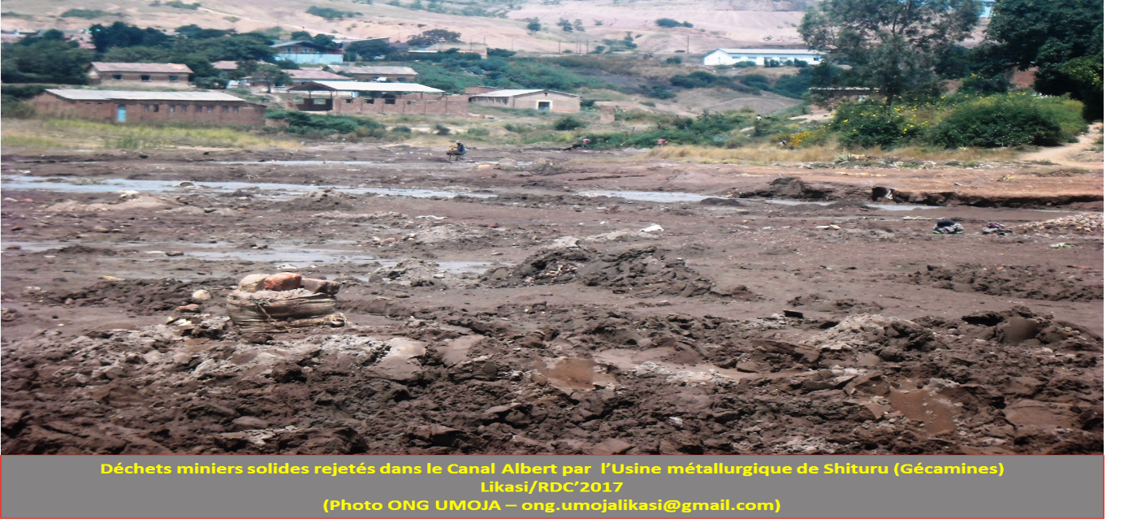

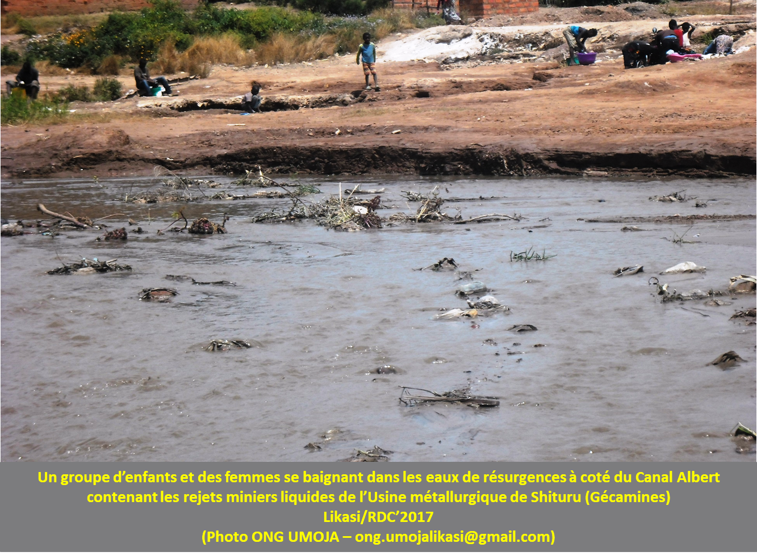

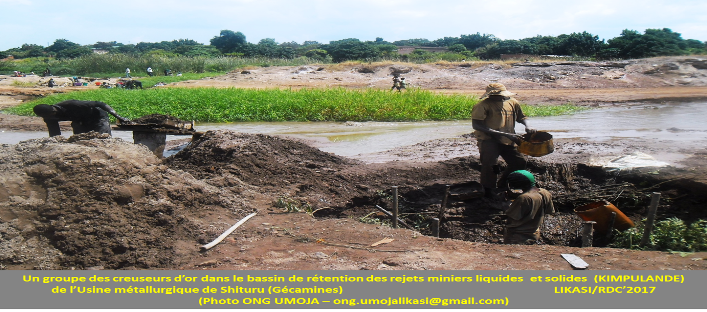

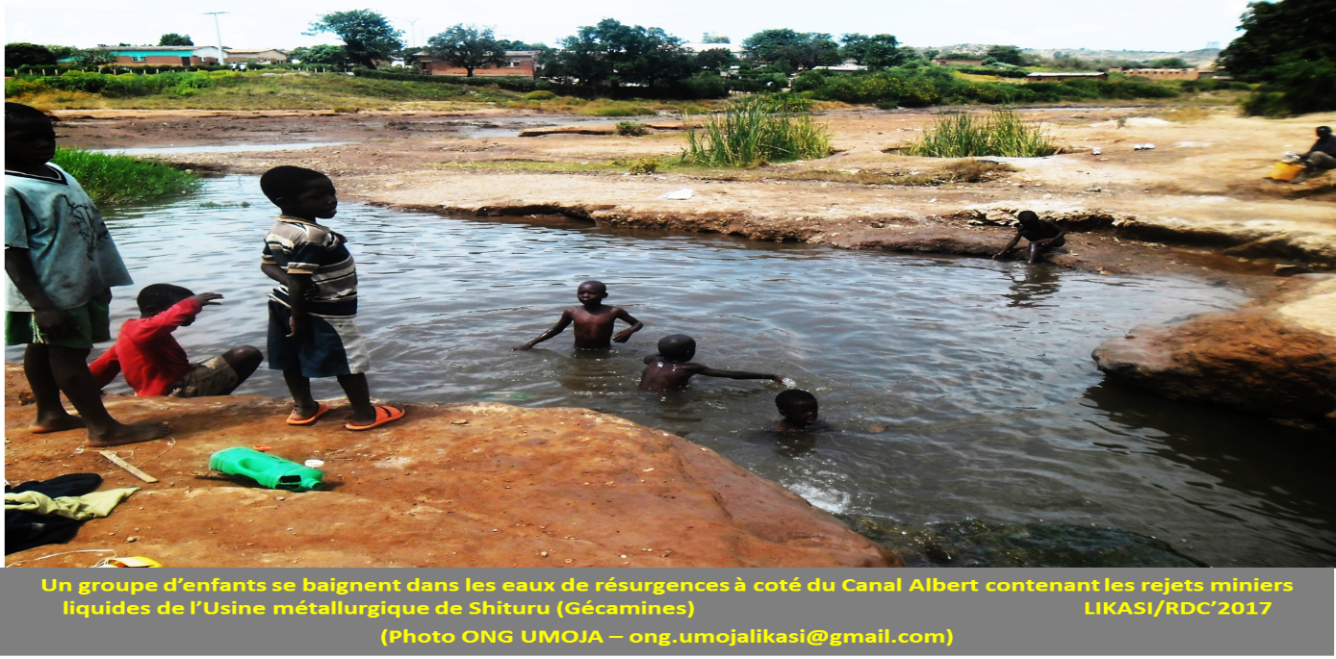

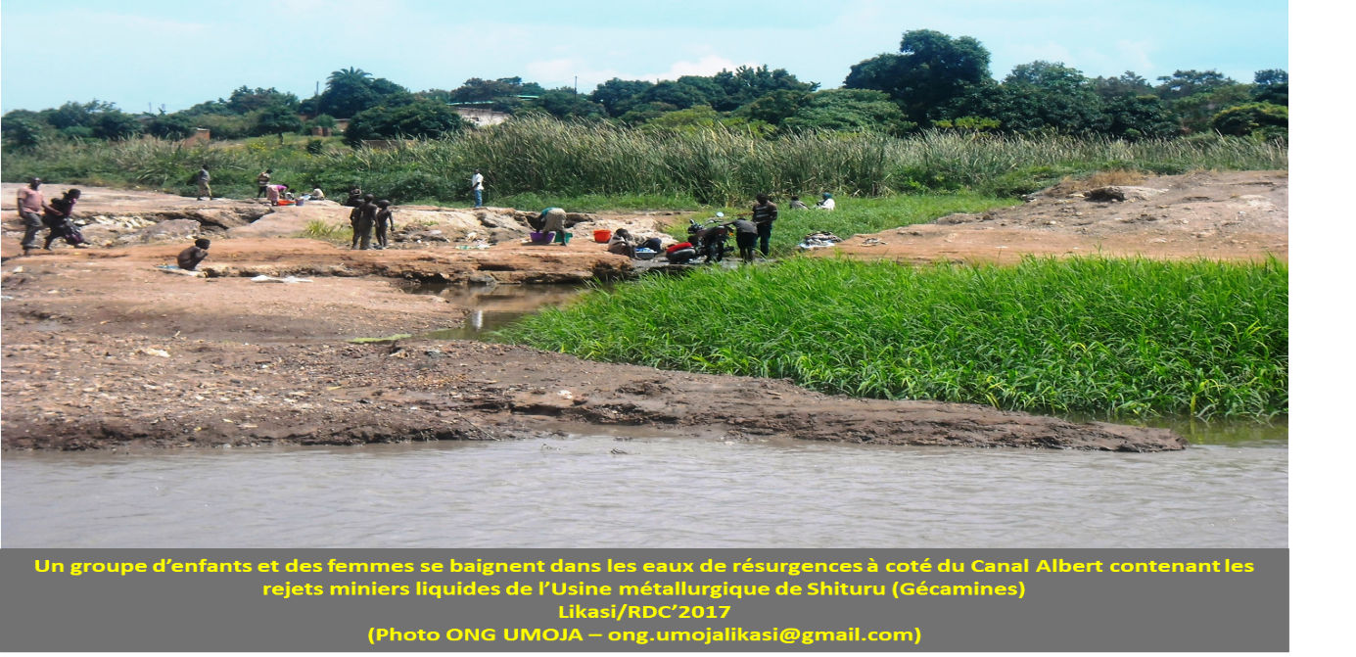

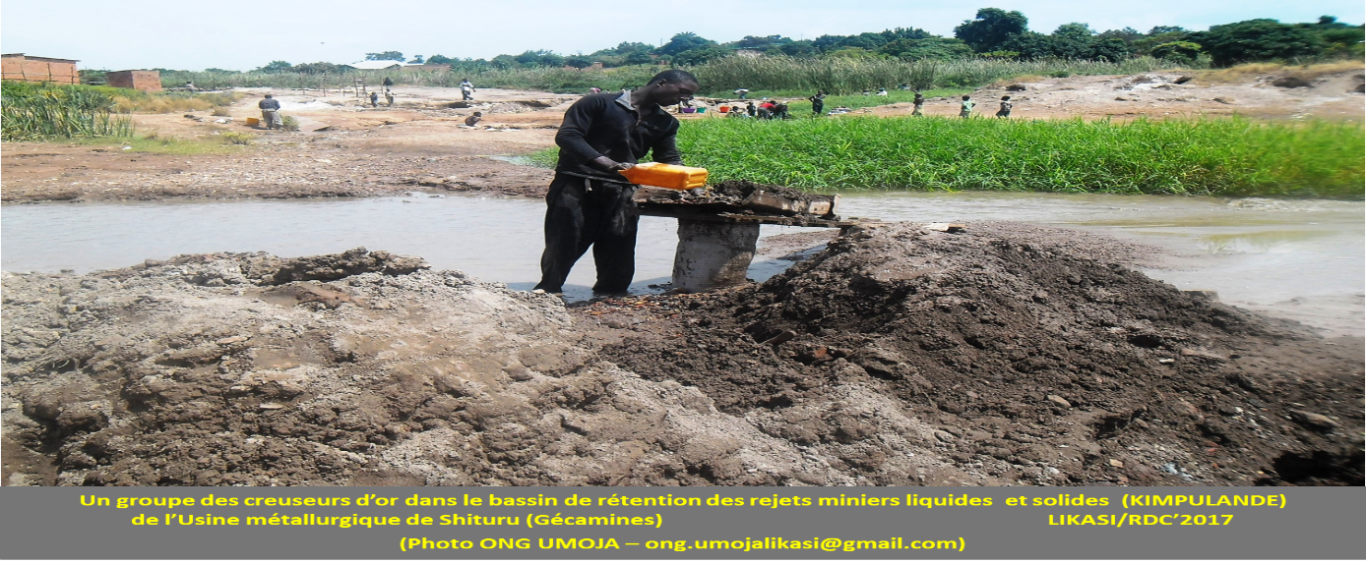

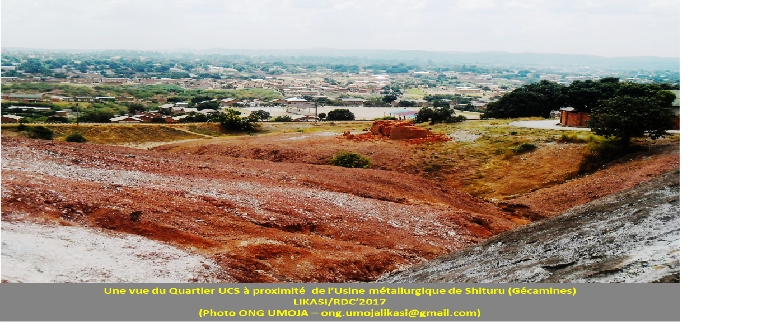

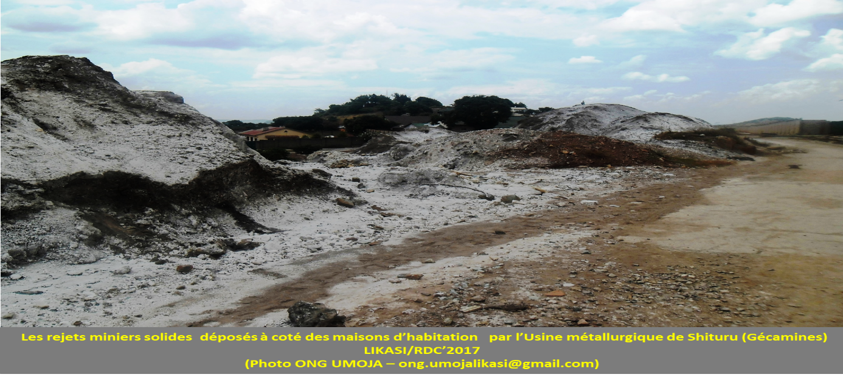

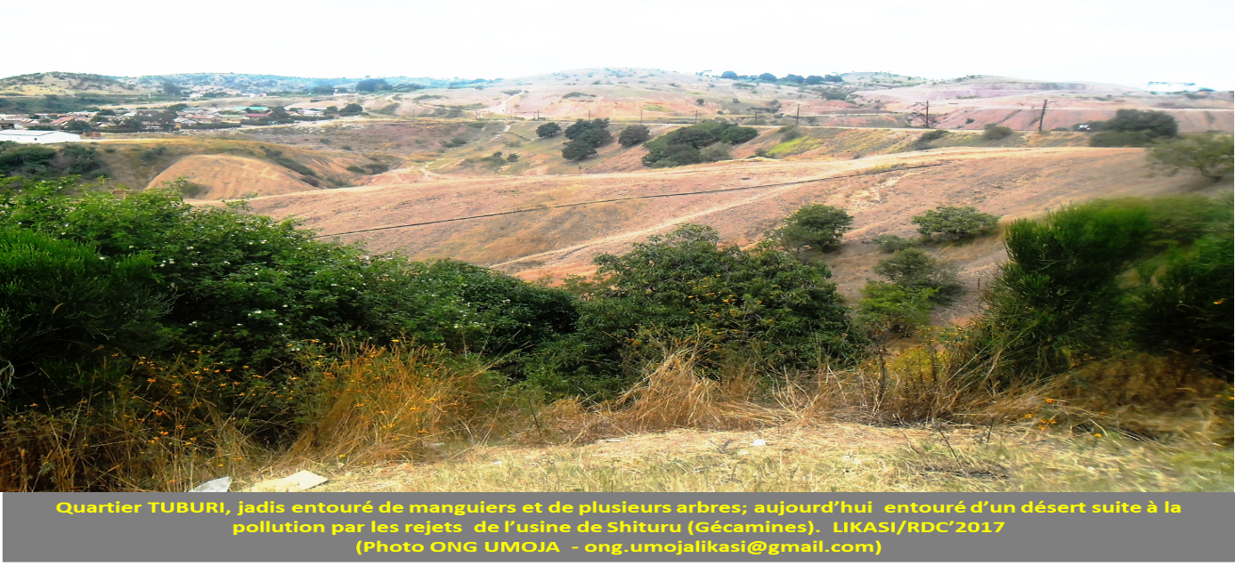

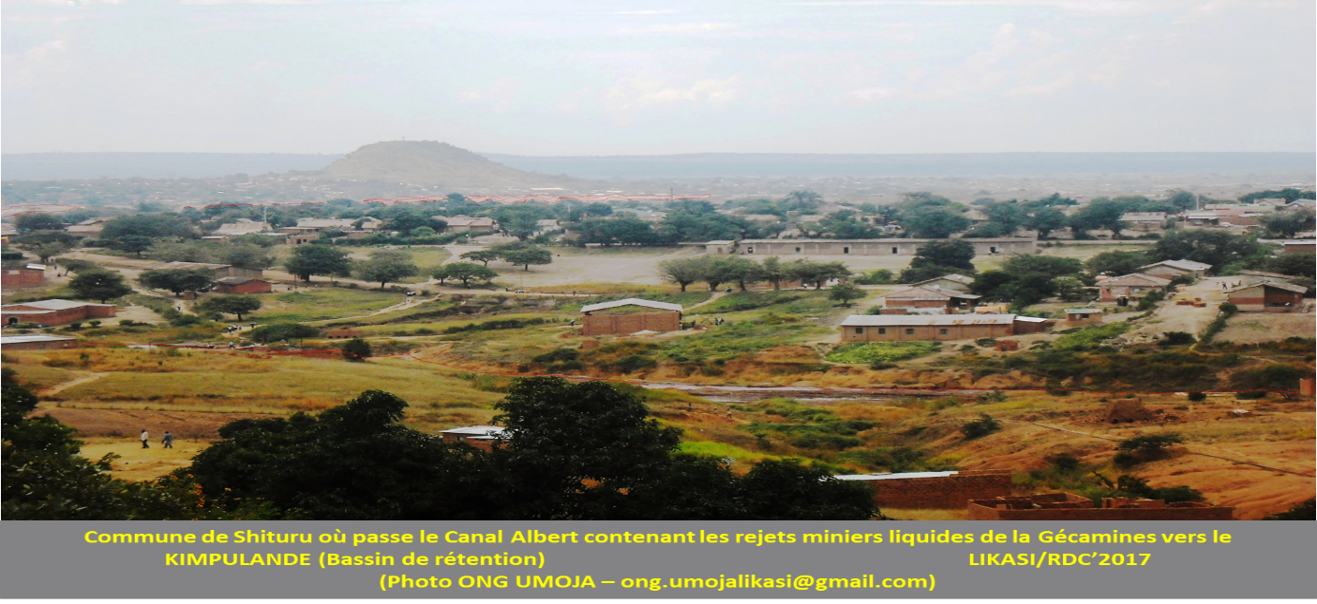

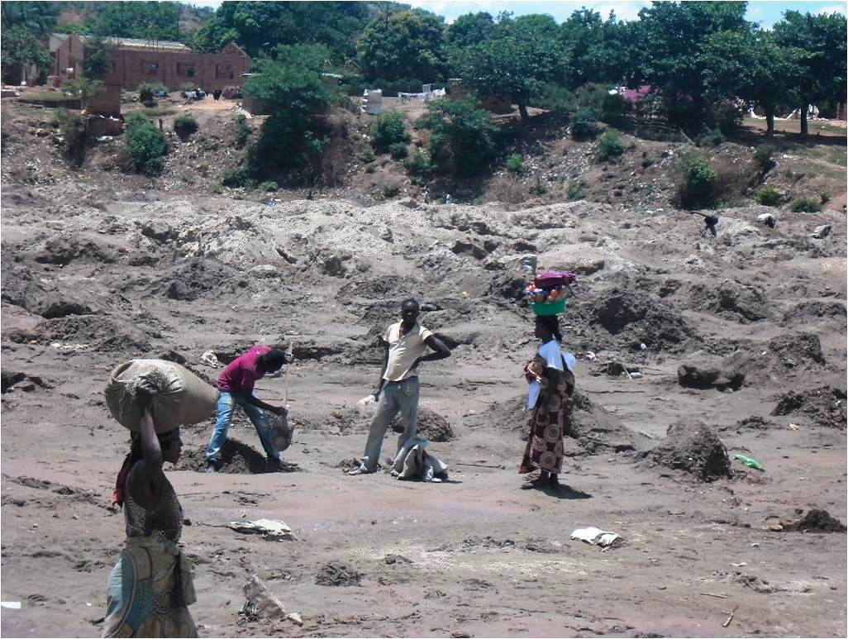

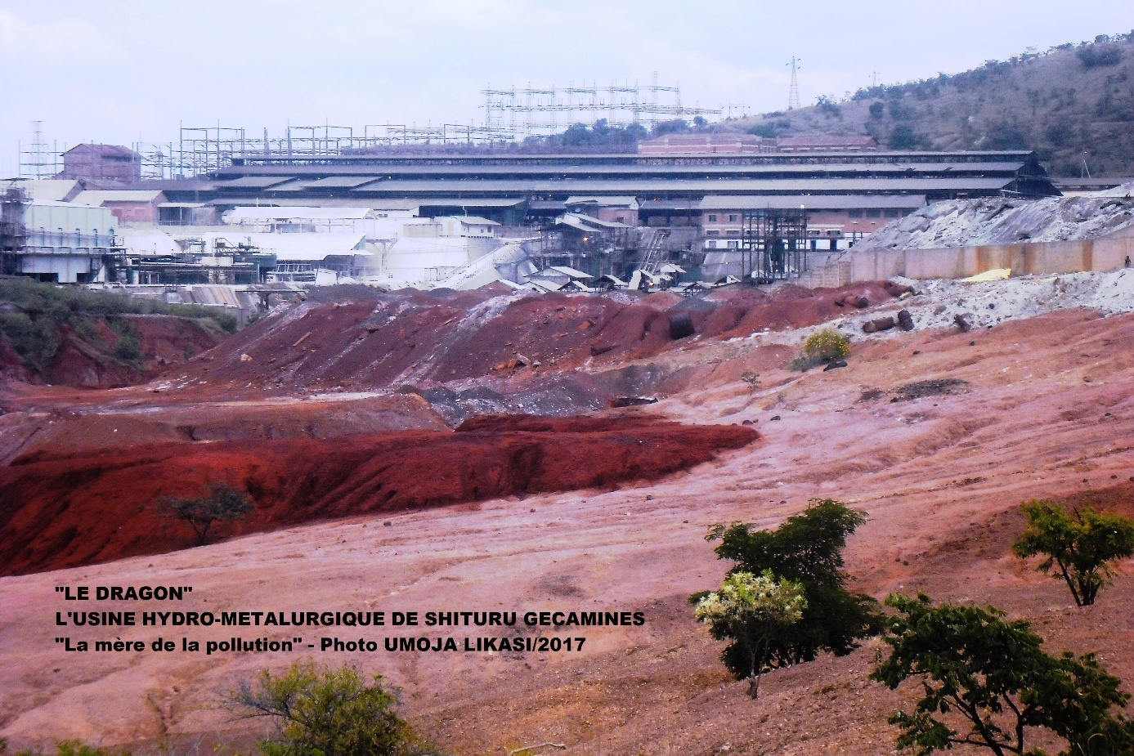

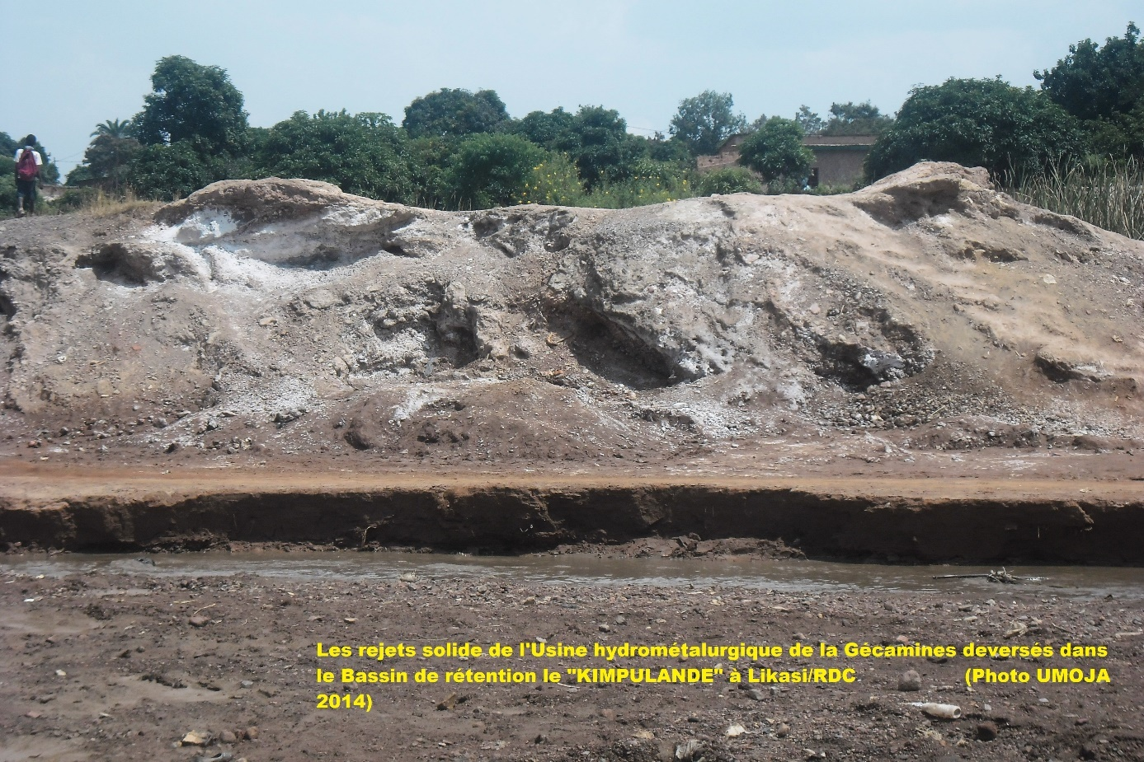
Appendix III: Pollution in Kipushi:

Desertification and manufacture of gravel used in masonry work

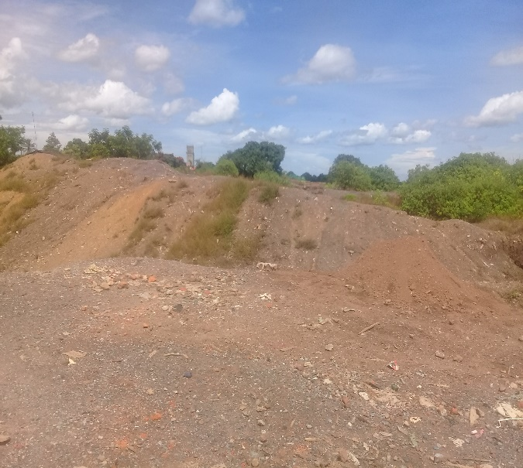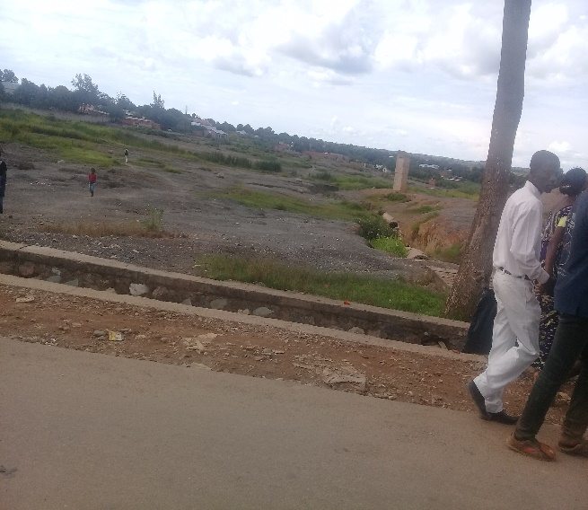

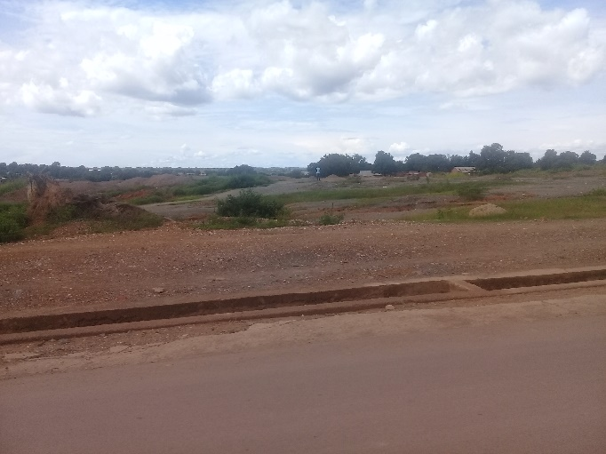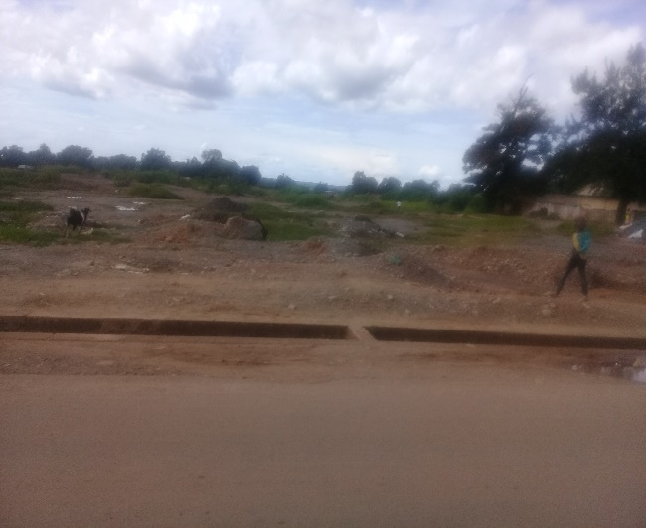

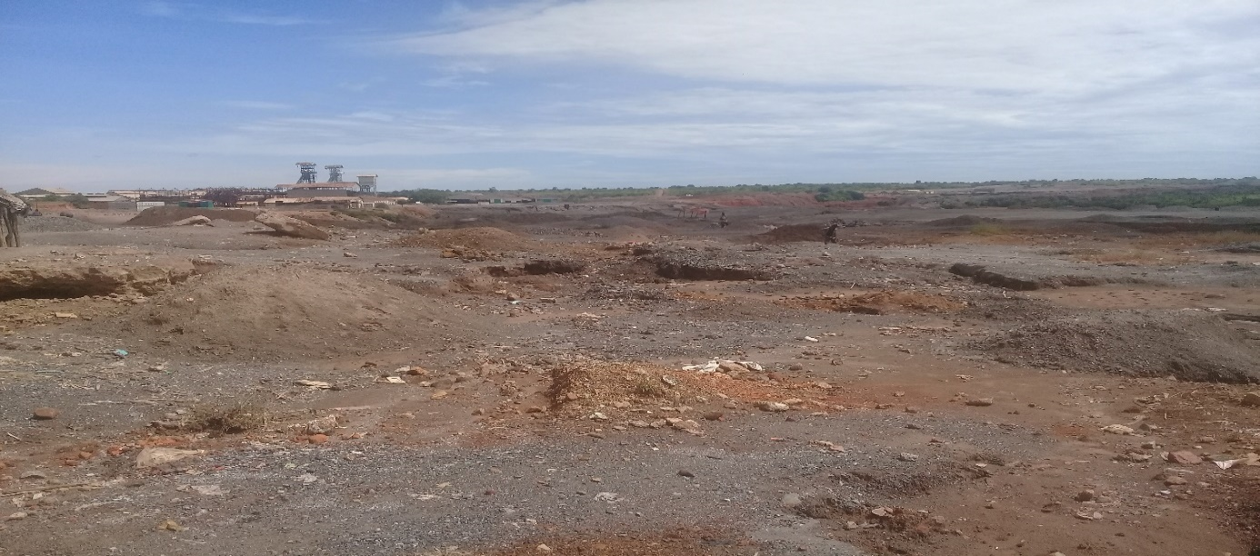

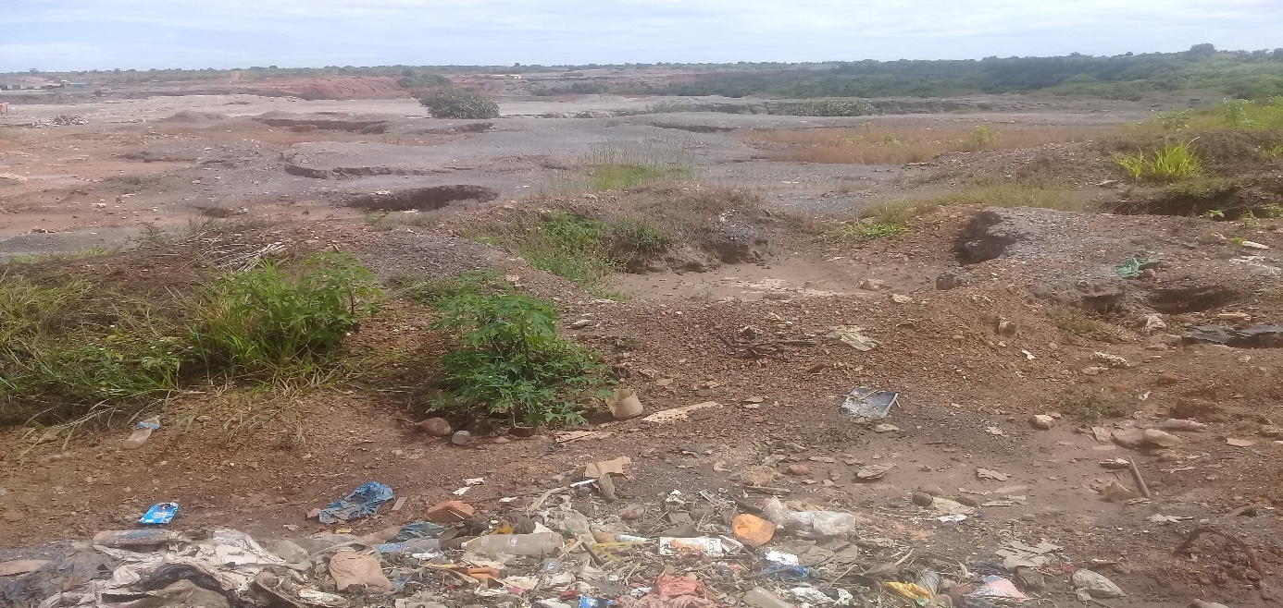

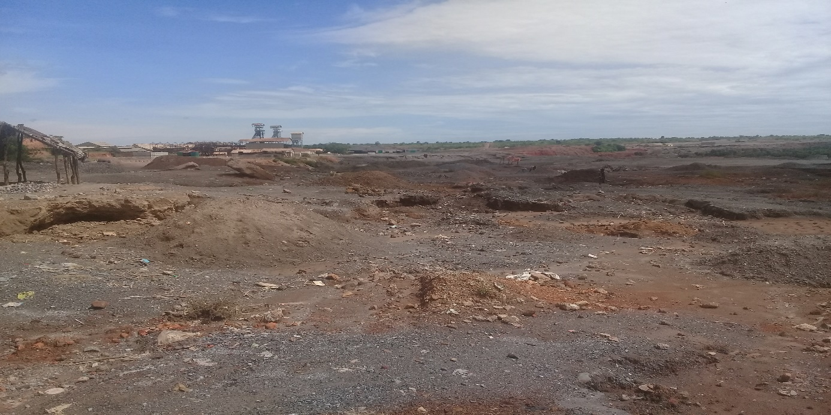
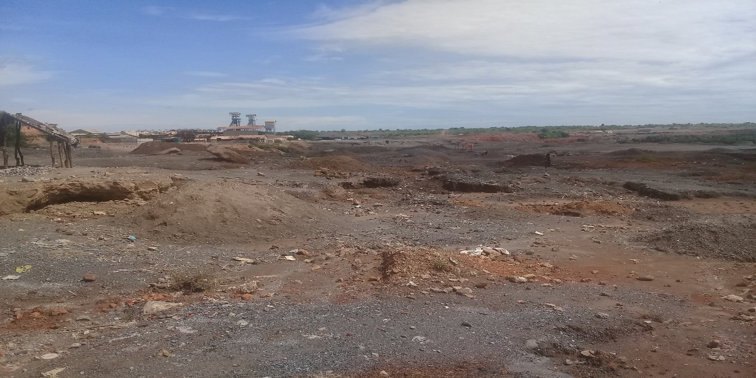
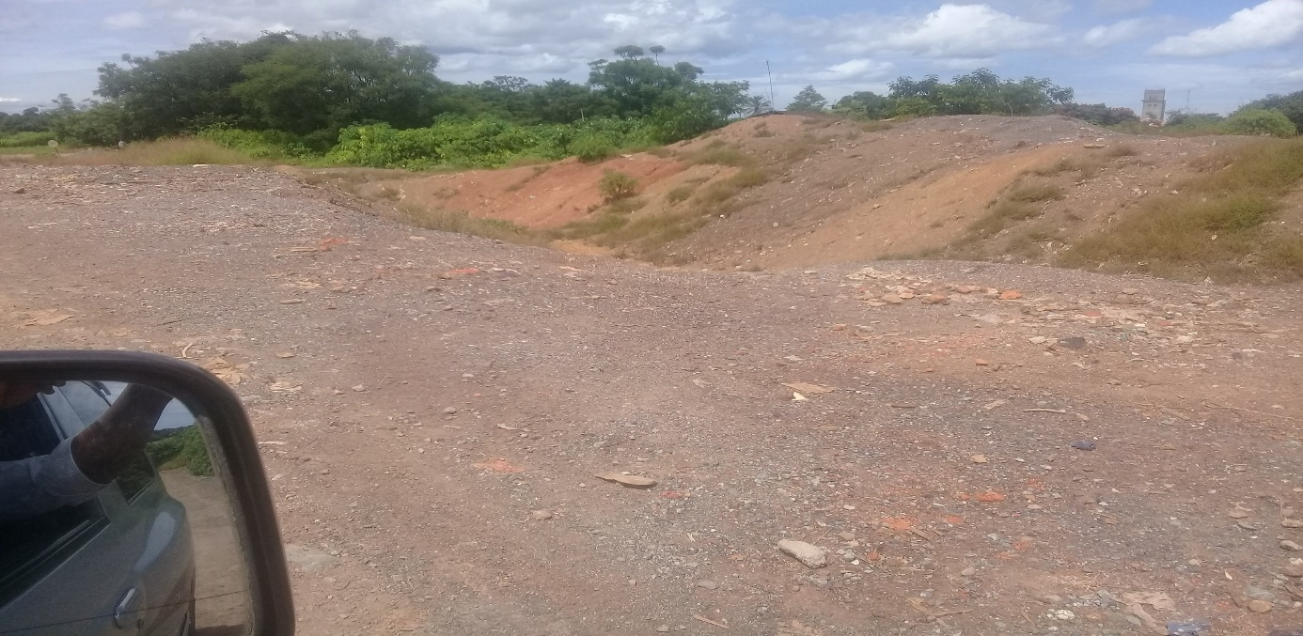

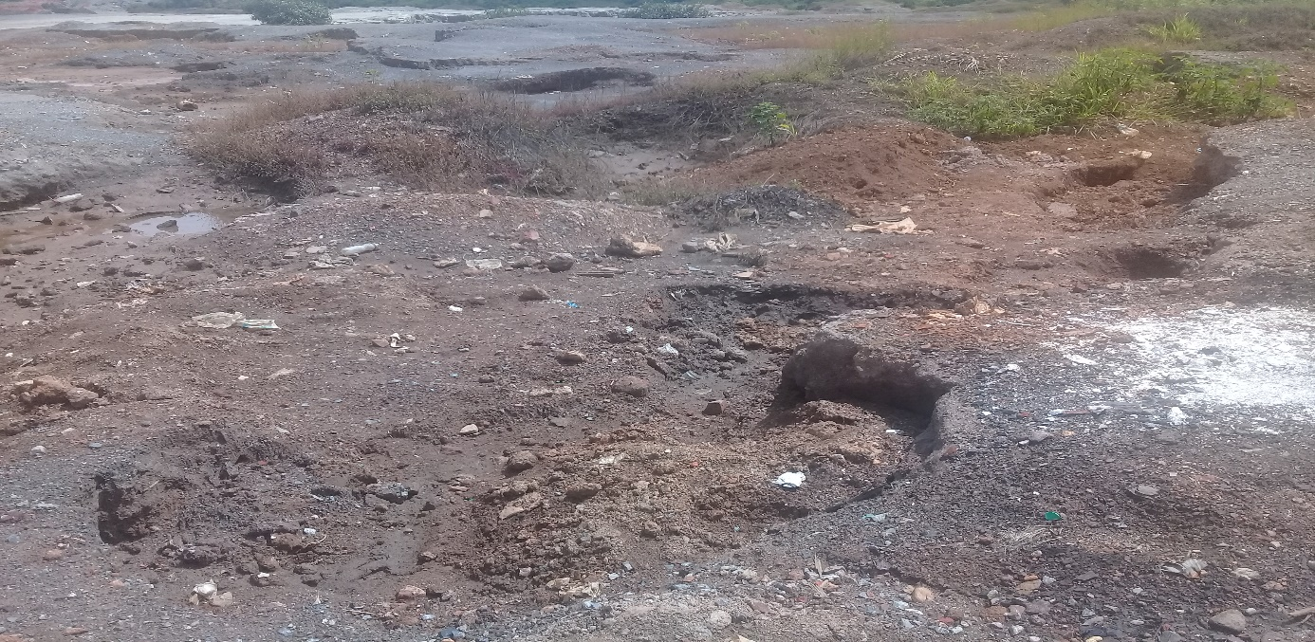
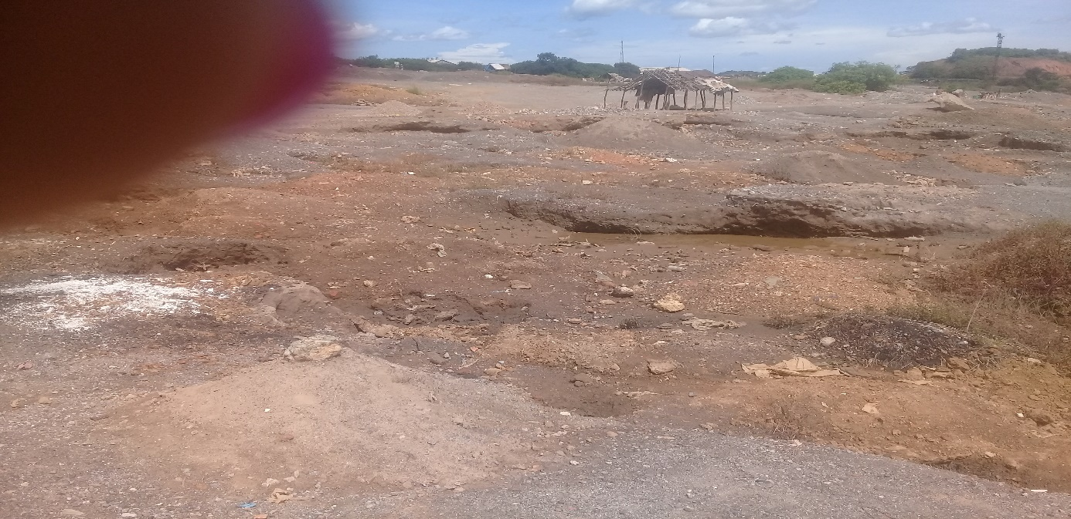
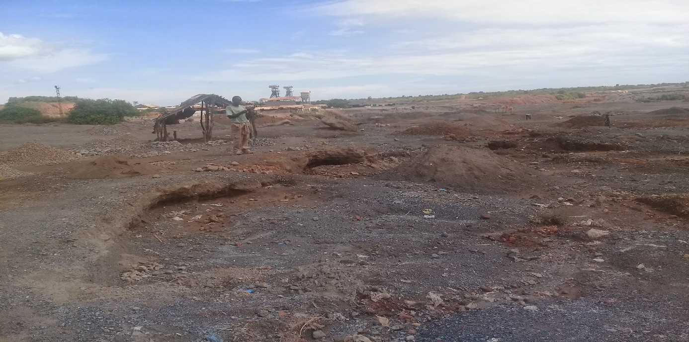
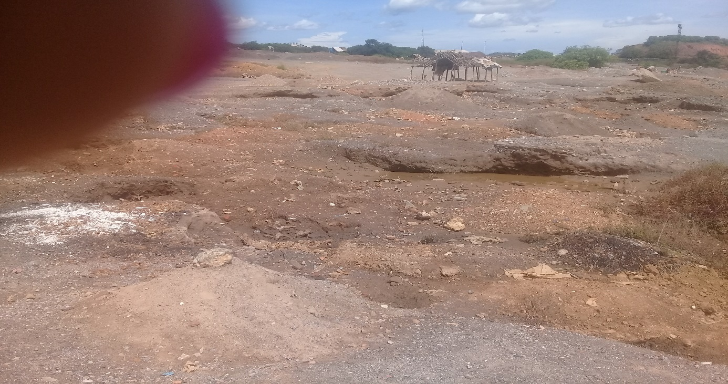

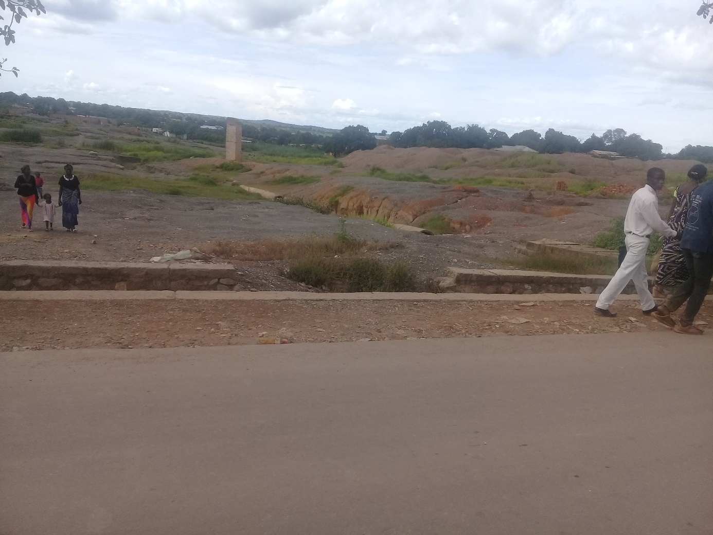

Appendix IV: Along the Likasi Lubumbashi Road:
accommodation of charcoal sellers, transport of uncovered ores laden with dust in the air, accident of a truck that spilled sulfur in a village, transport of acid, ....
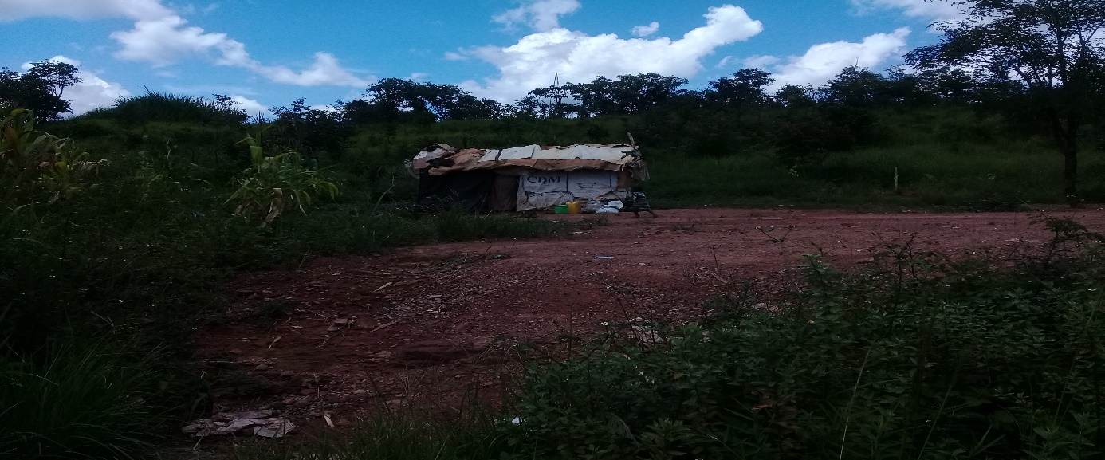

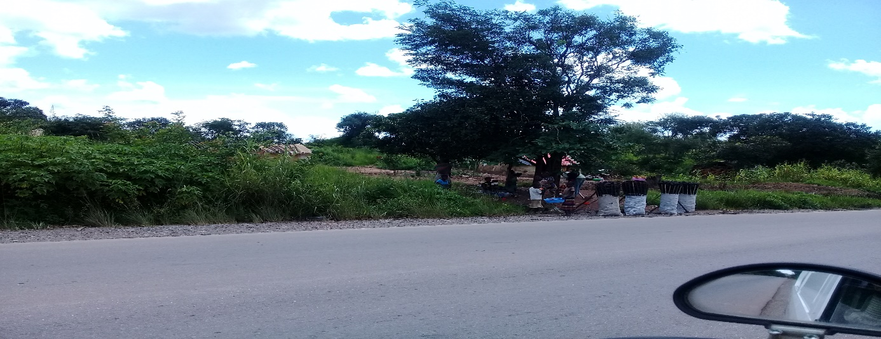
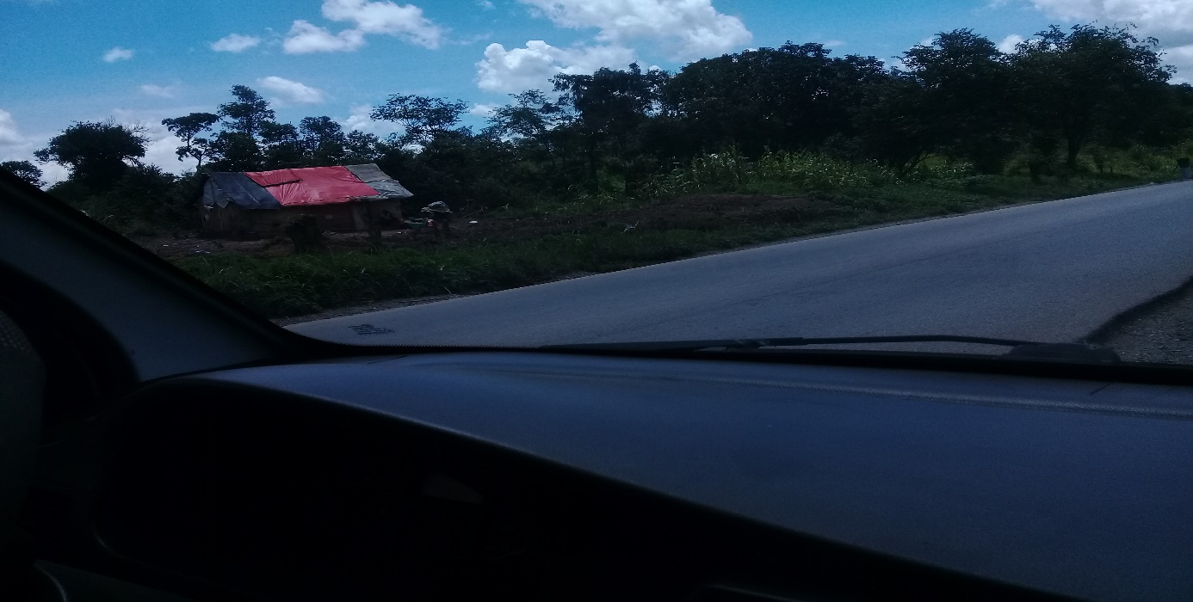

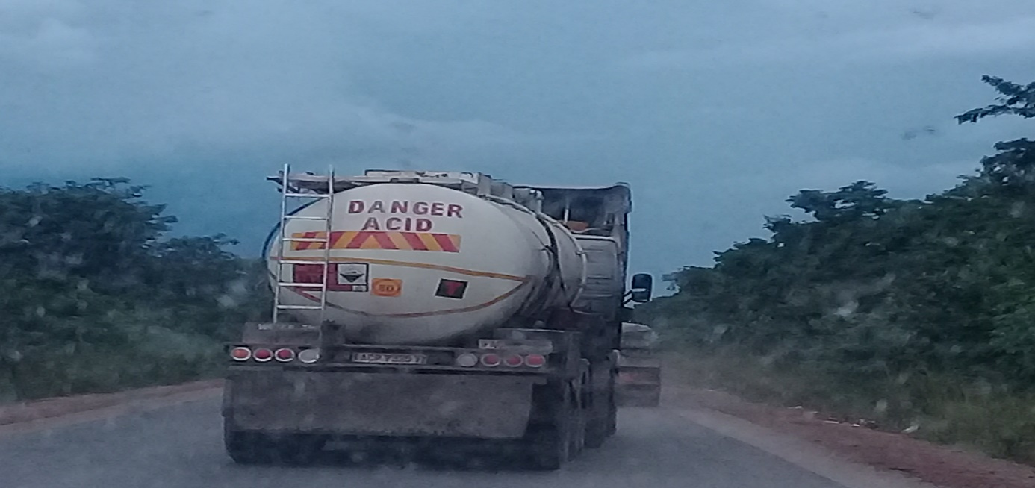
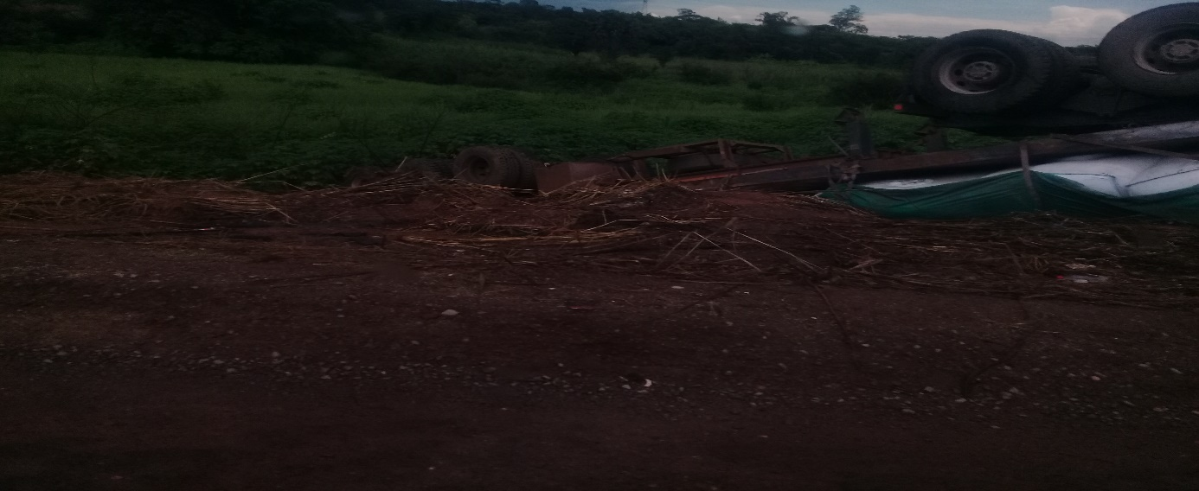

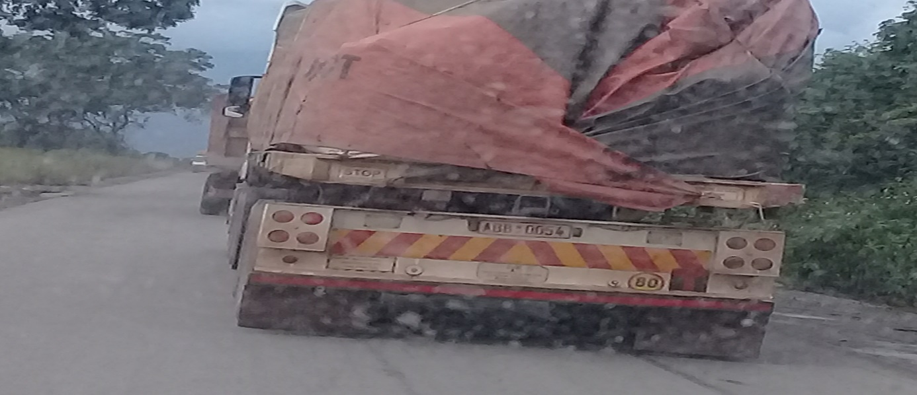

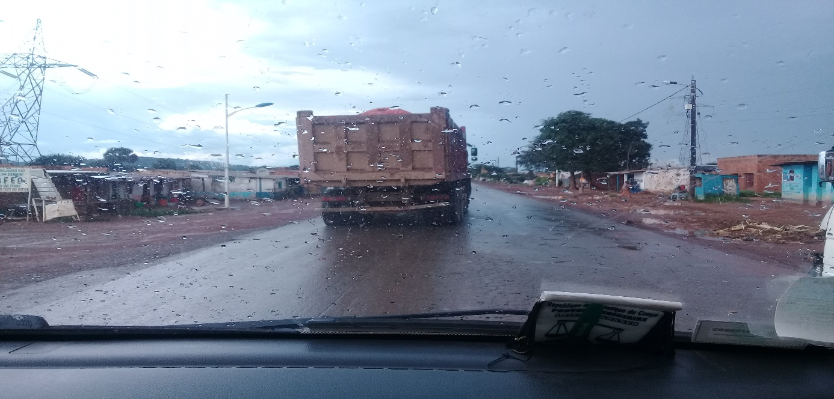

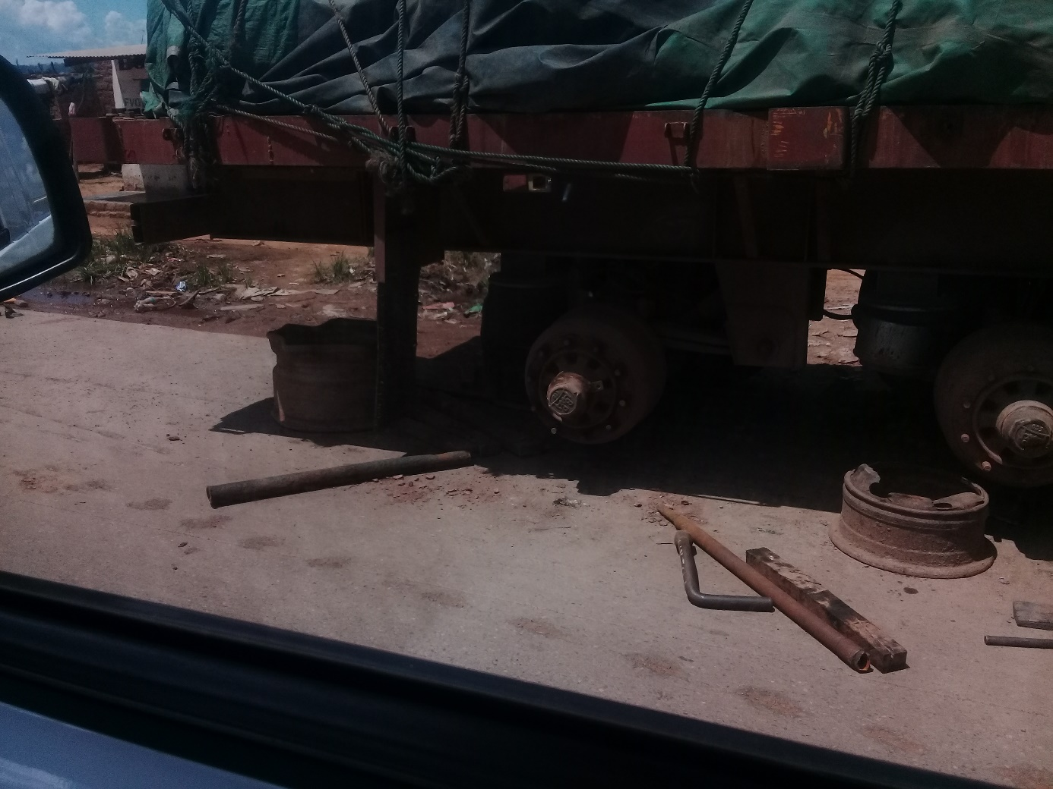

Appendix V: Along the Likasi Lubumbashi Road:
Rejection of sewage, sand mining used in construction
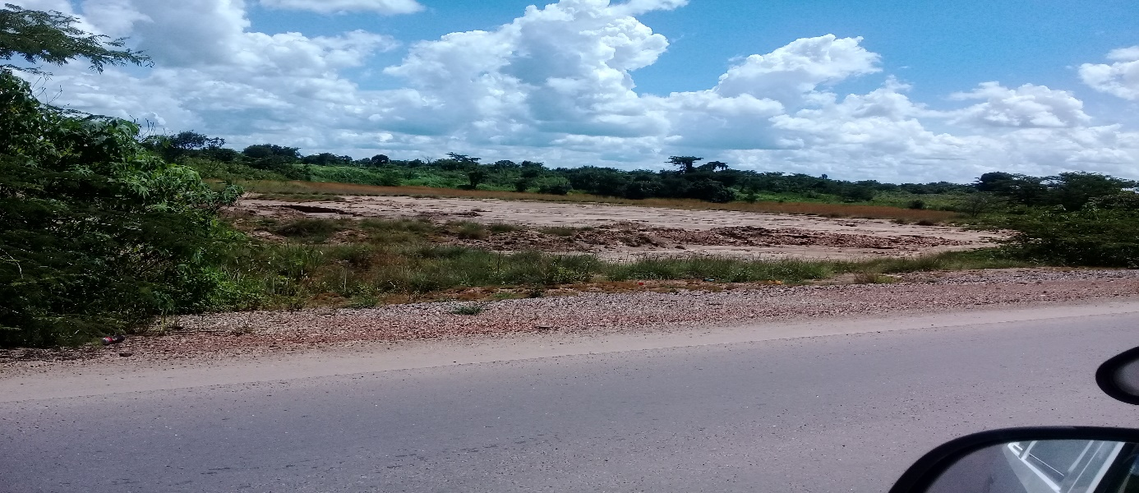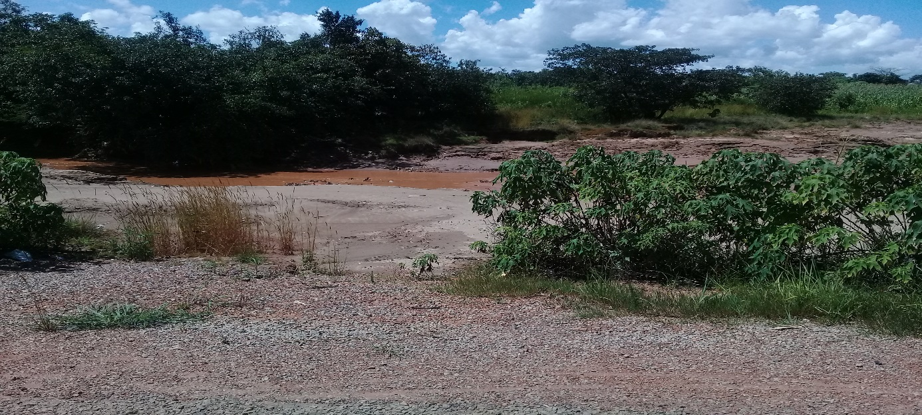

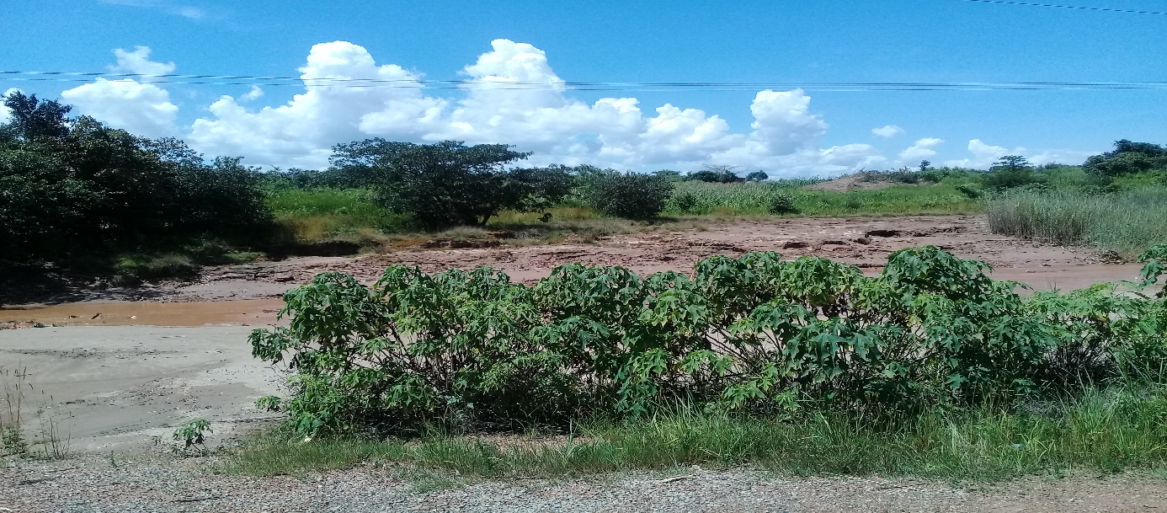

Appendix VI: View of a Chinese company from the Likasi road
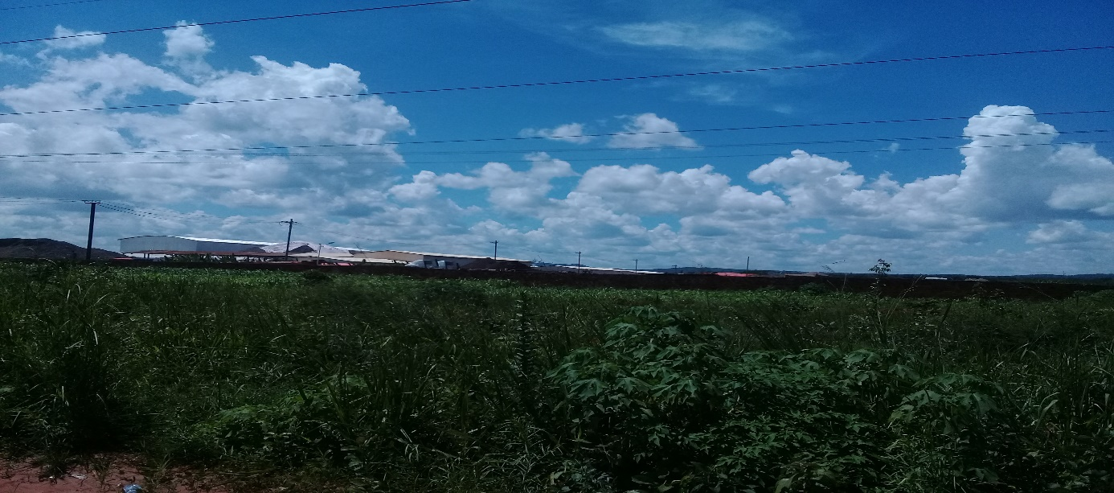

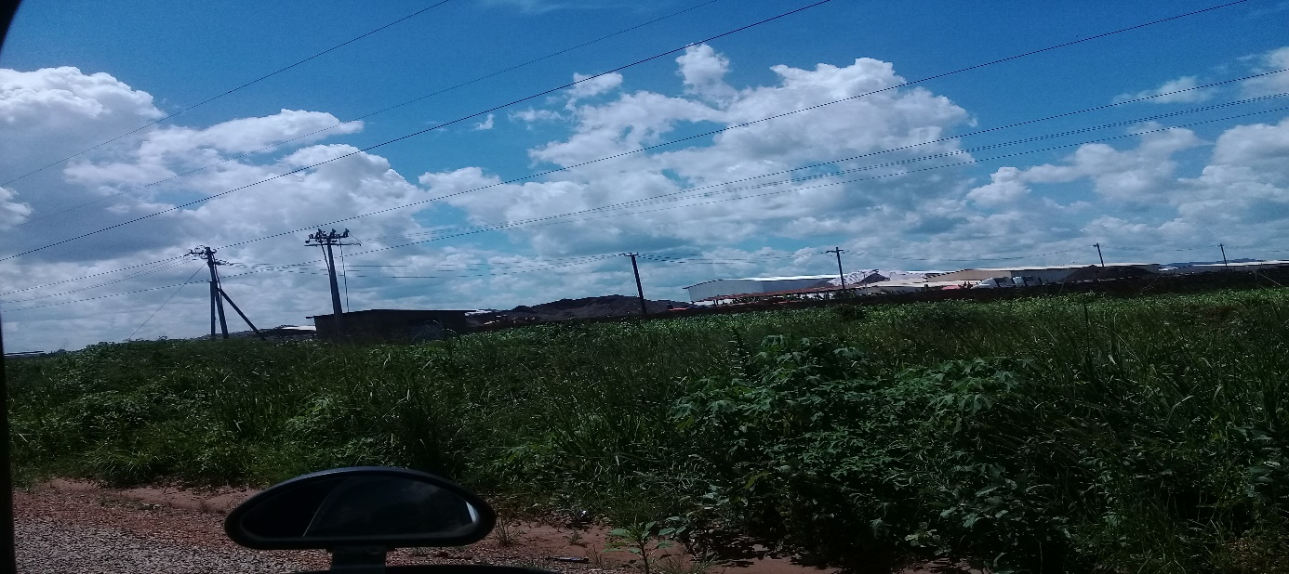

Appendix VII: Pollution with bottles and other plastic materials

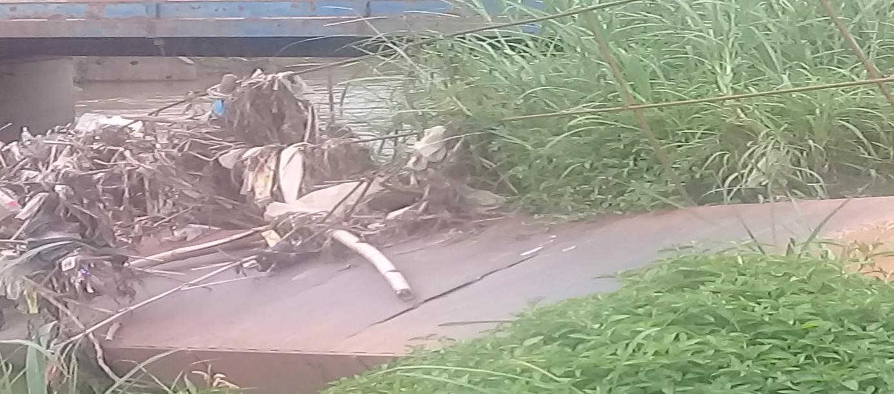

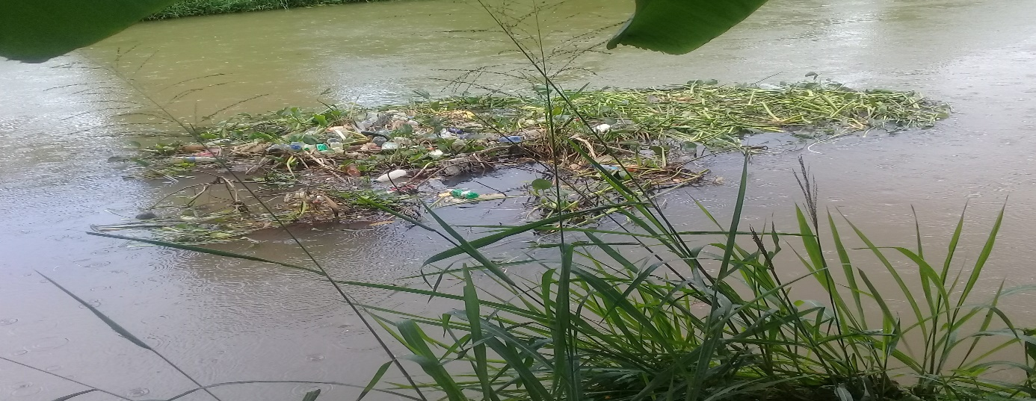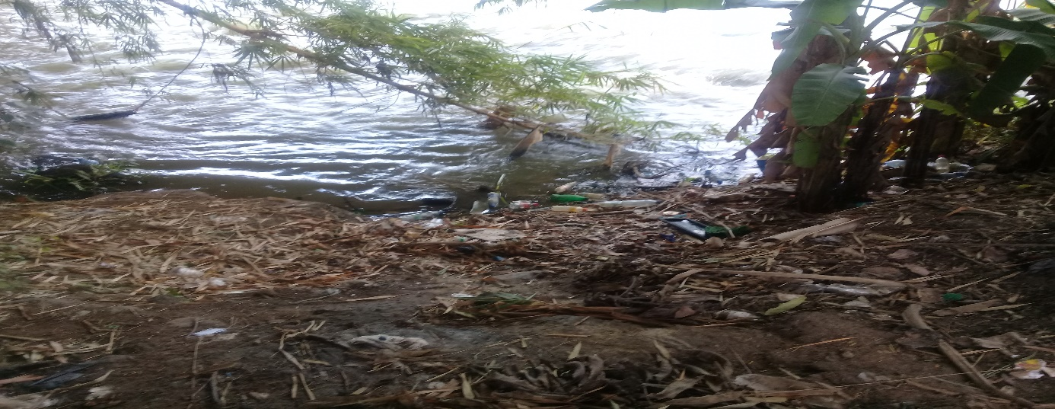

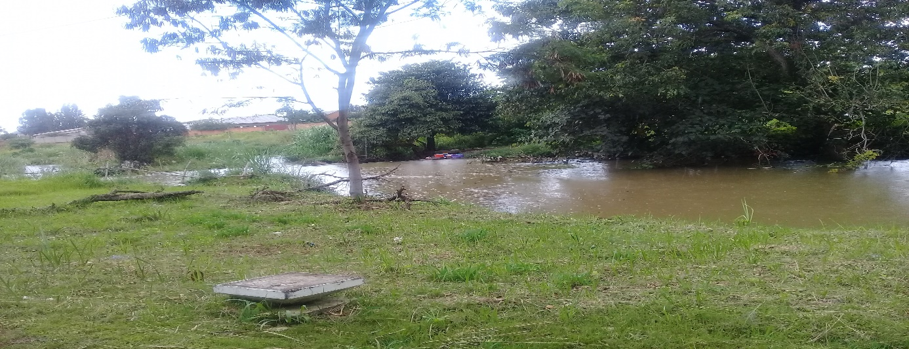

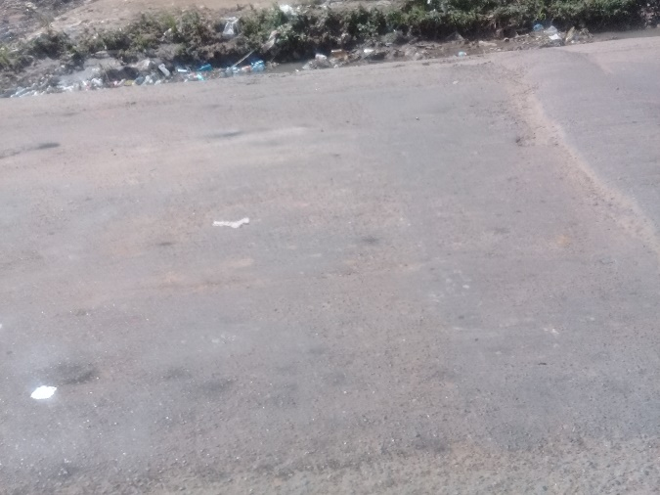

Appendix VII: A polluted farm, the images before and the moment of the pollution.
Today this farm is abandoned without any compensation. As all surrounding plantations

The woman standing int the picture is the owner of this farm which use to produce fish, vegetables and other things as shown in the pictures. CIMCO, a chinese industrial factory opened nearby and polluted the water from her farm, causing large amount of water and food poisening.
