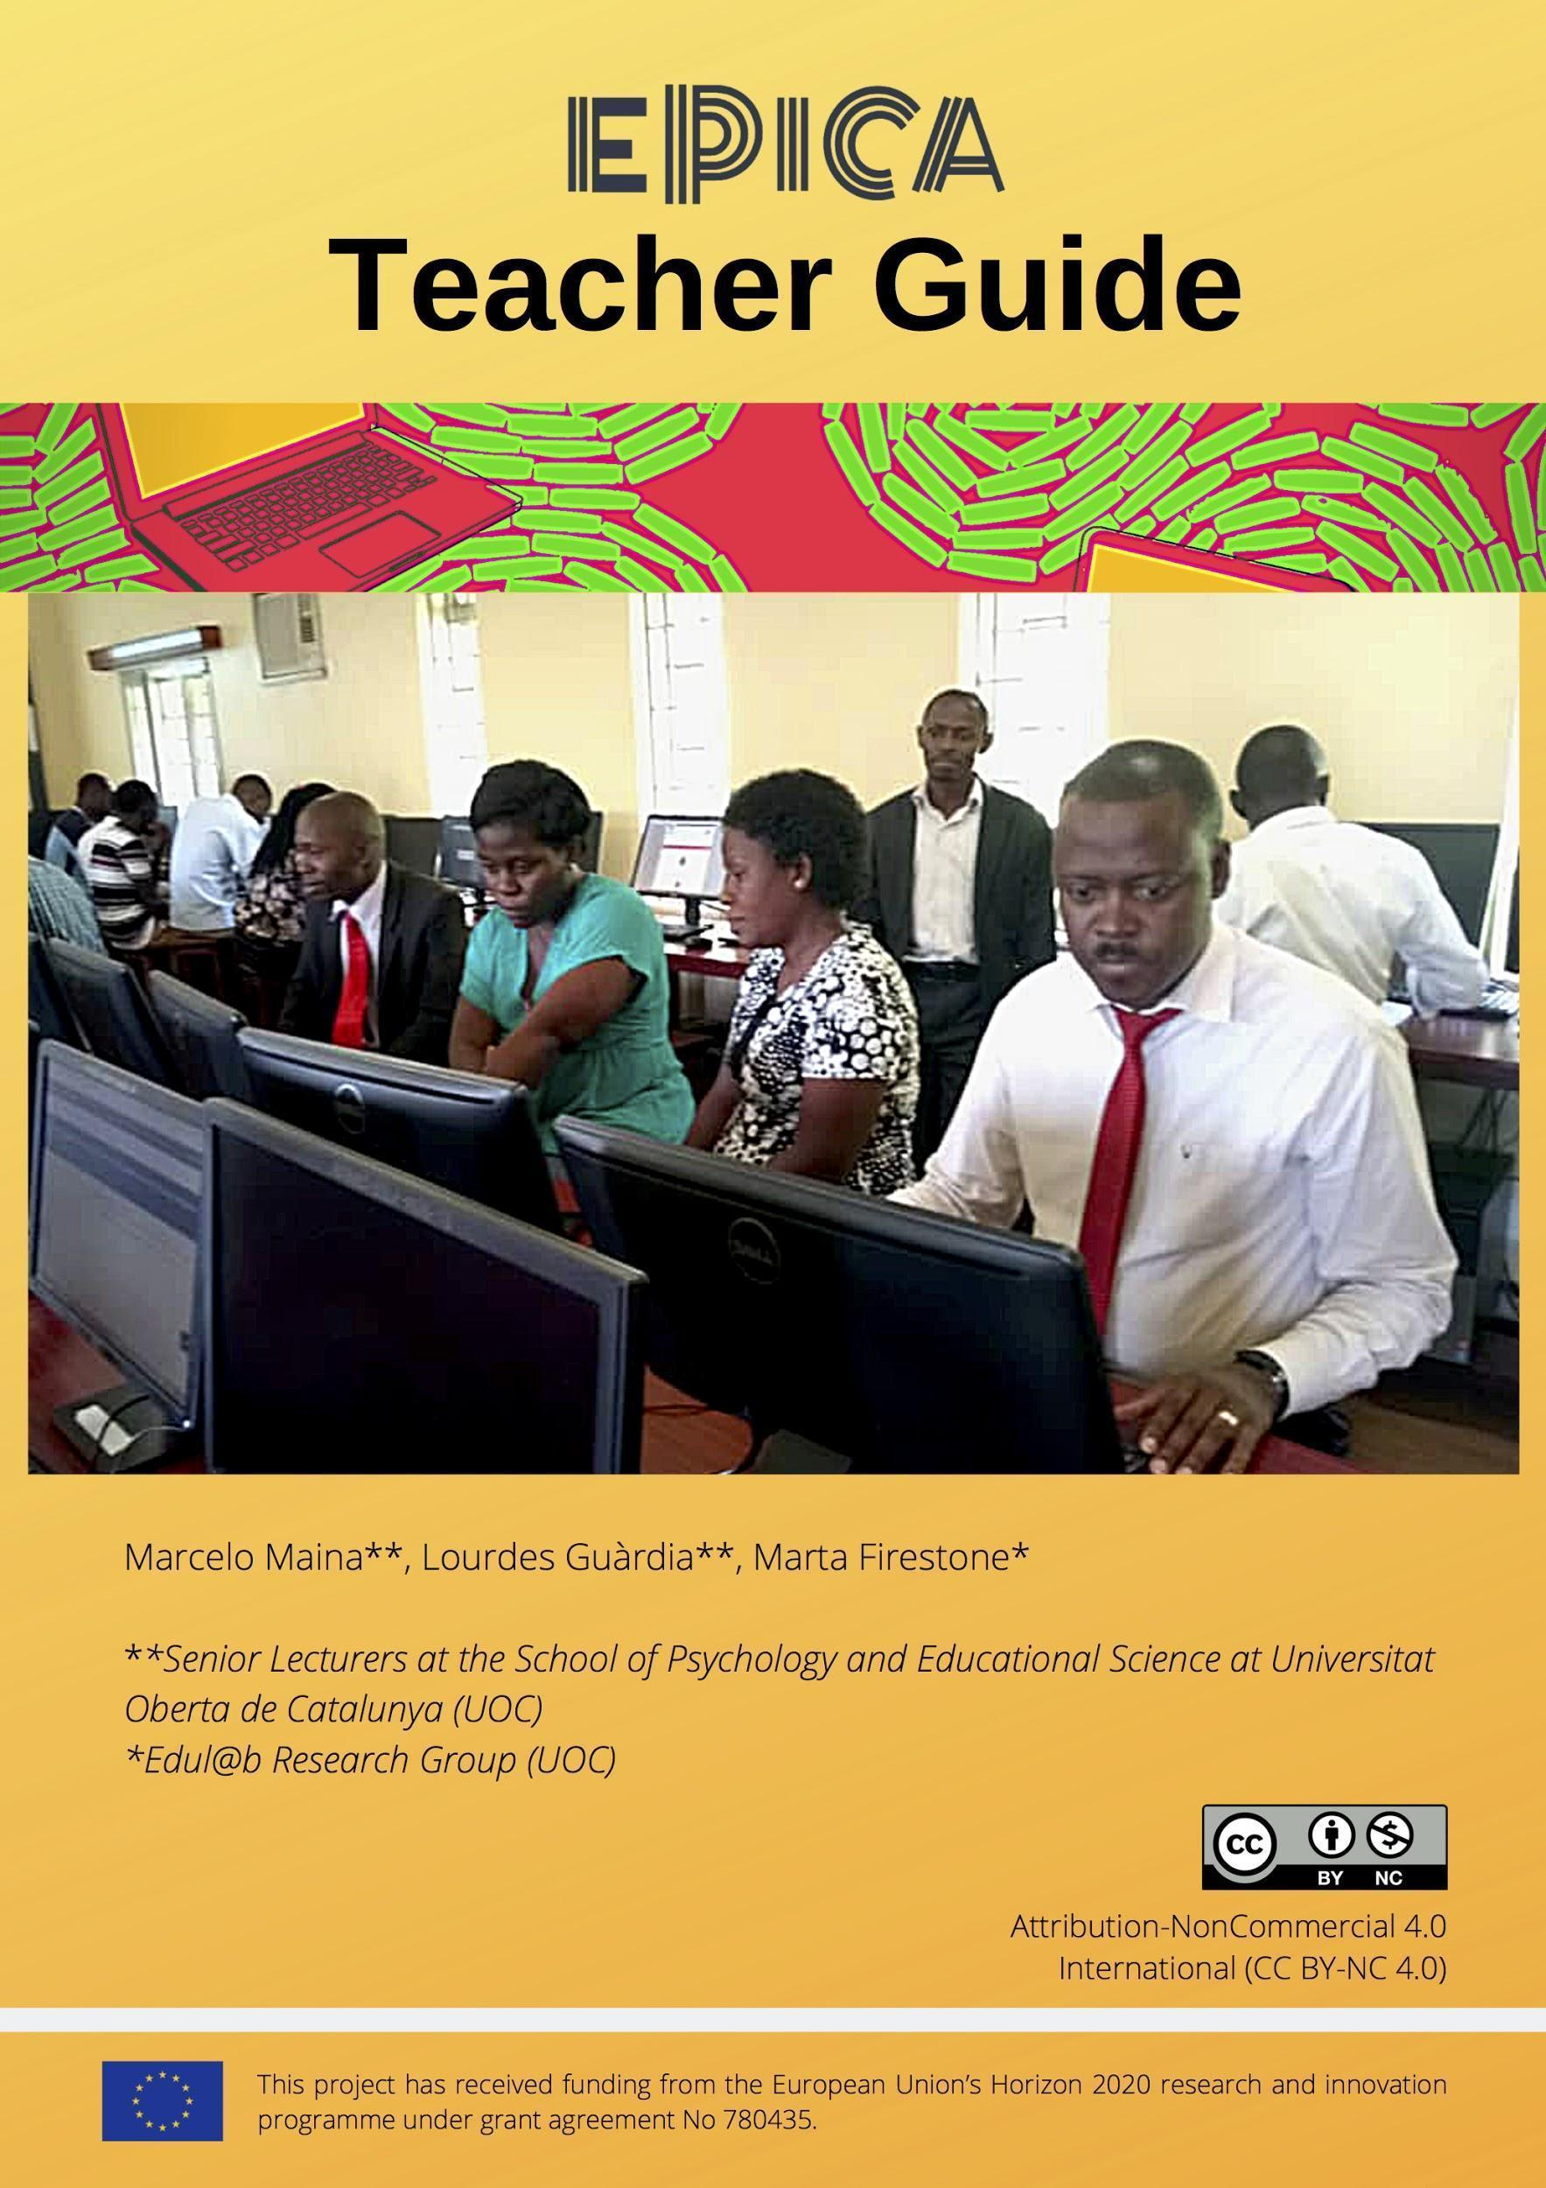
Table of contents
Introduction 3
1. Teacher’s credential process from start to end 4
2. Introducing the micro-credential process 5
2.1 Establish clear expectations 5
2.2 Explain the benefits of ePortfolios to students 5
2.3 Walk the walk 6
2.4 Scaffold students’ learning 6
2.5 Tie ePortfolios to skills assessment 6
3. Teaching Scenario 9
3.1 Theoretical Approach - Catalyst Framework 10
3.2 Articulation one: I - R - I 11
3.3 Articulation two: STAR 15
3.3.1 Video testimony 15
4. Teaching Example 18
4.1 Lesson plan [1] 18
4.2 Lesson plan [2] 19
4.3 Lesson plan [3] 20
5. References 22
Appendix I 23
1. ePortfolio Assignment Activity Template 23
2. Video assignment activity Template 27
29
3. Rubrics’ examples
3.1. Creative thinking 27
3.2 Problem solving 29
3.3 Communication and interpersonal skill
4. Employer Appraisal Form 31
Appendix II 34
1. Workflow 33
1.1 Workflow graphic 34
1.2 Example of Procedure 35

Introduction

To be able to assist students in their pursuit of putting together and submitting an ePortfolio of evidence showcasing their employability skills, you are invited to support students in making employability skills visible to teachers and potential employers or future customers, and assess whether these have been showcased effectively. We are asking you to guide your students in selecting relevant evidence in support of generic and/or specific employability skills as developed in their curricular, but also in their co- and extracurricular endeavours, and in any relevant experience they may have had as employees or service providers. Your role will be to support your students in identifying opportunities (assignments, internships, etc.) where skills have been acquired/developed and assess their ability to demonstrate said skills acquisition/development based on the evidence presented. This process of skills articulation allows for concrete situations of skills development to emerge, enhancing both student and teacher awareness, and provides you with insight as regards gaps in skills integration in the curriculum.

From your first introductory meeting with your students to the final appraisal by the employer, the credential process will consist of the following tasks. Timings between steps are discretional:

- Teacher: to introduce the skill(s) and tasks ahead;
- Students: to select relevant evidence;
- Teacher: to provide formative feedback;
- Students: to submit completed assignment;
- Teacher: to provide summative assessment and micro-credentials;
- Successful students: to revisit and customise ePortfolio and submit video testimony;
- Employer: to appraise students and write commendations if deemed worthy.

Important! The support materials to perform the different steps included in this this workflow are:
- the Handbook,
- the Teacher Guide,
- the Student Guide
- the Teacher ePortfolio tutorial,
- the Student ePortfolio tutorial.

Figure 1

Workflow of the Micro-credential Process

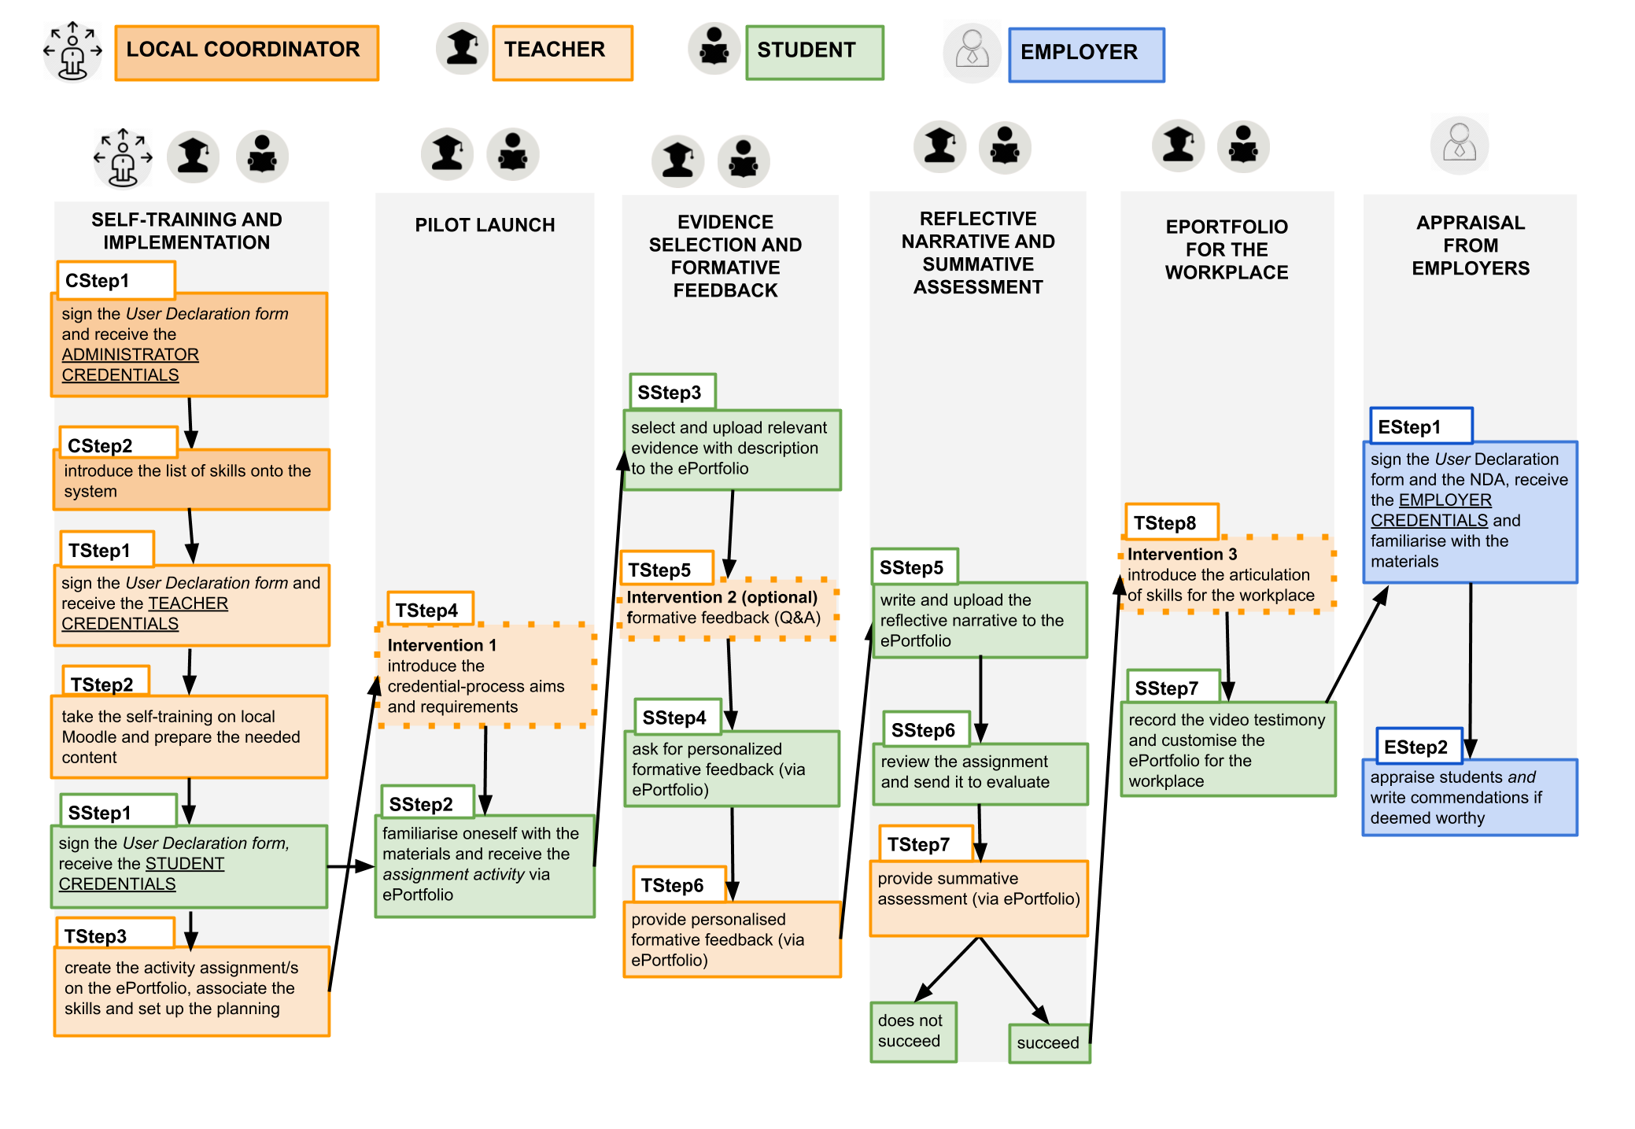

1. Teacher’s credential process from start to end

- Below is a step-by-step timeline which presents what the micro-credential process and pilot study at large entail for the teachers involved.

- Teachers to be given access to online platform

- Teachers to complete pre-training course

- Teachers to design pilot course and/or to redesign their syllabus so it embeds the pilot course

- Teachers to introduce employability skills and to break down credential process in a step-by-step fashion

- Teachers to introduce ePortfolio as a learning and assessment tool, and to present criteria in detail

- Teachers to illustrate with examples the difference between curricular, co-curricular, and extracurricular activities

- Teachers to introduce narrative inquiry and reflective practice to students, and to model how this applies to students’ ePortfolio

- Teachers to present what is understood by evidence, and to provide discipline-specific examples (if embedding pilot study within a subject)

- Teachers to assess evidence provided by students and to provide formative feedback

- Teachers to award badges to successful students

- Teachers to lead successful students to phase two by introducing the concept of articulation of skills to a professional audience

- Teachers to introduce the STAR method of interviewing and model how it should be applied to students’ video testimony

- Teachers to illustrate with examples what a professional ePortfolio should look and be like

You will find below some suggestions to introduce students to the micro-credential process, and some guidelines to assist you through the process.

2. Introducing the micro-credential process

2.1 Establish clear expectations
It is paramount that the rationale behind the micro-credentials process that students are about to embark upon is clearly explained to them from the onset, highlighting both the importance of employability skills and the articulation of these skills from an employer’s perspective. It may be interesting to present to students the list of employability skills that are identified as being particularly desirable by employers, and explain your choice of employability skill(s) for the current assignment.

2.2 Explain the benefits of ePortfolios to students
Students will have to put together an ePortfolio whereby they will be selecting, reflecting on, and uploading evidence which they believe showcases the skill(s) to be demonstrated. A link to an example (or numerous) of successful ePortfolio(s) created by students would be useful for you to review with your students (please see WatCV ePortfolios), followed by an explanation of what students need to do to complete the assignment, and the benefits of completion (both at a personal and at a professional level). It is worth going through all stages of the process presented in the Student Guide, clearly explaining what each and every one entails, how students ought to go about them, what support will be available throughout, and the completion deadline for each.
If time allows, you may wish to have your students write in class their first reflection on a time they used a professional skill, i.e. a skill which will be requested of them in the workplace. It would benefit them for you to go through the instructions for reflections and the marking rubric to clarify any points of confusion.

2.3 Walk the walk
The goal of the micro-credential process is to help students enhance their articulation of skills, and does so by having students follow a specific framework to create and structure an ePortfolio. This focuses on helping students identify, articulate, and persuasively demonstrate the implicit, transferable, professional skills and competences that they feel they have developed within a course context when they complete course activities and assignments, and beyond the classroom. You must draw students’ attention to these skills by explicitly stating where, when and how these skills are deployed while completing course assignments. You may want to consult the Handbook on employability skills which presents examples of assignments and learning outcomes associated to some employability skills. Make sure this knowledge does not remain tacit and is made explicit in your learning outcomes and assessment criteria so that students can identify it as opposed to only infer it (or miss it completely). Set time aside to focus exclusively on the inter-relationship between degree, self and future plans. Create a dialogue around employability skills with your students to provide them with the opportunity to reflect on their own ideas as part of this structured process.

2.4 Scaffold students’ learning
Help students start small: ask them to choose just one artefact and have them reflect on how they believe it helped them develop a given employability skill. Or, have students select a curricular activity and a co- or extracurricular activity, or even some past professional experience, and have them reflect on how each of those activities contributed to their acquiring or developing a certain skill/competence. Give them formative feedback.
You may want to model and exemplify by providing students with a piece of evidence of your actual learning journey and your own reflection as regards how a particular experience helped you develop a specific skill. This will help instil self-reflection in your students’ every day practice. Focus on the language used and the emphasis made.

2.5 Tie ePortfolios to skills assessment
Maintaining an ePortfolio demands a significant amount of time and energy from students, and they will resent it if their time and energy are not reflected in their final grade. Take time to explain the rubrics (see Appendix I) against which their work will be assessed so that students can fully understand what it is they must do, and what credit they will receive for doing it.
Bear in mind rubrics must be adapted/customised to any given discipline/subject by removing criterion which is not fit-for-purpose, adapting weighting (%), and modifying descriptors. Do double-check that the rubrics meet your programme learning outcomes.
Also set time to explain the role of employers in this process, and how their appraisal differs from your assessment by showing them the form against which the employer will appraise their work. Explain the value of being awarded a micro-credential by achieving a minimum grade of 80%, but also of being given a commendation by an employer so that students understand the importance of process completion, and feel engaged from the onset knowing their work will be rewarded.
Equally, emphasise the ongoing nature of the process and embed continuous formative feedback whenever possible, maybe by setting some time for your students to share their chosen evidence in class, or by setting up an online forum to engage dialogically with them, answering their queries as they progress through the process.
We have created a template for you to structure the process by designing an activity which clearly signposts and demonstrates the steps to follow when articulating each employability skill (see ePortfolio Assignment Activity Template in Appendix I). You are requested to copy and adapt the template onto the EPICA ePortfolio to suit the employability skill you are responsible for assessing.
To assist you in your assessment of students, we propose the following.
When assessing your students’ evidence, make sure:
- the situations they have chosen meet the criteria of the skill as presented in the rubric;
- the situations have been chosen according to evidence available to them;
- at least one piece of evidence is curricular. If presenting more than one piece of evidence per skill (and a maximum of four), only one of these is non-curricular;
- the evidence presented is sufficient, authentic, credible, objective, relevant, current, and verifiable;
- the evidence provides a description including title, date, role, and summary.

When assessing your students’ reflective narrative, please check:
- it conveys inquiry-based learning;
- it proves the acquisition/development of the employability skill(s) they have been asked to demonstrate;
- it provides context for their evidence;
- it describes the situation(s) for their evidence;
- it describes what students did in response to the situation(s) they present;
- it describes the outcome of their actions;
- it explains how students have used the skill(s) they have chosen/were required to showcase, and how the evidence they have provided meets the credential’s criteria;
- it is written in first-person;
- it is clear, succinct, and accurate; and
- of a professional standard.
Reflective thinking will be key for students to prove their acquisition of employability skills in writing. In this light, they will need to be acquainted with the process of inquiry and the language expected in such pursuit. Please see Teaching Scenario below for suggestions to engage students in reflective practice.
The STAR format (Situation/Task, Action, Result) will be used to guide students who have been awarded a grade of 80% and above through the process of articulating their employability skills in a video that they will be invited to submit. See Teaching Scenario further below for guidelines to introduce the STAR Model of interviewing to your students.
Students’ reflective narrative and video testimonies are an extraordinary opportunity for them to learn pithy, memorable and ambiguous language skills which will enable them to articulate the competences found in their ePortfolio. Opportunities for them to develop said communication skills are key throughout the micro-credential process.

3. Teaching Scenario

As part of this pilot, a generic teaching scenario has been envisaged. You will see it consists of two phases of articulation. The former, assessed by you, will require students to engage in the I-R-I (inquiry - reflection - integration) process explained below and which audience will be academic; whereas the latter, appraised by an employer, will require students to articulate their skills acquisition for the workplace using the STAR method of interviewing, also explained further below.

Thus, the intended learning outcomes (ILOs) of the study will be:
- for students to be able to prove their acquisition of employability skills to teachers (articulation one),
- for students to be able to showcase said employability skills to employers (articulation two).
To achieve the aforementioned aims, students will first be required to engage in the following processes and stages:

- Inquiry (I), understood as the curious and fluid study of experience, as a seeking for truth, information or knowledge by questioning; and experiential learning, as “the process whereby knowledge is created through the transformation of experience” (Kolb, 1984);
- Reflection (R), in Rodgers’ sense that it is a process “which needs to happen in community, in interaction with others” (Rodgers, 2002: 845), and
- Integration (I), by producing a reflective account whereby the acquisition and development of the skill(s) at hand is proven.

Table 1

Theoretical Approach - Catalyst Framework

3.1 Theoretical Approach - Catalyst Framework
Inquiry (I) | Inquiry (I) espouses investigation, exploration, search, quest, research, pursuit, and study (Kuklthau, Maniotes and Caspari, 2007). It follows a recursive, reflexive process whereby students explore and question their present and past experience with an inquisitive mind, trying to weave a narrative in the process.  According to Kolb (1984), effective learning occurs when we undergo a concrete experience followed by observation of, and reflection on that experience which leads to the formation of abstract concepts (analysis) and generalisations (conclusions). This investigative, problem-based cyclical process described by Kolb involves asking questions about authentic problems, analysing relevant evidence, creating and presenting evidence-based solutions, reflecting on the learning process, and developing new questions and plans for further inquiry.
Reflection (R) | Through reflection, learners develop their ability to integrate the insights they gain into their learning/life experience so that they can make better choices and improve their learning (Rogers, 2002).  Reflective pedagogy encourages students to connect and make meaning from diverse learning experiences. Helping students deepen and integrate their learning, reflection is central to powerful ePortfolio practice (Eynon and Gambino, 2017).
Integration (I) | Reflective writing is evidence of reflective thinking, whereby students develop their ability to connect and apply their learning across disciplines and terms, linking academic and lived curricula (Eynon and Gambino, 2017).

Upon completion of the self-training course, you will know the programme of study within which you will embed this pilot study.

Table 2
Teaching Scenario
Teaching scenario: Teachers to create an ad-hoc course/module to explain a certain employability skill and the associated activities necessary for its articulation. This scenario is based on the assumption that students will have had various opportunities throughout the programme to develop and demonstrate the skill at hand.
Stage | Action | Instruments
Planning | Review what students are asked to do in their course assignments, ​not from an academic or disciplinary knowledge perspective (the content that they are required to master), but from a ‘professional skills’ perspective (the process by which they complete the assignment).  Carefully consider what professional skills students are expected to identify and demonstrate in (and outside) their programme of study. Remember that students will have exercised these skills outside class, as they work through assignments, so you may not witness them directly. | e.g. Have students been asked to ​solve a problem​? If so, what other, related professional skills are associated with this skill that you assume they are exercising?  Have students been expected to start assignments with enough time to master their complexity? If such an approach was expected, they will have been asked to ​show initiative​.  Have students been required to illustrate the steps in their problem-solving? If so, you want them to illustrate the critical thinking​ that supports the problem solution.  Have your students been asked to ​work in a team​ to complete an assignment? If so, they may have been expected to ​take responsibility ​for their contribution.  Are they expected to work together productively? If so, they probably exercise ​conflict management skills.  Do students present their assignments publicly or on paper? If they do, they will be expected to organise their work for ​oral​ or ​written communication​.

3.2 Articulation one: I - R - I
Inquiry  ( I ) | Introduce pilot study aims and requirements to students, explain the concept of employability, present the skill(s) students will have to showcase, and frame them within their course of study. | Refer students to the handbook and to the student guide.  Explain rubrics, criteria, and types of evidence in detail. Illustrate with examples.
 | Explain and model what is understood by inquiry. | Get students to think of temporality, sociality, and place. “When do you think you may have acquired skill X? What were your thoughts and reactions at the time? Where were you?”…
 | Talk students through Kolb’s reflective model (right). Introduce students to the different types of ‘evidence’ (handbook, section 3.3).  Students to explore and identify curricular, co-curricular, and extracurricular situations as well professional or work related experiences which should provide them with direct or indirect evidence (see Handbook). | 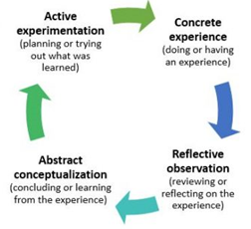  Kolb, D. A. (1984) Experiential Learning: Experience as the Source of Learning and Development. Prentice-Hall, Inc. Englewood Cliffs, N.J.Â
 | At the end of this phase, students ought to have a list of potential situations/scenarios where the skill(s) at hand may have been showcased. | A classroom activity where the cycle above is exemplified by the teacher and/or as a group exercise should clarify the process students are requested to engage with.
Teachers to provide formative feedback on evidence submitted to students, highlighting good practice, addressing common mistakes, and providing action points.
Reflection  ( R ) | Students to analyse the evidence they will be presenting against the criteria and rubric (student guide).  Students to think carefully about how the situations they have previously identified contributed to the acquisition/development of the skill(s) at hand.  Clear definition of skills, and assessment criteria are key for students to confirm or discard any chosen evidence.  At the end of this phase, students ought to have a collection of situations/pieces of evidence which demonstrate the skill(s) they are aiming to showcase. | Prompt your students to move beyond surface-level reflection. Begin reflection where the learners are. Have a quick open discussion to clarify assumptions and expectations about how learners perceive reflection so that you can minimise a likely potential mismatch between your expectations and your students’ preconceived notions about what engaging in reflection entails. Make use of and model their experiences in the learning process to help them anticipate the reflective process and see the benefits of reflection beyond learning. This can encourage openness and engagement in the reflection task. Make sure the purpose of the reflection is clear throughout.  Some of your students will naturally be more adept than others at engaging in reflection. For those who need some guidance, use a few guiding questions drawing on the 5 Rs: recalling (e.g. recalling an episode/event), recapturing (e.g. capturing the emotions, accomplishments, and challenges), relating (e.g. relating what was recalled to previous personal experiences), rationalising (e.g. understanding the patterns or learning from experiences to create meaning from past events), and redirecting (e.g. engaging in purposeful thinking directed towards future actions).
 |  | The following figure, which builds on the revised Bloom’s taxonomy (Anderson et al., 2013), can be an efficient awareness-raising activity which may help learners explore beyond the tip of the iceberg and develop depth of reflection:
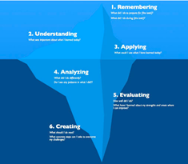
Anderson, L. W., Krathwohl, D. R., Airasian, P., Cruikshank, K. A., Mayer, R. E., Pintrich, P. R. and Wittrock, M. C. (2013). A taxonomy for learning, teaching, and assessing: A revision of Bloom’s taxonomy of educational objectives (abridged edition). Harlow, UK: Pearson Education.
Integration  ( I ) | Students to engage in reflective writing, i.e. to carefully explain and justify how each piece of evidence showcases skills acquisition.  At the end of this phase, students ought to have written their reflective narrative, clearly showcasing how the chosen evidence helped their acquisition/development of the skill(s) at hand. | Carefully-structured systematic disciplined writing is expected, often following a description, interpretation, and outcome thread. Model the structure you would like students to follow in their reflective narratives. A suggested template is provided in the student guide.  Draw on the language expected of students, and illustrate with examples. A detailed account is provided in the student guide.  Highlight the fact that:  - reflection is an exploration and an explanation of events not just a description of them;  - reflective writing often involves revealing anxieties, errors and weaknesses, as well as strengths and successes, as long as you show some understanding of possible causes, and explain what the experience taught you;  - it is often necessary to select just the most significant part of the event on which you are reflecting. If students try to tell the whole story, they are likely to use up their words on description rather than interpretation;  - it is often useful to reflect forward to the future as well as reflecting back on the past.
Teachers to assess students’ ePortfolio, consisting of their reflective narrative and supporting evidence, against the rubrics and criteria created for the task (see appendix).
Teachers to award students with a grade of or higher than 80% with a micro-credential which will allow them to proceed onto phase two. For unsuccessful students, the process ends here.

3.3 Articulation two: STAR
STAR | Successful students to engage in phase two of the pilot, where context, purpose, and audience will change, and which will focus on articulation of employability skills as per the STAR Method of Interviewing. | - Refer students to their student guide and explain and model the STAR method of interviewing (below this table), drawing on articulation of skills in a new context, i.e. the workplace, as key aim to meet in this phase.  - Draw on the integrative social pedagogy of ePortfolios and their value in enhancing students’ learning. Insist on the need to connect and integrate learning by including social elements which will help make learning more visible to others.
 | Explain and illustrate what professional ePortfolios should be and look like. | Refer students to the student guide for detailed instructions.

3.3.1 Video testimony
In the video testimony students must put together in their ePortfolio, they will be required to apply the STAR method of interviewing to the evidence they will have chosen to showcase their employability skills to employers. The STAR method of interviewing is a structured manner of responding to a behavioural-based interview question by discussing the specific situation, task, action, and result of the situation you are describing. In the current study, students will be required to think of the employability skill(s) they are showcasing, and present a situation(s) where they believe they acquired or developed said skill(s) following the structure below:
Situation(s): Describe the situation(s) that you were in or the task(s) that you needed to accomplish which you feel showcased the employability skill(s) at hand. You must describe specific event(s) or situation(s), not a generalised description of what you have done in the past. Be sure to give enough detail for the interviewer to understand. Situations can be from an academic endeavour, previous job, a volunteer experience, or any relevant event.

Task(s): What goal were you working towards?

Action(s): Describe the action(s) you took to address the situation(s) with an appropriate amount of detail and keep the focus on you. What specific steps did you take and what was your particular contribution? Be careful that you do not describe what the team or group did when talking about a project, but what you actually did. Use the word “I,” not “we” when describing actions. Keep in mind the employability skill(s) you are showcasing.

Result: Describe the outcome of your actions and do not be shy about taking credit for your behaviour. What happened? How did the event end? What did you accomplish? What did you learn? Make sure your answer contains multiple positive results and clearly showcases the employability skill(s) you have intended to demonstrate throughout.

You ought to make sure that students follow all parts of the STAR method in their video testimony. They should be as specific as possible at all times, without rambling or including too much information. They are encouraged to eliminate any situations that do not paint them in a positive light whilst keeping in mind that some experiences that have a negative result (such as “lost the game”) can highlight their strengths in the face of adversity. Therefore, encourage students to choose their examples wisely so they clearly prove acquisition/development of employability skills.

Below you will find some instructions which may help students understand how to approach their video testimony:
- Describe a situation in which you were able to use persuasion to successfully convince someone to see things your way.
- Describe a time when you were faced with a stressful situation that demonstrated your coping skills.
- Give me a specific example of a time when you used good judgment and logic in solving a problem.
- Give me an example of a time when you set a goal and were able to meet or achieve it.
- Tell me about a time when you had to use your presentation skills to influence someone’s opinion.
- Give me a specific example of a time when you had to conform to a policy with which you did not agree.
- Please discuss an important written document you were required to complete.
- Tell me about a time when you had to go above and beyond the call of duty in order to get a job done.
- Tell me about a time when you had too many things to do and you were required to prioritize your tasks.
- Give me an example of a time when you had to make a split second decision.
- What is your typical way of dealing with conflict? Give me an example.
- Tell me about a time you were able to successfully deal with another person even when that individual may not have personally liked you (or vice versa).
- Tell me about a difficult decision you’ve made in the last year.
- Give me an example of a time when something you tried to accomplish and failed.
- Give me an example of when you showed initiative and took the lead.
- Tell me about a recent situation in which you had to deal with a very upset customer or coworker.
- Give me an example of a time when you motivated others.
- Tell me about a time when you delegated a project effectively.
- Give me an example of a time when you used your fact-finding skills to solve a problem.
- Tell me about a time when you missed an obvious solution to a problem.
- Describe a time when you anticipated potential.

From the beginning of this process, we advise the role of the teacher be that of facilitator, guiding students in helping them engage with the different stages of the study by undertaking either one of the jobs below:

Figure 2

Role of Facilitator
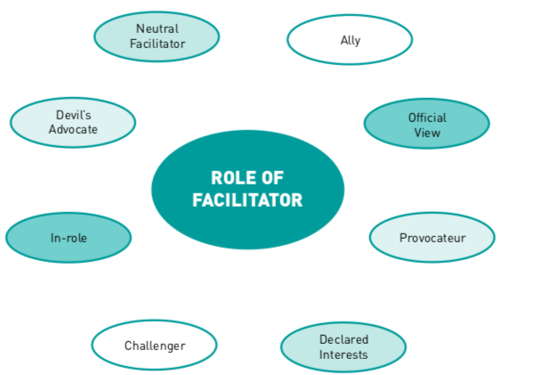

The following is an example of how Communication and interpersonal skills may be presented to students for the purpose of this pilot study.

4. Teaching Example
The example below consists of three generic lesson plans which have been designed to guide you when planning your teaching interventions. They are not meant to be prescriptive, but rather to be adapted or simply taken as inspiration for your work. Although the lessons below have been designed with a face-to-face scenario in mind, please note that they could also be delivered online or following a blended approach. Equally, if instead of two lessons you would rather have two, and choose to only provide formative feedback on a one-to-one basis, some of the content suggested in lesson plan [2] would have to be taught in your first intervention.

4.1 Lesson plan [1]
Table 3
Lesson Plan [1]
Topic: Pilot Presentation and articulation one |  | Teaching Intervention 01
Teaching objectives:
- to introduce students to the aims of skills assessment and micro-credentialisation;
- to present and unpack intended learning outcomes, activity structure, and materials;
- to introduce students/familiarise students with the concepts of employability skills, audience, purpose, inquiry, reflection, integration, and articulation;
- to introduce what is meant by communication and interpersonal skills.
Key words:
employability skills, criteria, situation, evidence, audience, context, purpose, inquiry, reflection, integration, articulation
Materials:
handbook, student guide
Starter: Introduce aims of the pilot study. Ask students to unpack the pilot’s ILOs:
- for students to be able to prove their acquisition of employability skills to teachers (articulation one),
- for students to be able to showcase said employability skills to employers (articulation two).
Elicit concept of employability skills from students, and what this may mean in the context of communication. Refer students to the handbook and to the student guide.
Main lesson:
Explain rubrics, criteria, and types of evidence in detail. Elicit examples from students before illustrating with a focus on communication and interpersonal skills.
Explain phase one of the pilot study, focusing on the concept of articulation. “What does articulation mean, what does it imply, and what does it look like?” If the concepts of audience, context, and purpose do not come up, exemplify their implications when articulating a message to a different audience.
Plenary:
Get students to think of temporality, sociality, and place. “When do you think you may have acquired communication and interpersonal skills? What were your thoughts and reactions at the time? Where were you when you developed such skill? What were you doing? Why and how do you think such an activity helped you develop this skill?” Probe students with the questions which should help them clarify the process of inquiry and reflective practice they are requested to engage with. Show students an image of the reflective cycle and spell out the process of gathering evidence. Refer students to the student guide where process has been broken down and job-aids have been provided.
Homework – follow-up task:
Students to come up with a list of activities they feel helped them develop communication and interpersonal skills, and an explanation/justification as to how and why they believe this to be the case. To be submitted within two weeks.
Teacher Tasks:
Be available for student consultations.

4.2 Lesson plan [2]
Table 4
Lesson Plan [2]

Topic: Formative feedback |  | Teaching Intervention 02  [optional]
Teaching objectives:
- to provide classroom formative feedback, i.e.
  - to highlight strengths and weaknesses of students’ work;
  - to illustrate what consists as valid evidence,
  - to introduce reflective narrative.
Key words:
situation, direct and indirect evidence, reflective narrative
Materials:
handbook, examples of direct and indirect evidence, student guide
Starter:
Ask students for feedback on their quest for evidence. Elicit types obtained. From students’ answers, identify and classify evidence into direct and indirect. Explain the difference between the two.
Main lesson:
Drawing on students’ lists of evidence, highlight strong and weak examples focusing on how the former would contribute to the task, and how the latter would fall short. Illustrate how supporting evidence will help weave the narrative students are to write. Introduce reflective writing, do’s and don’ts, and a template if using one. Refer students to the student guide.
Plenary:
Get students to share a brief example of how they will embed their evidence in their reflective practice, or rather how they will bring reflective thinking to their chosen evidence to weave a narrative. Focus on the importance of storytelling, reflective thinking, and justifying of evidence, and how language should be used to this effect. Refer students to the student guide. Remind students submissions are final.
[mins]
Homework – follow-up task:
Students to submit ePortfolio consisting of reflective narrative and supporting evidence within two weeks.
Teacher Tasks upon final submission:
Assess ePortfolio and award micro-credentials when students achieve >80%.

4.3 Lesson plan [3]
Table 5
Lesson Plan [3]
Topic: Introduction to articulation two |  | Teaching Intervention 03
Teaching objectives:
- to introduce students to the aims of phase two;
- to introduce students to the STAR method of interviewing;
- to illustrate skills expected in the workplace;
- to present professional persona and digital footprint.
Key words:
audience, purpose, articulation, style, register, appropriateness, ePortfolio for the workplace, social pedagogy
Materials:
teacher guide, student guide, employer guide, examples of ePortfolios
Starter:
Introduce students to phase two where focus shifts to the workplace. Identify differences in audience and purpose and the implications this brings.
Main lesson:
Elicit from students what they consider would need adapting from their school persona to their professional image. Link to ePortfolio structure and customisation for the workplace. Provide examples of professional bios/brief personal statements and the language expected in the workplace. Introduce STAR method of interviewing and video testimony requirements. Refer students to the student guide.
Plenary:
Students to practise in class a mock application of the STAR method of interviewing, selecting a situation or situations they feel contributed to their acquisition/development of employability skills, task(s), actions taken, and results achieved. It may be interesting to (also) make students start this exercise by thinking of results first and visit the process in reverse order, especially if no situation comes to mind.
Homework – follow-up task:
Students to revisit and customise their ePortfolio and record video testimony for employer to appraise.
Teacher Tasks:
N/A

5. References

Association of American Colleges and Universities (AAC&U). (2009). Inquiry and analysis VALUE rubric. https://www.aacu.org/value/rubrics/inquiry-analysis

Greenstein, L. M. (2012). Assessing 21st Century Skills: A Guide to Evaluating Mastery and Authentic Learning. Thousand Oaks: Corwin.

Hansen, K. and Hansen, R. S. (2012). The Quintessential Guide to Behavioral Interviewing. Kettle Falls: Quintessential Careers Press.

Ornellas, A., Falkner, K., & Edman Stålbrandt, E. (2019). Enhancing graduates’ employability skills through authentic learning approaches. Higher Education, Skills and Work-Based Learning, 9(1), 107–120.

The Open University. (2019). Putting together a portfolio of evidence. http://www.open.ac.uk/choose/vocational-qualifications/about-us/putting-together-portfolio-evidence

Faculty Innovation Center, The University of Texas at Austin. (2017, October 26). What is a rubric?
https://facultyinnovate.utexas.edu/sites/default/files/build-rubric.pdf

University of Waterloo. (2016). WatCV. https://uwaterloo.ca/centre-for-teaching-excellence/support/integrative-learning/watcv/watcv-resources

Vanderbilt University Center for Teaching. (2013). Gathering evidence: Making student learning visible. https://my.vanderbilt.edu/sotl/files/2013/09/4SoTLEvidence.pdf

Appendix I

1. ePortfolio Assignment Activity Template

Example of activity to be created by the teacher within the EPICA ePortfolio

Title
Showcasing your [Teacher to write the employability skill, e.g. Communication and interpersonal skill]

Upload Icon image Activity
[Teacher to upload the corresponding icon]

Description
The aim of this assignment activity is to effectively make your [Teacher to write the skill to be showcased here, e.g. Communication and interpersonal skills] visible to teachers and potential employers by articulating its acquisition to both an academic and a professional audience.
[Teacher: Communication and Interpersonal skill is the ability to articulate, transmit, and effectively defend arguments, ideas, feelings or information. To listen, understand, and be receptive to others].
By assembling an ePortfolio following the guidelines provided, you will be able to showcase and articulate this skill to these two different audiences and present yourself as a potential candidate for the workplace.
Before you start this activity, familiarise yourself with the Student Guide [Teacher to add link] and the Student ePortfolio Tutorial [Teacher to add link to the Student ePortfolio Tutorial].

Articulation One

- Select and upload your evidence

After following the guidelines provided by the teacher, you need to select relevant evidence in support of your [Teacher to write the skill here, e.g. Communication and interpersonal skill], developed in your curricular, co-curricular and extracurricular endeavours, and in any relevant work-related or professional experience, you may have had. This first step will be the result of a process of inquiry in which you will be required to audit your work by following a recursive, reflexive process whereby you will explore and question your present and past experience with an inquisitive mind, trying to weave a narrative in the process.

Please remember: In this first phase of the process, the audience of your ePortfolio is your teacher, who will be assessing your submission.

To select your evidence, please, review
- Section 3.3 ‘Evidence of learning of the Handbook’ [Teacher to add link to the Handbook],
- the job-aids included on Section 2.1 ‘Inquiry - Explore and identify’ of the Student Guide [Teacher to add link to the Student Guide],
- ‘Simulation of the process within the EPICA ePortfolio’ [Teacher to add link to the simulation]
- the Student ePortfolio Tutorial [Teacher to add link to the Student ePortfolio Tutorial].

Remember to select a minimum of one piece of curricular evidence of the skill you are showcasing, and a maximum of four pieces of evidence which demonstrate(s) how you have met the skill’s credentials’ criteria included in the rubric. Each piece of evidence you choose to demonstrate your [Teacher to write the skill here, e.g. Communication and interpersonal skill] can showcase one criterion or more than one of the criteria stated in the [Teacher to write the name here e.g. Communication and interpersonal skill] rubric. Do bear in mind that all evidence combined, however, must meet all the criteria.
Map out the final artefacts you will use in your submission, and identify what you will want to explain about each and every piece of chosen evidence to best demonstrate your capabilities. Articulation of how and why each choice contributed to your current competence is key.
After selecting your evidence, you will need to upload it onto your ePortfolio and write an introductory description to each item you will be submitting, including a title, the date the event took place, the role you had, a summary of the context in which you created this piece of evidence, how it demonstrates the competence at hand and the criteria it meets. To start preparing your submission, you will need to create a “Story/Evidence” within your ePortfolio and upload all evidence with its corresponding description.
Once uploaded your evidence to the ePortfolio within the corresponding “Story/Evidence”, ask for personalised formative feedback by sending the teacher a private message through the ePortfolio. Once you have the feedback, please, revisit your work and, if required, improve it according to the indications provided by the teacher.

In order to perform this task, please check:
- Section 3.2 ‘Your evidence’ in the Student Guide [Teacher to add link to the Student Guide], and
- the Student ePortfolio Tutorial [Teacher to add link to the Student ePortfolio Tutorial]

- Write and upload your reflective narrative and submit your work for assessment
After revisiting your work, please write your reflective narrative to prove the acquisition/development of your [Teacher to write the skill here, e.g. Communication and interpersonal skill]. The narrative should explain how you have acquired and used the skill you want to showcase, and how the evidence you have provided meets the credential’s criteria. Spend time thinking about the evidence. Your reflective narrative allows you to explain and justify (integrate) in writing your choice of evidence.
Once elaborated, please upload your reflective narrative within the “Story/Evidence” created in the ePortfolio.

In order to perform this task, please check:
- Section 3.3 ‘Reflective narrative - Integration’, and
- Section 3.3.1 ‘Reflective narrative - example’
- ‘Simulation of the process within the EPICA ePortfolio’.
- Appendix II ‘Workflow’.
in the Student Guide [Teacher to add link to the Student Guide].

Do make sure that your submission includes your reflective narrative and all supporting evidence (including the corresponding introductory paragraph for each piece) and send it for assessment. Once the submission ("Story/Evidence") has been sent for assessment, it will no longer be possible to edit it!

Assessment by the teacher will measure whether you have effectively articulated your acquisition and development of the [Teacher to write the skill here, e.g. Communication and interpersonal skill] in an academic context.
If your work is deserving of a micro-credential, i.e. you have achieved 80% or above, you will be awarded a badge.
Assessment by your teacher will also inform you on when you will be allowed to proceed onto the next phase and on whether the process has finalised for you and you do not proceed on to phase two. Please, check your notifications to see the assessment of each of the showcased skills.

Competences
[Teacher to add the tag of the skill, e.g. Communication and interpersonal skill]

Evaluation Criteria
[Teacher to add the Evaluation Criteria included in the rubric]

Teaching Notes
[Teacher to upload the rubric that is going to be used to assess the skill in PDF format]

2. Video assignment activity Template

Articulation Two

- Record your video testimony and customise your ePortfolio for the workplace (only if you succeed in the previous phase)

In this second phase of the process, the audience of your ePortfolio has shifted and is no longer your teacher but an employer who will be appraising whether your employability skills are fit for the workplace. This implies that you now have to think about your professional persona, and how you want to be viewed in the profession.

After succeeding in phase one, you will be required to revisit your ePortfolio and adapt it for the workplace by uploading a professional photo, and a short professional bio. You will also be invited to create another "Story/Evidence" in the ePortfolio and give it a meaningful title (e.g. My employability skills for the workplace). This time the submission will be targeted to an employer who will appraise your work.

You should record and upload onto your "Story/Evidence" a three-to-five minute-long video testimony for an employer to appraise, where you must present and articulate a situation(s) where you believe you acquired or developed the employability skill(s) at hand following the STAR method of interviewing.
Please beware that in your video testimony you are invited to articulate all the employability skills which were awarded a micro-credential, however many these are.

After uploading the video testimony, you have 2 options:
- Option A: choose to showcase the employability skill(s) by using the same evidence already submitted for assessment. In this case you only need to give public permission to the “Story/Evidence” previously submitted for the employer to access.
- Option B: choose to rethink the evidence which you feel better supports the video testimony. In this case you must limit access to their previous “Story/Evidence” by setting its privacy to ‘private’, and upload the chosen pieces of evidence onto the new “Story/Evidence”. You may choose to customise previously submitted evidence, present it as it was but in a smaller number, and/or upload additional evidence. Once uploaded the evidence, you must also give public permission to the “Story/Evidence” to make it visible to the employer.

Once completed, send a private message to the employer via ePortfolio asking for appraisal.

In order to perform this task, please check:
- Section 4.1.1 ‘The STAR Method’,
- Section 4.1.2 ‘Video testimony - example’
- Section 4.1.3 ‘Video testimony - script’, and
- Section 4.2 ‘How to customise your ePortfolio for the workplace’
- Appendix II ‘Workflow’
in the Student Guide [Teacher to add link to the Student Guide] and
- the ‘Simulation of the process within the EPICA ePortfolio’.

Once you have completed these steps, your submission will be appraised by an employer. You will receive his/her feedback on your ePortfolio via private message.
If you have managed to stand out, you will also receive a written commendation by the employer who will have appraised your work in a public message related to the Story/Evidence you created for the workplace.

3. Rubrics’ examples
A rubric is a scoring guide used to assess performance, a product, or a project. It has three parts: performance criteria; a rating scale; and indicators. For you and your students, the rubric defines what is expected and what will be assessed. Whether for online or face-to-face courses, it indicates that you will evaluate according to specified criteria, making grading and ranking simpler, more transparent, and fairer (The University of Texas at Austin, 2017).
Generic Rubrics’ examples of the employability skills included in the Skill up taxonomy (Ornellas et al., 2019) have been elaborated and made available to be reused and/or adapted.

3.1. Creative thinking
Creative thinking is both the capacity to combine or synthesise existing ideas, images, or expertise in original ways and the experience of thinking, reacting, and working in an imaginative way characterised by a high degree of innovation, divergent thinking, and risk-taking (Association of American Colleges and Universities, 2009).

Figure 3

Example of a rubric of Creative thinking

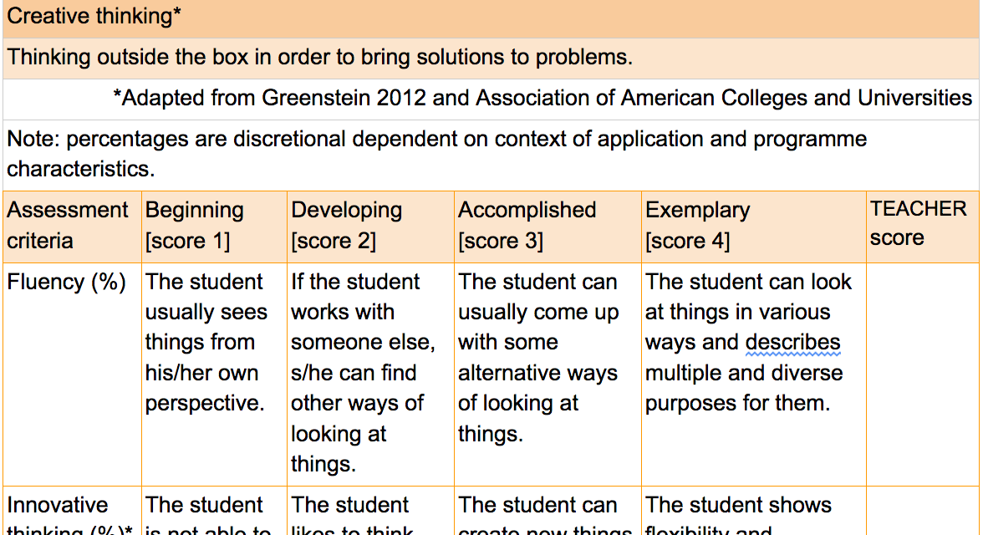

3.2 Problem solving
Problem-solving is the process of designing, evaluating and implementing a strategy to answer an open-ended question or achieve a desired goal (Association of American Colleges and Universities, 2009).

Figure 4

Example of a Rubric of Problem-solving

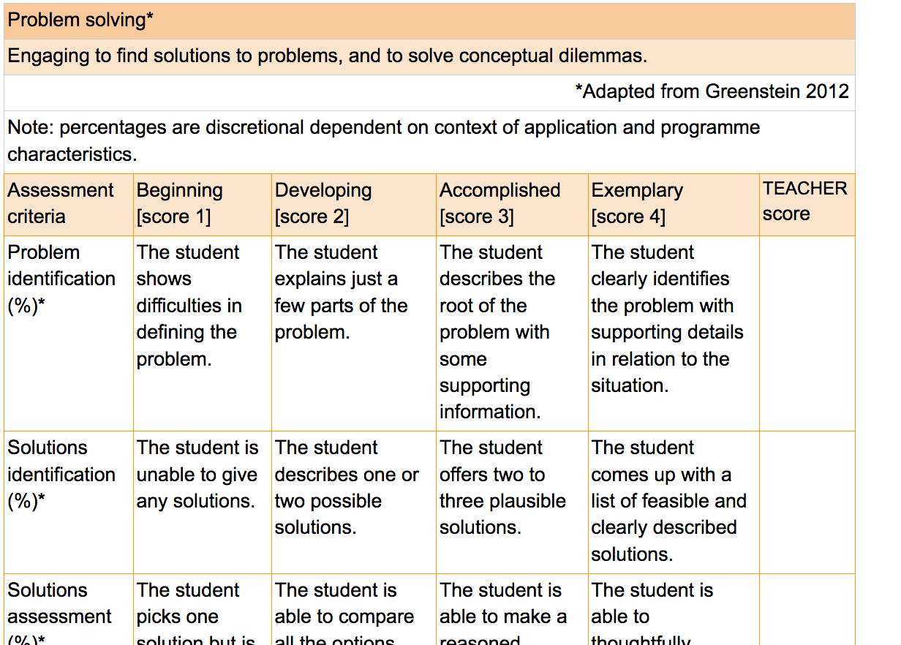

3.3 Communication and interpersonal skill
Oral communication is a prepared, purposeful presentation designed to increase knowledge, to foster understanding, or to promote change in the listeners' attitudes, values, beliefs, or behaviours. Written communication is the development and expression of ideas in writing. Written communication involves learning to work in many genres and styles. It can involve working with many different writing technologies and mixing texts, data, and images. Written communication abilities develop through iterative experiences across the curriculum (Association of American Colleges and Universities, 2009).

Figure 5

Example of a Rubric of Communication and Interpersonal Skill

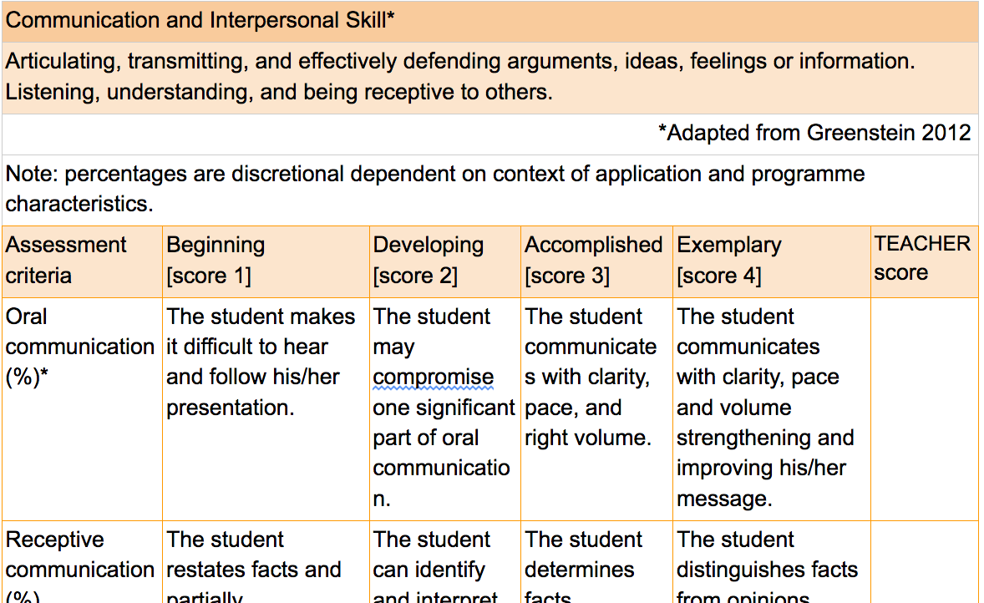

4. Employer Appraisal Form
Below is the form employers will be using to inform their appraisal of phase two of the pilot study, i.e. the customised ePortfolio for the workplace, which will include a video testimony and all supporting evidence.

The purpose of this appraisal form is twofold:
- to help you become acquainted with the criteria students’ work ought to meet before appraising it;
- to inform the final questionnaire which will be made available to you by a link to appraise students’ EPICA ePortfolio at large using these criteria.
In the final questionnaire, you will be requested to respond following a Likert scale asking you to strongly disagree, disagree, agree, or strongly agree with the statements provided.
Overall ePortfolio

Is the ePortfolio fit for the workplace?
Did the student present enough information to showcase their professional persona?
Did s/he do so in a professional manner?
Was the language used suitable for the workplace?

Video testimony - STAR method

Has the student successfully showcased the development of the presented skills?
Is the situation (S) presented by the student representative of the skill/s s/he was aiming to showcase?
Is the task (T) described by the student representative of the skill/s s/he was aiming to showcase?
Are the described actions (A) consistent with the task/s assumed?
Has the articulation of the results (R) been clear and efficient, that is, do the conclusions reached by the student show a growth in skill/s?
Has the student explained that s/he can transfer the skill/s to the workplace?
Has the student been able to limit the video to the established time (3 to 5 minutes)?
Is the information provided by the student objective?
Is the student's presentation focused on personal achievements and not on shared achievement?
Has the student presented himself / herself in a professional manner?

Evidence
Was the evidence submitted relevant to the task at hand?
Was the evidence presented representative of the skill/s it was aiming to showcase?
Was the evidence sufficient to demonstrate the skill/s s/he aimed to showcase?
Was the evidence reliable?
Was the evidence objective, that is, not based on subjective personal experience alone?
Overall Appraisal
Is the student’s work worthy of a commendation on your part?

Appendix II

1. Workflow

1.1 Workflow graphic

Figure 6

Workflow Graphic

1.2 Example of procedure
This example illustrates the procedure followed within the Epica framework.
1.2.1 Self-training and implementation
CStep1
- sign the Pilot User agreement
- receive the ADMINISTRATOR CREDENTIALS

CStep2
- introduce the list of skills to be piloted in the institution onto the system

TStep1
- sign the Pilot User agreement,
- receive the TEACHER CREDENTIALS (MyD)
- inform students of the need to sign the Pilot User agreement

TStep2
Take self-training on local Moodle.
During self-training, the teacher is encouraged to perform the following activities in order to be ready to start with the pilot right after the course:
- identify activities throughout the programme that may have driven to the acquisition of the skills to be piloted. This will enable the teacher to support students in the inquiry process (see the job-aids included on Section 2.1 ‘Inquiry - Explore and identify’ of the Student Guide)
- design/adapt the content needed to perform the pilot (activities, rubrics, planning) and familiarise themselves with the ePortfolio.

SStep1
- sign the Pilot User agreement
- receive the STUDENT CREDENTIALS to access the EPICA ePortfolio (MyD)

TStep3
In case it was not done during self-training, the teacher should:
- create the assignment activity/ies in the ePortfolio taking the ePortfolio Activity template as a model and associate the skill to be piloted with the class group (an activity per skill should be created within the ePortfolio). The rubric which will be used to assess the student should be uploaded in PDF format in the field ‘assessment criteria’ together with the Student Guide and the ePortfolio Student Tutorial. A relevant image icon needs to be added to the assignment activity (see the ePortfolio Assignment Activity Template in Appendix I of the Teacher Guide),
- set up planning and assign the assignment activity/ies to the students of the class group.
1.2.2 Pilot launch
TStep4
Intervention 1:
- introduce the pilot study aims and requirements to students
- explain the activity and provide students with specific guidelines to perform it (see Lesson plan [1] in Section 4.1 in the Teacher Guide).

SStep2
- attend Intervention 1
- familiarise oneself with the supporting materials
- log in to the ePortfolio and check the assignment activity/ies you should have received from your teacher. The rubric to check the assessment criteria that students’ work should meet can be downloaded by clicking on the Teaching Notes related to the assignment activity, available in the left column.

1.2.3 Evidence selection and formative feedback
SStep3
- engage in the inquiry process and select relevant evidence for each skill the student is asked to showcase following the guidelines provided in the student guide (see the job-aids included on Section 2.1 ‘Inquiry - Explore and identify’ of the Student Guide)
- create a "Story/Evidence" within the ePortfolio for each skill to be showcased and give it a meaningful title depending on the skill (e.g. My Communication and Interpersonal skill) (see the Process Simulation within the Epica ePortfolio).
- upload all the evidence selected in relation to a skill, with its description in the corresponding text box in its "Story/Evidence". Write down the skill tag for which you are providing evidence. These steps do not have to be performed at the same time for all the skills to be showcased. The planning made by the teacher within the ePortfolio establishes the calendar for each assignment activity.

TStep5
Intervention 2 (optional):
- provide general formative feedback to students (Q&A session) highlighting good practice and providing action points (feedback can be provided through different modes depending on the delivery method of each university) (see Lesson plan [2] in Section 4.2 of the Teacher Guide).

SStep4
- attend Intervention 2 when performed
- ask for personalised formative feedback on the "Story/Evidence" created by sending the teacher a private message through the ePortfolio. This will enable the student to revisit the work on the basis of the feedback and to improve it.

TStep6
- provide personalised formative feedback (via ePortfolio) and clear action points to improve the submission. Once the submission ("Story/Evidence") has been sent for assessment, it will no longer be possible to edit it.

1.2.4 Reflective narrative and summative assessment
SStep5
- write the reflective narrative for each skill to be showcased and upload it onto the corresponding ‘"Story/Evidence"’ already created in the ePortfolio (see Section 3.3 ‘Reflective narrative - Integration’ of the Student Guide).

SStep6
- submit it for assessment at once. The submission of the work ("Story/Evidence") should include the reflective narrative and all supporting evidence (including the corresponding introductory paragraph for each piece). Once the submission ("Story/Evidence") has been sent for assessment, it will no longer be possible to edit it. A submission for each skill is expected and final.

TStep7
- go to the rubric previously prepared to assess the skill. The rubric will be used outside the ePortfolio and the final result of the summative assessment will be reported in the evaluation feature of the ePortfolio. If the student’s submission is deserving of a micro-credential, i.e. it has achieved 80% or above, the student will be awarded a badge.
- clearly explain the following actions required of the student in the open text field available in the evaluation feature. Students should be clearly informed on when they will be allowed to proceed onto the next phase, or on whether the process has finalised for them and they do not proceed on to phase two.
1.2.5 ePortfolio for the workplace (only for the students who succeed in phase one)
TStep8
Intervention 3:
- introduce the STAR method of interviewing and articulation of skills for the workplace (see Lesson plan [3] in Section 4.3 of the Teacher Guide).

SStep7
- attend Intervention 3
- create another "Story/Evidence" in the ePortfolio and give it a meaningful title (e.g. My employability skills for the workplace). This time the submission will be targeted to an employer who will appraise the work and should include all the skills which had been awarded a badge,
- record the video testimony and upload it into the "Story/Evidence" created onto the ePortfolio. In the video testimony the student is invited to articulate all the employability skills which were awarded a micro-credential, however many these are (see the Video testimony - script in Section 4.1.3 of the Student Guide),
- after uploading the video testimony, the student has 2 options:
- Option A: If the student chooses to showcase their employability skill(s) by using the same evidence already submitted for assessment, they must give public permission to the “Story/Evidence” previously submitted for the employer to access.
- Option B: If the student, however, chooses to rethink the evidence which they feel better supports their video testimony, they must limit access to their previous “Story/Evidence” by setting its privacy to ‘private’, and upload their chosen pieces of evidence onto their new “Story/Evidence”. The student may choose to customise previously submitted evidence, present it as it was but in a smaller number, and/or upload additional evidence. Once uploaded the evidence, the student must also give public permission to the “Story/Evidence” to make it visible to the employer,
- customise the ePortfolio for the workplace (see the guidelines to customise the ePortfolio to employers in Section 4.2 of the Student Guide). Portabily, the tool included in the ePortfolio, can be used to give an attractive appearance to the ePortfolio,
- send a private message to the employer asking him/her to provide feedback on the "Story/Evidence" created.
1.2.6 Appraisal by employers
EStep1
- sign the Pilot User agreement
- receive the EMPLOYER CREDENTIALS to access the EPICA platform (MyD)
- receive the Employer Guide and the link to the appraisal form
- familiarise oneself with the ePortfolio, the micro-credential process, and the relevant materials. Review in detail the employer appraisal form (see Section 3 of the Employer Guide) in order to acquaint yourself with the criteria set for the appraisal of students.

EStep2
- check notifications and read the message from the student,
- receive the link to the appraisal online form by email,
- review the ‘Story/Evidence’ received from the student,
- review the video testimony
- review all evidence provided
- review the student profile
- appraise students by answering the appraisal online form received outside the platform.
- provide the student with qualitative feedback based on the appraisal form by answering the private message first sent by the student within the ePortfolio. The text written in the final text box of the appraisal form can be used as feedback by copying it into the private message,
- write a commendation if deemed worthy by writing a public message to the student in the text box available below the ‘Story/Evidence’ presented by the student (see Process Simulation within the ePortfolio).

Story/Evidence is a feature of the EPICA ePortfolio which enables the student to create a story by uploading pieces of evidence in different file formats.

